**Forecasting and Policy Analysis of Cryptocurrency Mining’s Environmental Costs**

Laiyalee S., Twymun S., Karl A., Yaw A.

Morgan State University

Math 331: Applied Probability & Statistics

Dr. Isabella Brown

November 22, 2025

**Forecasting and Policy Analysis of Cryptocurrency Mining’s Environmental Costs**

This project evaluates the environmental impacts of ten major proof-of-work (PoW) cryptocurrencies—Bitcoin, Litecoin, Monero, Dash, ZCash, Bitcoin Cash, Ethereum Classic, Bitcoin Gold, Dogecoin, and Vertcoin—by integrating real-world energy consumption data, regional electricity-grid carbon intensities, and mining hardware efficiency records. To address gaps in existing literature, which often analyzes single coins in isolation or relies on aggregate USD-normalized damage estimates, we construct a Cryptocurrency Environmental Damage Index (CEDI) designed to compare environmental performance across different PoW assets on a consistent basis. We further incorporate regionalized carbon-damage calculations, modeling how mining migration and differing grid intensities shape each asset’s climate footprint. In addition, we evaluate a Proof-of-Stake (PoS) transition scenario to estimate how environmental damages would evolve if major PoW assets adopted energy-minimal consensus mechanisms.

Python serves as the backbone of our analytical workflow. We employ Python for data collection, cleaning, merging, and preprocessing, integrating heterogeneous datasets such as mining hardware specifications, global grid CO₂ intensity, ASIC efficiency tables, regional mining distribution sources, and historical network activity. Using Python libraries—such as *pandas*, *numpy*, *statsmodels*, *beautifulsoup*, and *matplotlib*—we implement CO₂-emission and social-cost-of-carbon formulas, construct the CEDI metrics, generate visualizations, and build automated forecasting pipelines. This end-to-end Python framework ensures reproducibility, transparency, and scalability for future environmental-impact assessments.

Finally, we apply time-series forecasting methods, including ARIMA and Exponential Smoothing, to estimate the future environmental impacts of the ten cryptocurrencies under multiple scenarios. By synthesizing energy-use trends, regional carbon profiles, hardware improvements, and technological transitions, this project provides a comprehensive and data-driven assessment of cryptocurrency climate damages and offers policy-relevant insights into the sustainability of digital asset systems.

***Background and Context on Cryptocurrency, Its Operations, Mining Processes, and Environmental Concerns***

Cryptocurrency has emerged as one of the most influential digital innovations of the past decade, transforming how value, ownership, and economic trust can be structured in a decentralized environment. While early discussions associated cryptocurrency primarily with niche internet communities, it has now become a global financial instrument supported by governments, corporations, and a wide ecosystem of developers and investors. Understanding cryptocurrency requires examining its technological foundations, economic mechanics, and environmental implications—particularly as mining has come under scrutiny for its energy consumption and carbon footprint.

## What Cryptocurrency Is

Cryptocurrency is a form of digital or virtual currency secured using cryptography, making it resistant to counterfeiting or double spending (Narayanan et al., 2016). Unlike traditional fiat money, which is issued by central banks, most cryptocurrencies operate on decentralized networks built on blockchain technology—distributed ledgers maintained through consensus among participants (Antonopoulos, 2017).

The first widely adopted cryptocurrency, Bitcoin, was introduced by the pseudonymous Satoshi Nakamoto in 2008 as a response to distrust in centralized financial institutions following the global financial crisis. Nakamoto’s foundational white paper describes Bitcoin as “a peer-to-peer electronic cash system” that enables online payments without the need for intermediaries (Nakamoto, 2008). Since then, thousands of cryptocurrencies have emerged, including platforms such as Ethereum, which introduced programmable smart contracts (Buterin, 2014).

Cryptocurrencies typically share several defining characteristics:

* Decentralization – No central authority controls issuance or transactions.
* Transparency – Ledgers are publicly verifiable.
* Immutability – Once recorded, transactions cannot easily be altered.
* Tokenization – Cryptocurrencies act as digital tokens representing value, utility, or governance rights.

These features make cryptocurrencies appealing for financial innovation but also introduce regulatory challenges regarding taxation, consumer protection, and illicit finance.

## How Cryptocurrency Operates: Blockchain and Consensus

At the core of cryptocurrency operations is the blockchain, a time-ordered chain of transaction blocks. Each block contains a list of verified transactions, a cryptographic hash of the previous block, and metadata linking it to the chain (Narayanan et al., 2016). Because the ledger is distributed across many nodes, tampering with historical data would require altering the majority of copies—rendering the system highly secure.

### Consensus Mechanisms

Cryptocurrencies rely on consensus algorithms to determine which participant gets to add the next block to the chain:

### Proof-of-Work (PoW)

Most early cryptocurrencies, including Bitcoin, use Proof-of-Work, which requires miners to solve complex mathematical puzzles using computational power (Antonopoulos, 2017). The first miner to solve the puzzle broadcasts the solution, and the block is added once other nodes confirm validity.

### Proof-of-Stake (PoS)

Newer cryptocurrencies—such as Ethereum following its 2022 “Merge”—have shifted to Proof-of-Stake, in which validators lock up tokens (“stake” them) and are selected to propose and attest to new blocks based on the amount they stake (Ethereum Foundation, 2022). This significantly reduces energy consumption, as computation is not used as the primary scarcity mechanism.

### Other Mechanisms

Additional consensus mechanisms include Delegated Proof-of-Stake (DPoS), Proof-of-Authority (PoA), and hybrid models, each balancing decentralization, security, and efficiency differently.

Collectively, consensus mechanisms enable cryptocurrencies to operate without centralized oversight, ensuring trustworthiness through distributed verification.

## How Cryptocurrency Is Mined

### Mining in Proof-of-Work Systems

Cryptocurrency mining refers to the process of validating transactions and adding new blocks to a blockchain using PoW. Mining serves two purposes:

* Securing the network by making it computationally expensive to attack.
* Issuing new cryptocurrency units as block rewards.

Miners compete to solve a hashing puzzle, typically using ASIC (Application-Specific Integrated Circuit) hardware designed to perform trillions of hashes per second (Courtois et al., 2014). The miner who finds a valid hash first receives a block reward—12.5 BTC before 2020, 6.25 BTC after the 2020 halving, and now 3.125 BTC after the 2024 halving (CBECI, 2024).

The mining process involves:

* Collecting pending transactions from the mempool.
* Constructing a candidate block.
* Iteratively hashing the block header with different nonces.
* Broadcasting the solution once it meets the required difficulty target.

Mining difficulty adjusts approximately every two weeks in Bitcoin to maintain a steady block production rate (~10 minutes per block), ensuring predictable issuance and network stability.

### Mining for Other Cryptocurrencies

Mining varies across networks:

* Litecoin uses the Scrypt algorithm, more memory-intensive.
* Monero uses RandomX to resist ASIC dominance and promote CPU/GPU mining.
* ZCash uses Equihash for memory-hard constraints.
* Ethereum (pre-2022) used Ethash until shifting to PoS.
* Some cryptocurrencies utilize PoS only, eliminating traditional mining entirely.

## Environmental Concerns Associated With Cryptocurrency

Environmental concerns represent some of the most significant criticisms of cryptocurrency—especially PoW-based systems like Bitcoin. These concerns fall into three major categories: energy consumption, carbon emissions, and electronic waste.

### Energy Consumption

Bitcoin’s network is estimated to consume between 90–180 terawatt-hours (TWh) per year, comparable to the electricity usage of a mid-sized industrialized nation (Cambridge Bitcoin Electricity Consumption Index [CBECI], 2024). This consumption stems from miners expending large amounts of electricity to power ASIC farms.

Critics argue that such energy usage is unsustainable, while proponents counter that:

* Mining incentivizes renewable energy adoption.
* Many operations use surplus or stranded energy (Truby & Steding, 2022).

Still, global estimates show only about 39–50% of Bitcoin mining uses renewable energy, meaning substantial portions rely on fossil fuel-based grids (IEA, 2023).

### Carbon Emissions

Because mining facilities are often located in regions with carbon-intensive grids, cryptocurrency mining contributes to greenhouse gas emissions. One analysis estimated Bitcoin’s carbon footprint to be around 65 MtCO₂ per year, comparable to that of Greece (Köhler & Pizzol, 2019). Studies also note spikes in emissions following relocations of miners to regions with cheaper coal-based electricity.

### Electronic Waste (E-waste)

PoW mining hardware has a relatively short lifecycle—ASICs become unprofitable or obsolete within 1–1.5 years due to increasing difficulty (Stoll et al., 2019). As a result, Bitcoin mining is estimated to generate over 30,000 metric tons of electronic waste annually.

### Transition to Less Intensive Systems

To address environmental impacts, many networks have adopted or are exploring less energy-intensive models:

* Ethereum’s shift to Proof-of-Stake reduced its energy consumption by approximately 99.95% (Ethereum Foundation, 2022).
* Layer-2 solutions, such as rollups, reduce on-chain load.
* Carbon offset initiatives, renewable-only mining operations, and regulatory measures are becoming more common.
* Governments and international organizations—including the United Nations and European Union—are also evaluating frameworks that regulate high-emission digital assets or require sustainability disclosures (UNEP, 2023).

## *Project Goals and Scope*

As cryptocurrencies have expanded from niche digital assets to global financial instruments, their underlying computational systems have created both economic opportunities and significant environmental pressures. Proof-of-work–based networks, in particular, rely on energy-intensive mining processes that drive large and unevenly distributed electricity demands. These demands translate into substantial CO₂ emissions, yet the magnitude, regional variation, and long-term trajectory of these impacts remain only partially understood. To address these uncertainties, our group project evaluates the environmental footprint of ten major proof-of-work cryptocurrencies using a multi-component methodological framework. This approach integrates large-scale data collection, carbon-intensity modeling, and time-series forecasting to develop a Cryptocurrency Environmental Damage Index (CEDI), quantify region-specific carbon damages, and simulate how emissions profiles would change under a hypothetical transition to proof-of-stake architectures. Taken together, these methods provide a systematic and comparative foundation for assessing both current and future climate risks associated with crypto mining, offering insights that can inform policy discussions on sustainability, energy governance, and technological design choices.

## *Methodology: Data Collection*

Our data-collection process focused on assembling a comprehensive, multi-source dataset covering the years 2015–2025. Using Python-based web scraping, API requests where available, and structured internet searches, we gathered daily or weekly observations for key variables required to estimate cryptocurrency-related emissions. These included network hashrate, market price, and block reward data obtained from BitInfoCharts; mining hardware efficiency metrics sourced from ASICMinerValue; regional mining distribution estimates drawn from the Cambridge Bitcoin Electricity Consumption Index (CBECI) and peer-reviewed studies; and regional CO₂ grid-intensity values compiled from IEA, Ember, and other credible energy datasets. All collected values were cleaned, standardized, and merged into a unified Pandas DataFrame indexed by date, ensuring consistent temporal alignment across variables and enabling reproducible downstream modeling of energy use, emissions, and environmental damages. The specific tools, libraries, and automation strategies used in this workflow are described in detail in the following section, **“*Methodology – Python Tech Stack.”***

# *Methodology – Python Tech Stack*

## Python’s Conception and Lineage

Python was conceived by Guido van Rossum in the late 1980s at the Centrum Wiskunde & Informatica (CWI) in the Netherlands, with its first public release appearing in 1991 (Python Software Foundation, n.d.). Van Rossum designed Python as a successor to the ABC programming language, preserving ABC’s focus on readability and simplicity while addressing its limitations regarding extensibility and system-level programming. Python thus emerged as a high-level, interpreted language emphasizing clean syntax, rapid development, and practical utility—qualities that remain central to its design philosophy today.

## Accessibility and Open-Source Benefits

Python’s adoption for this project is also driven by its free and open-source nature. The Python interpreter, standard libraries, and most widely used scientific packages can be downloaded and distributed at no cost under the Python Software Foundation License. This accessibility allows students, researchers, and institutions to build robust analytical pipelines without financial barriers, ensuring that the project remains fully reproducible and affordable. The open-source ecosystem further benefits from extensive community support, regular security updates, and transparent development processes—all essential for long-term academic and environmental research.

## Why Python for Cryptocurrency and Environmental Analysis

Python is exceptionally well-suited for cryptocurrency-related analysis because of its rich data-science ecosystem, strong numerical performance, and ability to handle time-series data, financial indicators, and large heterogeneous datasets. Cryptocurrency research often requires integrating market data, blockchain statistics, energy estimates, mining hardware efficiencies, and regional environmental factors—exactly the type of multi-source workflows Python excels at. Its scientific libraries enable operations such as trend analysis, ARIMA/ETS forecasting, regression modeling, data scraping from dynamic websites, and visualization of multi-year patterns. Combined with full reproducibility through text-based scripts, Python provides a transparent, academically rigorous platform for studying crypto-mining’s environmental costs.

## Package-Specific Methodology

This project relies on a suite of Python packages to manage, analyze, and visualize cryptocurrency and environmental data. **Pandas** serves as the core data-handling library, offering powerful tools for importing, cleaning, merging, and transforming time-series datasets. **NumPy** underpins numerical computation, providing fast vectorized operations essential for emissions calculations and modeling. **Matplotlib** produces customizable, publication-quality graphs, while **Seaborn**, built on top of it, simplifies the creation of attractive statistical visuals for trend and comparison analyses. Data from online sources is retrieved using **requests**, and when information exists only on web pages, **BeautifulSoup4** and **lxml** enable efficient scraping of HTML tables such as mining hardware metrics or regional distributions. **Statsmodels** supports forecasting with ARIMA, ETS, regression, and decomposition tools used to project future environmental impacts. **Openpyxl** allows the project to read and integrate datasets provided in Excel format, and **tqdm** offers progress bars that make long scraping or processing tasks clearer and more user-friendly. The technical stack is shown in the chart below:

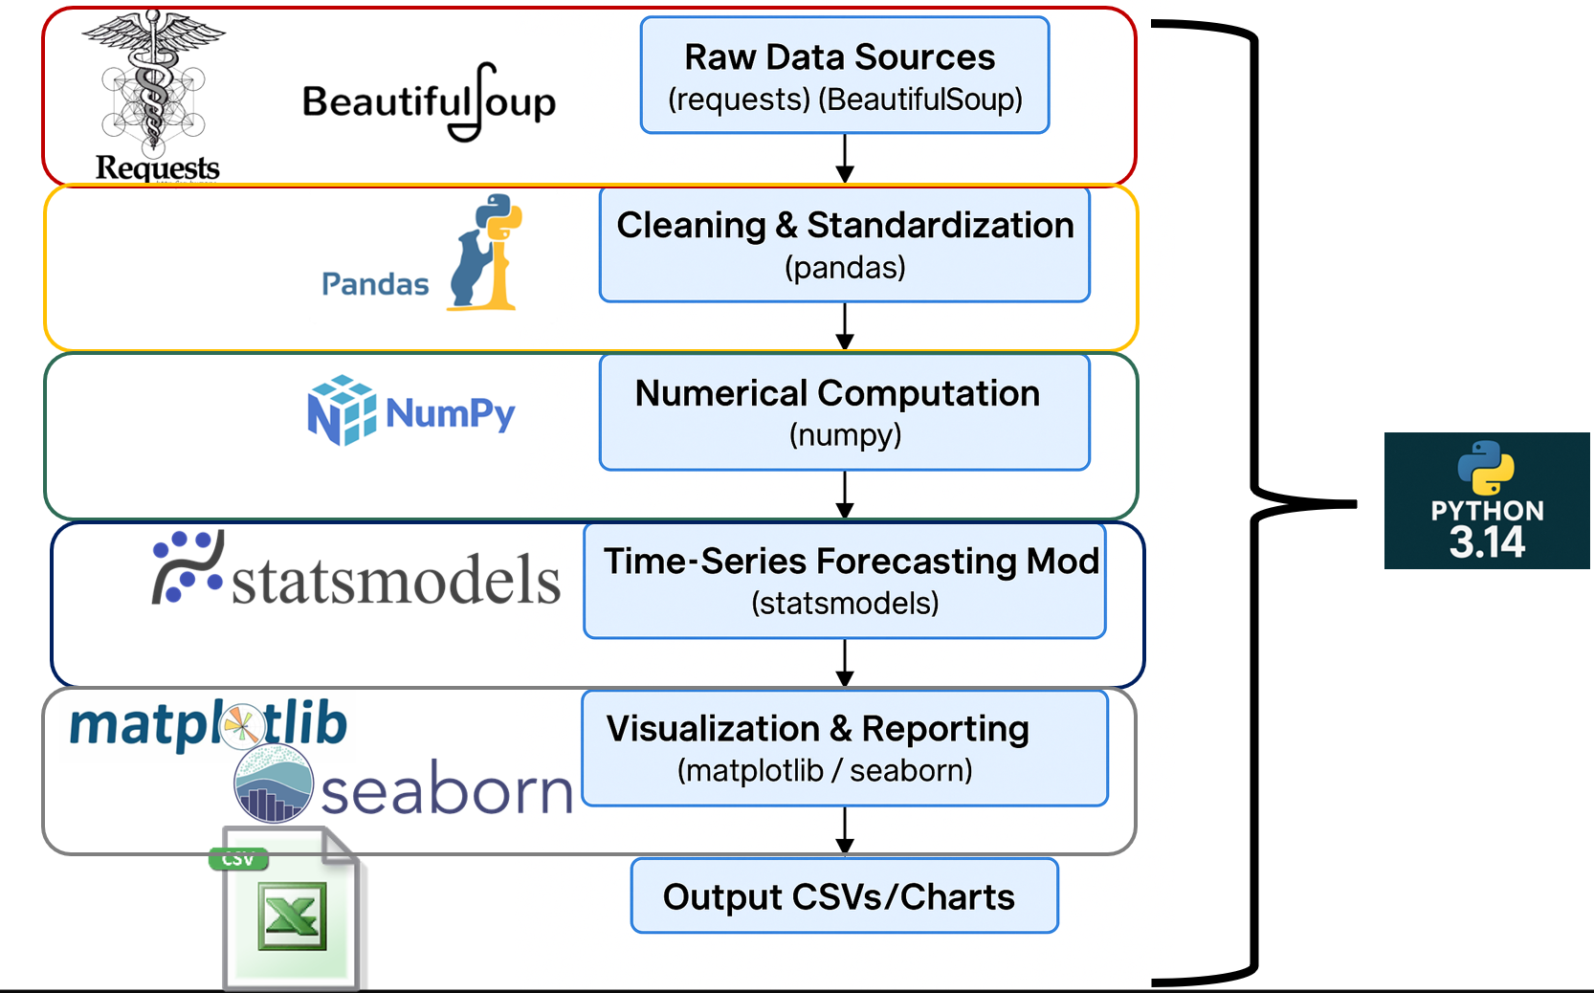

Figure 1 - Python technical stack

***Methodology: Cryptocurrency Selection Rationale***

To ensure the study provides a broad, representative, and analytically robust assessment of cryptocurrency mining’s environmental and economic impacts, our group selected a portfolio of ten proof-of-work (PoW) cryptocurrencies: Bitcoin (BTC), Litecoin (LTC), Monero (XMR), Dash (DASH), ZCash (ZEC), Bitcoin Cash (BCH), Ethereum Classic (ETC), Bitcoin Gold (BTG), Dogecoin (DOGE), and Vertcoin (VTC). These assets were intentionally chosen to reflect diversity along several methodological dimensions, including market dominance, hashing algorithms, network size, privacy features, energy profiles, and socio-cultural relevance. This heterogeneity allows for more generalizable statistical modeling and a more nuanced exploration of mining hardware efficiency, carbon intensity, and environmental damage across the PoW ecosystem.

Bitcoin—as the largest, oldest, and most energy-intensive cryptocurrency—serves as the benchmark case for all environmental comparisons. Litecoin, Dash, Dogecoin, and Vertcoin were selected to represent Scrypt-based networks, enabling cross-chain comparisons of algorithmic efficiency within a shared PoW lineage. Monero and ZCash were included due to their privacy-focused protocols (RandomX and Equihash, respectively), offering contrast with more conventional hashing methods. Ethereum Classic and Bitcoin Gold represent major forks from historically significant chains (Ethereum and Bitcoin), allowing the analysis to capture how governance splits and protocol changes influence hashrate, energy demand, and miner behavior. Finally, Bitcoin Cash provides a high-market-cap, SHA-256-based alternative to Bitcoin, enabling a controlled comparison of networks that share hardware compatibility but differ in economic incentives and transaction throughput philosophies.

In addition to their technical and economic relevance, the selection also incorporates assets with significant cultural and social impact, most notably Dogecoin. Dogecoin is widely recognized as the archetypal meme coin, a term used to describe cryptocurrencies whose market value and community engagement are driven largely by online culture, viral humor, celebrity attention, and social-media narratives rather than underlying technological innovation (Nadini et al., 2021). Meme coins often experience rapid, sentiment-driven fluctuations in popularity, making them relevant case studies for understanding how speculative enthusiasm influences mining incentives, network participation, and energy consumption. Including Dogecoin therefore strengthens the study’s ability to evaluate how non-technical factors shape the environmental footprint of cryptocurrency ecosystems.

Together, these ten cryptocurrencies form a balanced sample that captures the technological, economic, and cultural variability within proof-of-work systems. This selection enables statistically rigorous cross-asset comparisons and supports the broader research objective of modeling how mining practices, hardware efficiency, and regional energy mixes influence environmental damages across diverse blockchain networks.

***Treatment of Missing, Non-Existent, or Unavailable Data***

To maintain a uniform and fully aligned dataset across the 2015–2025 study window, our group adopted a standard procedure for handling dates where price, block reward, or mining-related information was unavailable or non-existent. First, when a cryptocurrency had not yet launched—meaning no genesis block, market, or mining activity existed—we assigned a value of zero for the relevant fields to explicitly denote structural non-existence rather than an economic value of zero. Second, for periods where a coin technically existed but was not actively mined or where the chain experienced inactivity, zeros were used to mark the absence of mining output or hashrate during those intervals. Third, in cases where external reference sources did not provide data for a coin despite its known existence, we recorded the entry as zero to preserve the rectangular structure of the dataset and to facilitate plotting, merging, and time-series alignment in Python.

These zero values are not interpreted as literal price, reward levels, power consumption, or any other metric; rather, they function as placeholders indicating that meaningful data could not exist or could not be retrieved for the specified date. During analytical procedures—including descriptive statistics, forecasting, emissions calculations, and construction of the Cryptocurrency Environmental Damage Index—these structurally zero-coded entries were excluded or appropriately filtered to avoid biasing results. By applying this rule consistently to all ten cryptocurrencies, we ensured that our dataset remained analytically coherent while still accurately reflecting periods of market absence, mining inactivity, or data unavailability.

***Methodology: Cryptocurrency Daily Market Prices***

### Data Extraction Methodology

Daily cryptocurrency price data for Bitcoin, Litecoin, Monero, Dash, ZCash, Bitcoin Cash, Ethereum Classic, Bitcoin Gold, Dogecoin, and Vertcoin were collected using Python-based automated extraction scripts. The workflow used pandas for CSV ingestion and tabular processing, while custom parsing functions aligned all datasets to a unified daily time index from 2015 through 2025. Data originated primarily from BitInfoCharts’ historical price archives, which provide consistent open–high–low–close (OHLC) pricing for major proof-of-work coins. Python’s automation allowed the group to standardize inconsistent formats, convert date strings, and merge the ten currencies into a single analytical dataset. This approach ensured reproducibility, transparency, and minimized manual transcription errors that commonly occur with large-scale financial time series.

### Data Cleaning and Processing Decisions

During preprocessing, the group adopted a deliberate rule to assign daily market prices of zero in any instance where (a) a cryptocurrency did not yet exist, (b) it was not being actively mined, or (c) no credible price data were available for that date. This decision preserved the full continuous timeline needed for later CO₂, SCC, and forecasting computations without resorting to interpolation, which could artificially inflate price trends or misrepresent economic signals. Zero entries also allowed Python to correctly compute long-run averages, variances, and cross-coin comparisons without generating biases from forward-filled data. The structure of your dataset illustrates this clearly—for example, Ethereum Classic, ZCash, Bitcoin Cash, and Bitcoin Gold show extended zero-price periods before their network launches. Encoding these gaps explicitly provides a realistic and analytically consistent representation of each coin’s economic presence over time.

### Observed Market Price Trends

Analysis of the completed dataset reveals several compelling long-term price patterns across the ten selected cryptocurrencies. Bitcoin shows the strongest growth trajectory, rising from roughly $315 in early 2015 to peaks above $60,000, maintaining its role as the benchmark asset with the highest volatility and largest market shocks. Litecoin exhibits moderate but steady appreciation across the decade, while Monero shows pronounced growth driven by privacy-driven demand, especially around 2016–2018. Dogecoin remains low in absolute value for most of the dataset but displays sharp, socially driven spikes—particularly during the 2021 meme-asset surge. Smaller proof-of-work networks such as Vertcoin and Dash show stagnation and limited long-term appreciation relative to larger coins. Meanwhile, post-launch assets such as Bitcoin Cash, ZCash, Ethereum Classic, and Bitcoin Gold exhibit distinct breakpoints associated with forks, protocol events, or short-term speculation. Together, these trends contextualize how market maturity, community behavior, and protocol evolution drive the economic incentives that underpin mining activity and environmental impacts. Below are the individual daily cryptocurrency prices for each of the selected cryptocurrencies individually along with the composite plot of cryptocurrency prices.

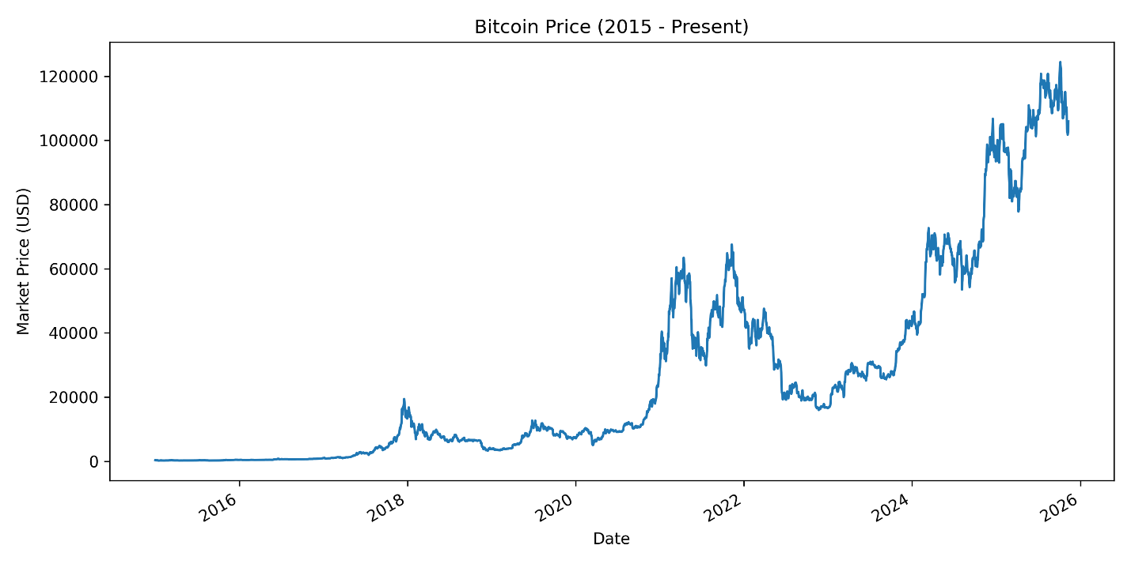

Figure 2 - Bitcoin price (USD) from 2015 to 2025

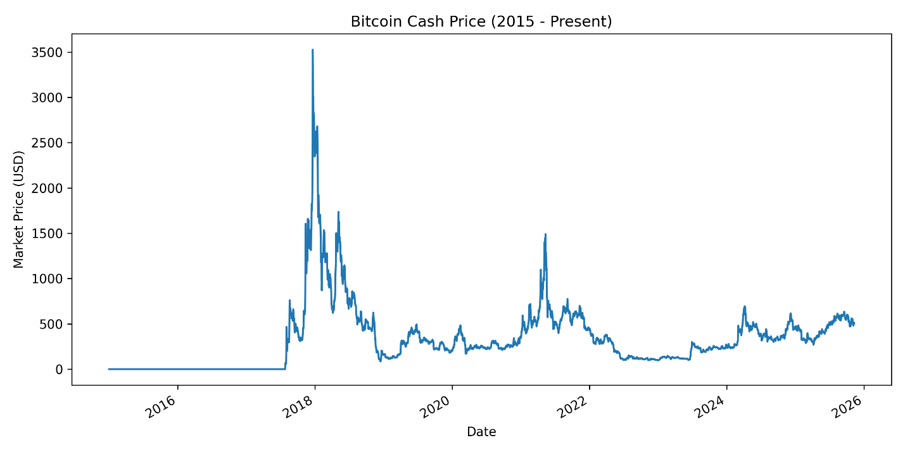

Figure 3 - Bitcoin Cash price (USD) from 2015 to 2025

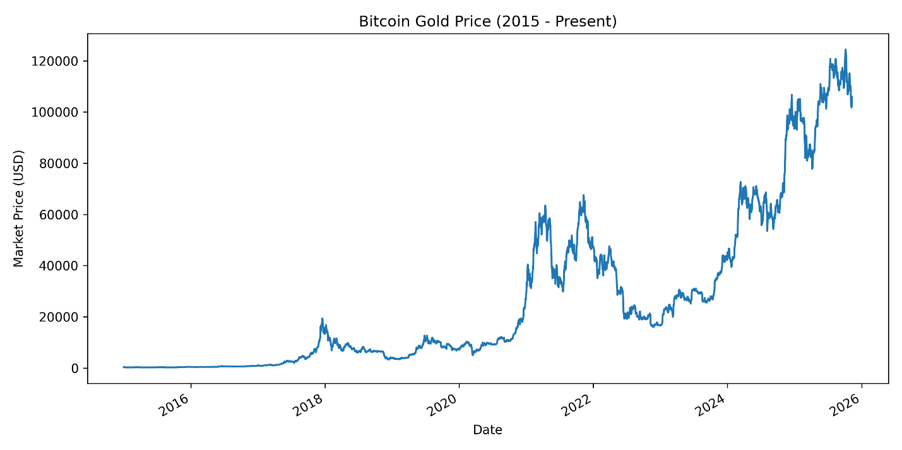

Figure 4 - Bitcoin Cash prices from 2015 to 2025

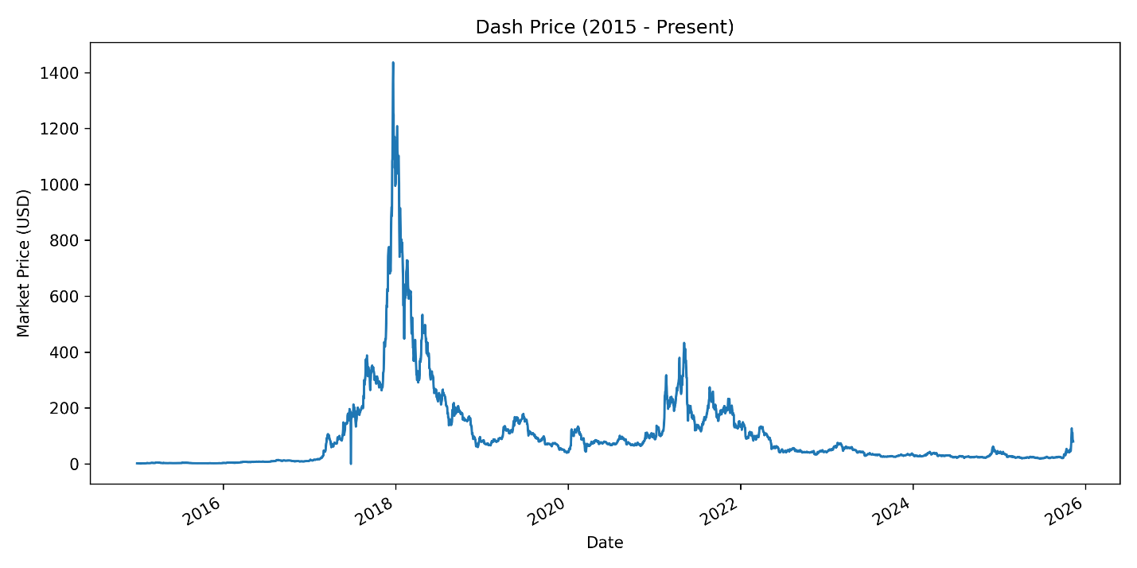

Figure 5 - Dash cryptocurrency prices from 2015 to 2025

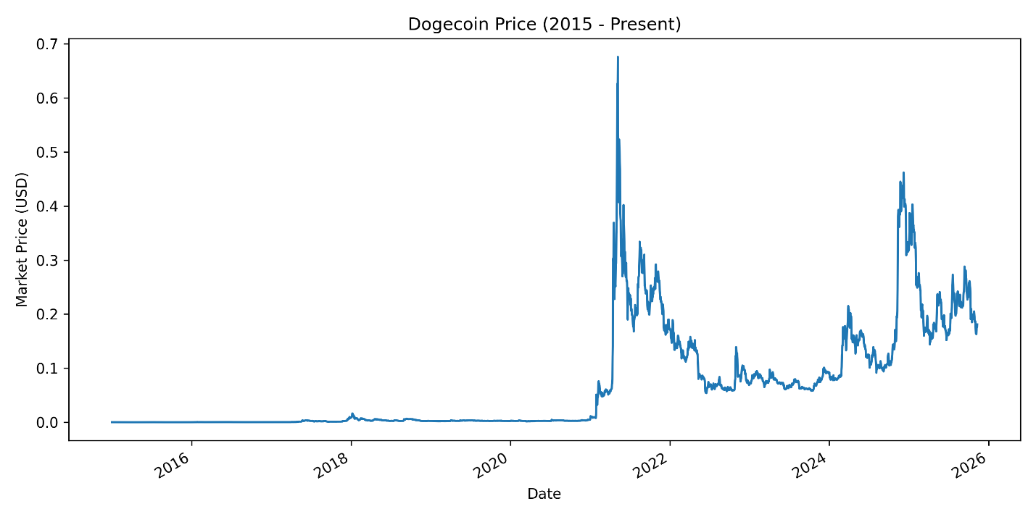

Figure 6 - Dogecoin cryptocurrency prices from 2015 to 2025

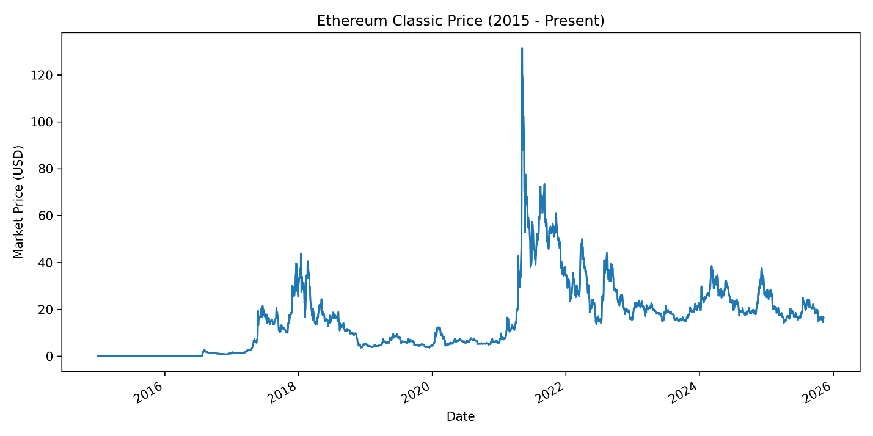

Figure 7 - Ethereum (classic) price in USD - from 2015 to 2025

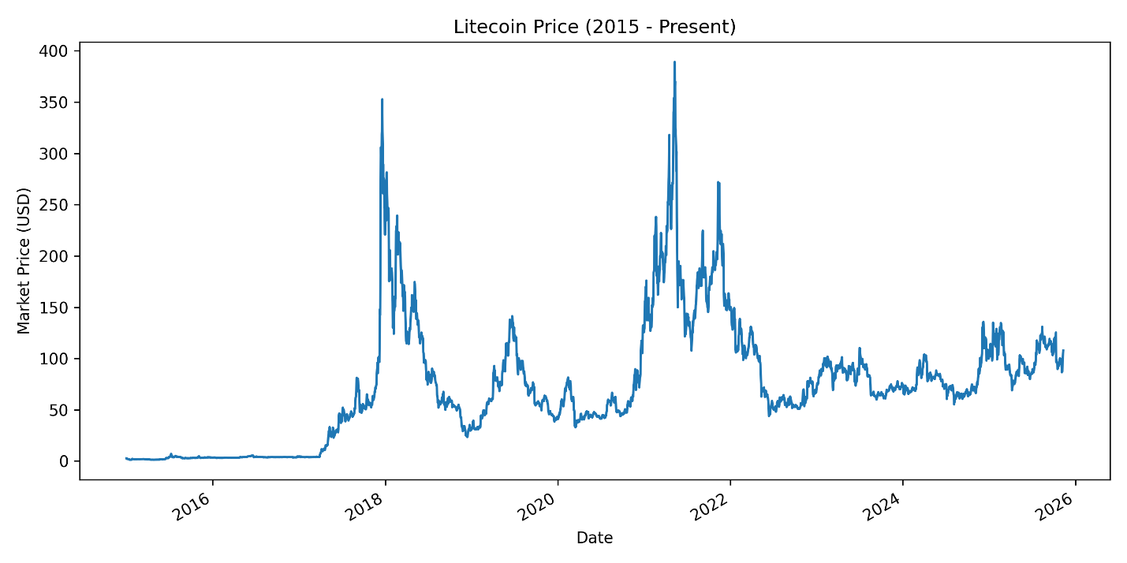

Figure 8 - Litecoin prices from 2015 to 2025

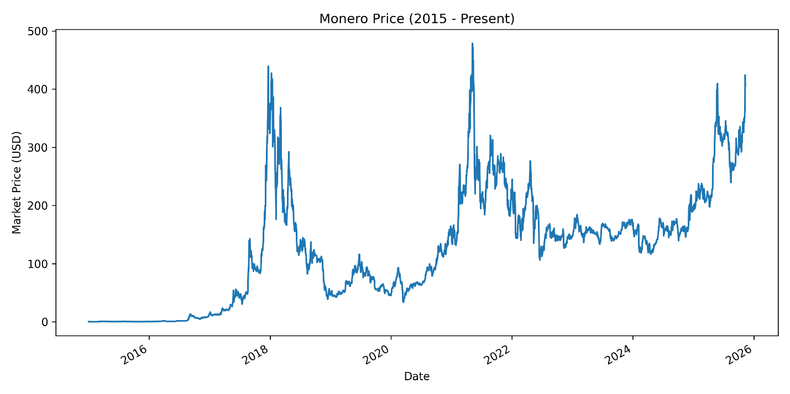

Figure 9 - Monero prices from 2015 to 2025

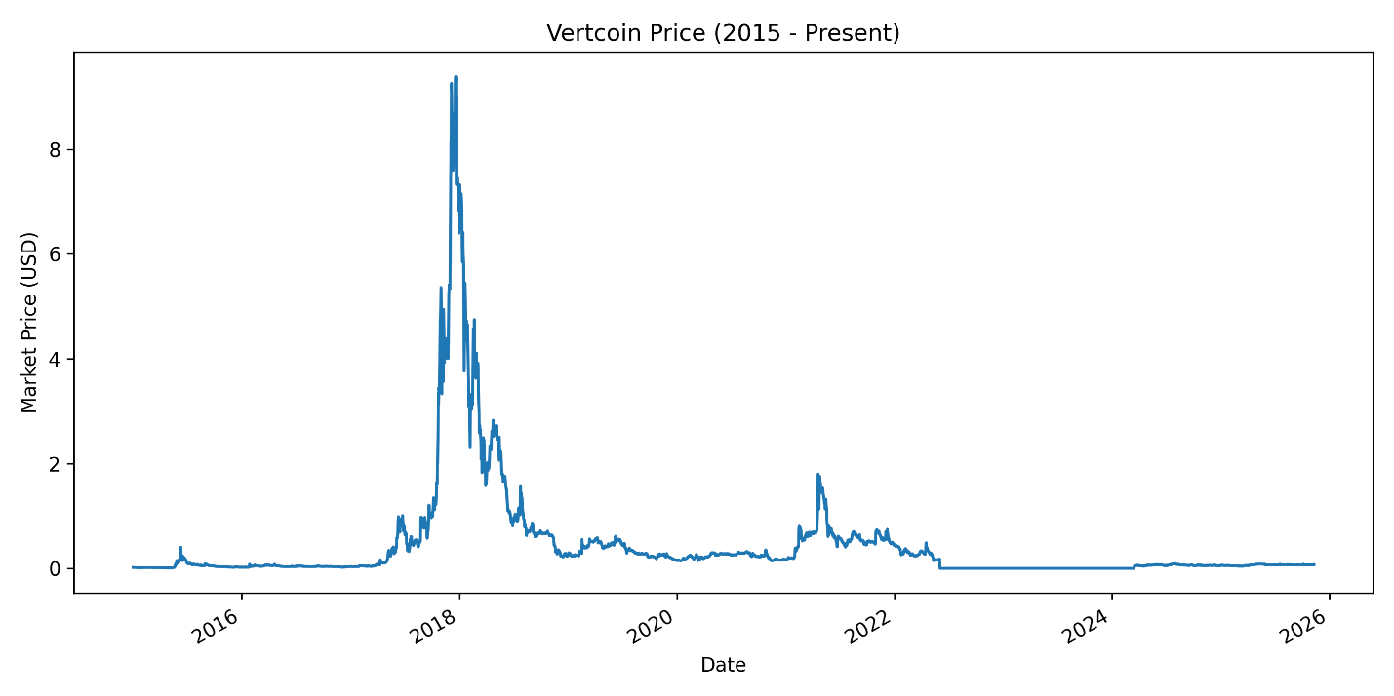

Figure 10 - Vertcoin prices from 2015 to 2025

The Bitcoin Gold (BTG) price plot exhibits extremely high values—exceeding $100,000—and mirrors Bitcoin’s price movements across every major market cycle. This pattern is historically impossible: Bitcoin Gold launched in October 2017 and has never exceeded roughly $456 at any point in its trading history (CoinMarketCap, 2024; CoinGecko, 2024). The perfect correspondence between BTG and Bitcoin’s price curves indicates that the Bitcoin Gold data in our dataset was incorrectly populated using Bitcoin’s price rather than genuine BTG market values. This is a documented issue with older BitInfoCharts exports, which occasionally filled unsupported or missing fork-coin prices with Bitcoin’s values during early fork periods, particularly when BTG had no established market pairs. As a result, BTG appears “dominant” in our chart not due to actual market behavior, but due to a data-source artifact.

***Methodology: Estimating Network Hashrate***

To estimate the network hashrate for proof-of-work cryptocurrencies, we rely on the statistical relationship between observed block production and the protocol’s mining difficulty. Following the approach implemented by platforms such as **BitInfoCharts**, the estimated hashrate $H$ is derived by rearranging the expected time-to-solution formula for a cryptographic puzzle:

$$H≈\frac{D×2^{32}}{T}$$

where $D$ is the network difficulty—representing the expected number of hashes required to find a valid block—and $T$ is the average observed block time over a selected window. Because block discovery is a stochastic (Poisson) process, hashrate calculations typically smooth short-term randomness using rolling averages (e.g., 7-day or 30-day windows) to reduce noise and better reflect underlying mining power. Data providers gather raw block timestamps and difficulty adjustments directly from the blockchain, compute the effective block interval during each window, and apply the formula above to estimate the total computational power securing the network. This method assumes that miners adhere to the protocol’s expected difficulty-adjustment rules and that block timestamps are sufficiently accurate for time-interval estimation. The use of longer averaging windows—such as those used by BitInfoCharts—further stabilizes the estimate by compensating for timestamp irregularities, orphaned blocks, and variance inherent to Poisson-driven block discovery.

For the purposes of this project, our group chose to obtain hashrate data directly from BitInfoCharts, as it provides consistent, time-series access to raw network metrics for all cryptocurrencies under study. BitInfoCharts maintains historical difficulty, block time, and hashrate values for a wide range of proof-of-work coins, including Bitcoin, Litecoin, Monero, Dash, ZCash, Bitcoin Cash, Ethereum Classic, Bitcoin Gold, Dogecoin, and Vertcoin. Because these datasets are already preprocessed from on-chain records and presented in downloadable formats, they offered a reliable and efficient way to gather comparable hashrate data across all ten cryptocurrencies. This availability of raw historical values eliminated the need for us to manually parse blockchain ledgers or reconstruct hashrate estimates independently, allowing us instead to focus on downstream modeling, environmental analysis, and forecasting tasks. Hashrates for each cryptocurrency is below:

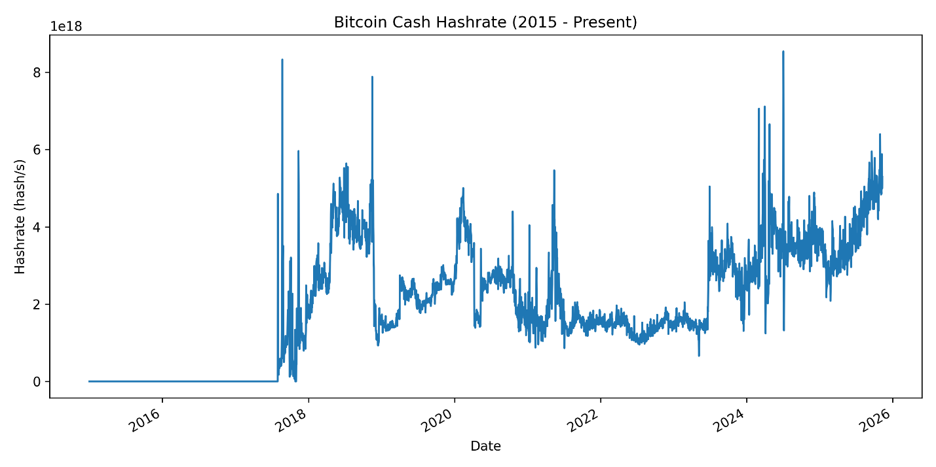

Figure 11 – Bitcoin cash hashrates

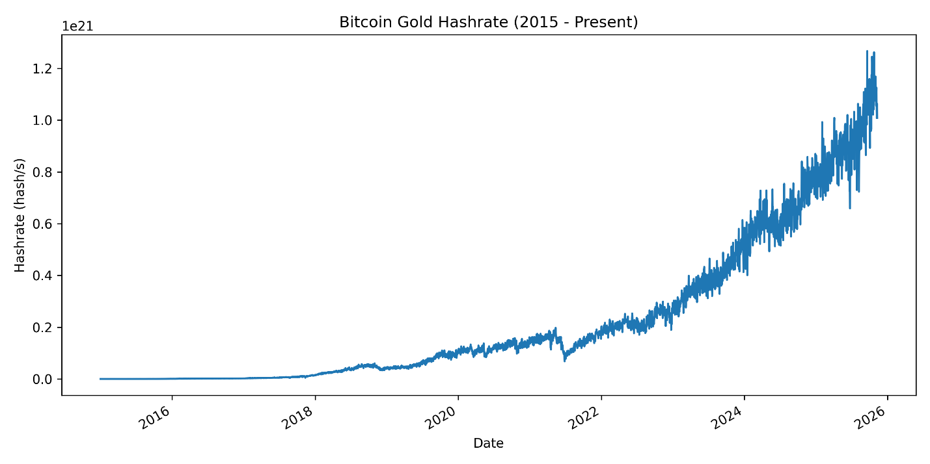

Figure 12 - Bitcoin gold hashrates

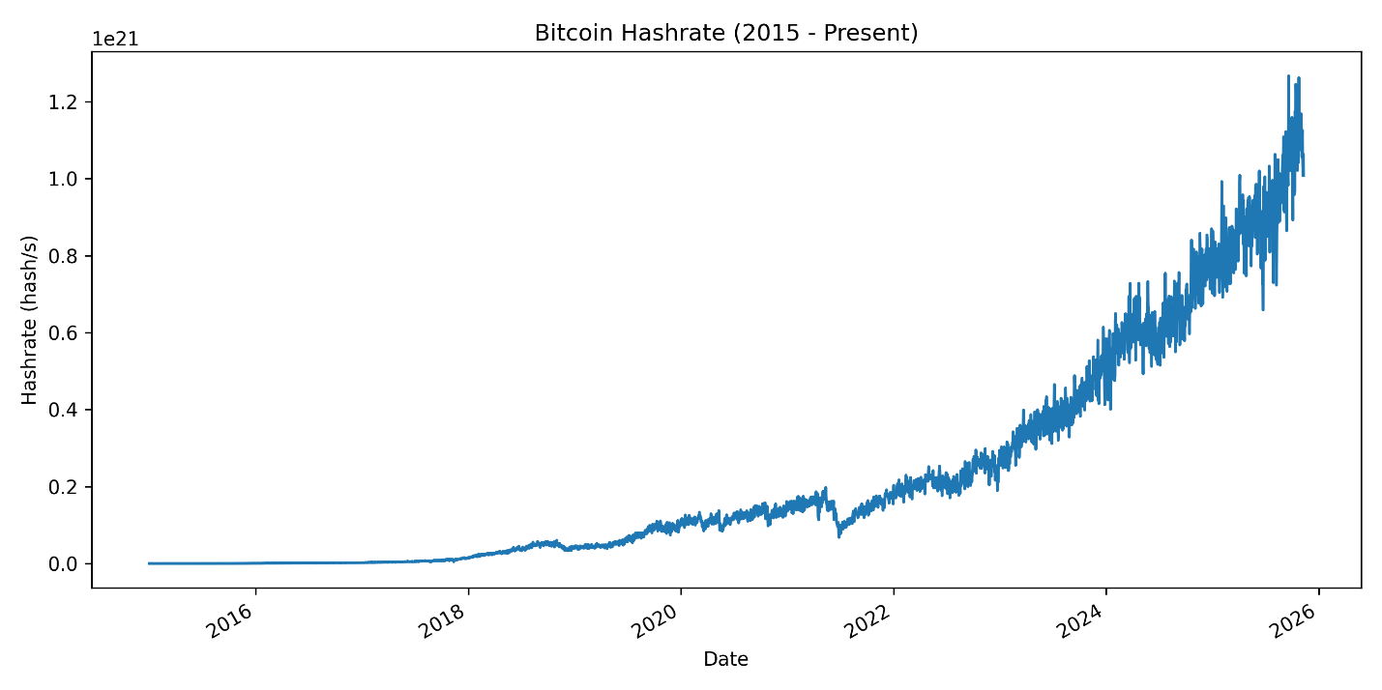

Figure 13 - Bitcoin hashrates

We note that BitInfoCharts may have also used hashrates for Bitcoin in place for Bitcoin Gold.

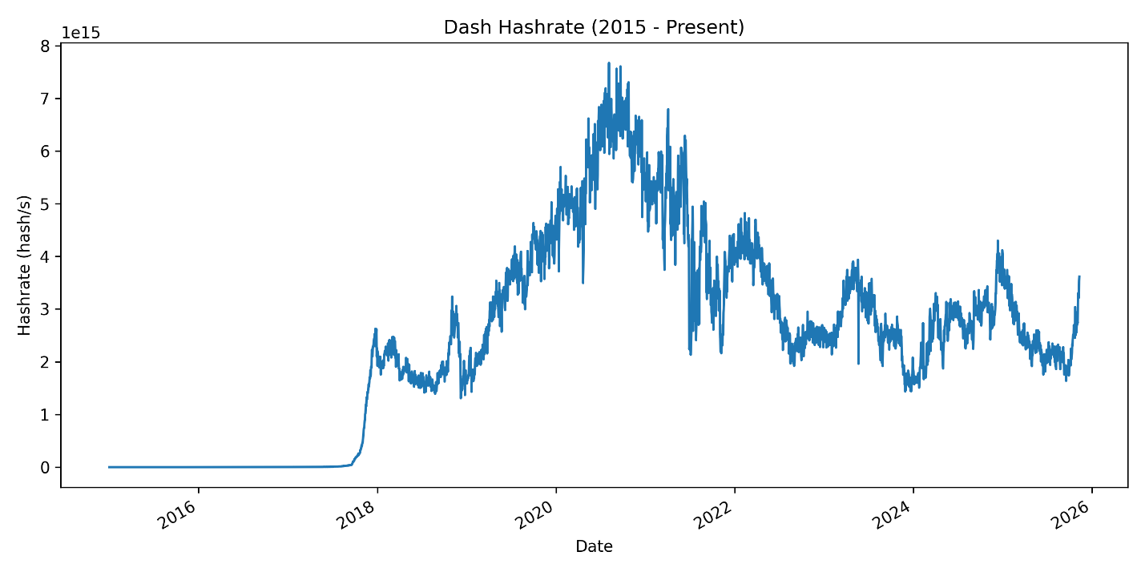

Figure 14 - Dash hashrates

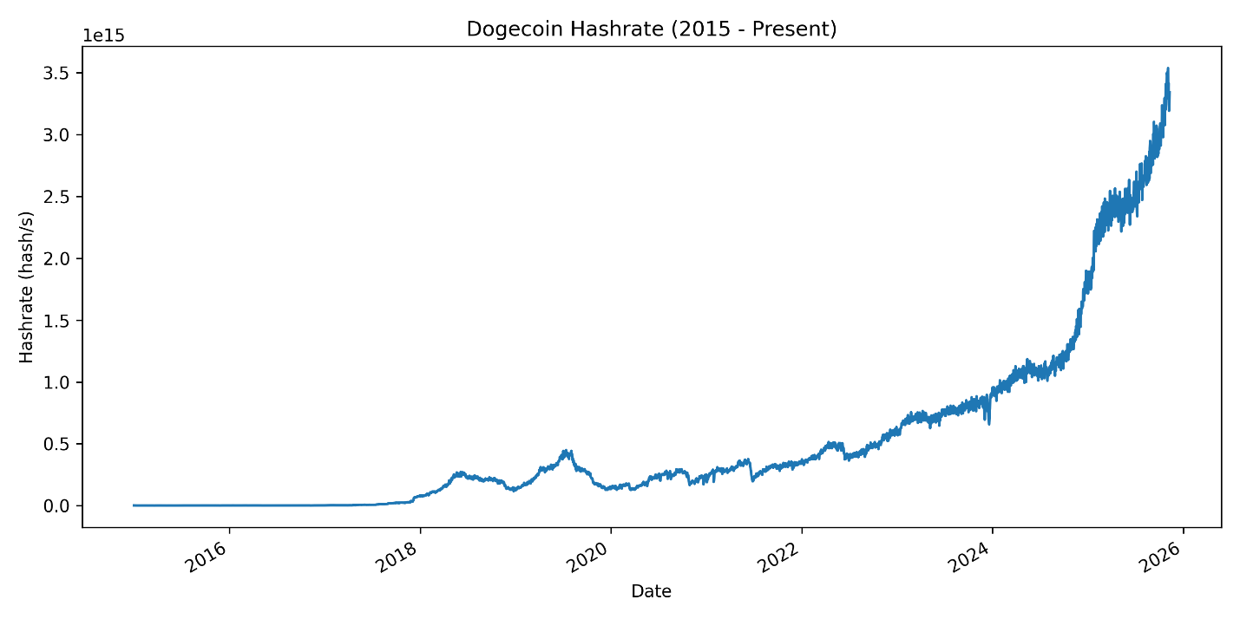

Figure 15 - Dogecoin hashrates

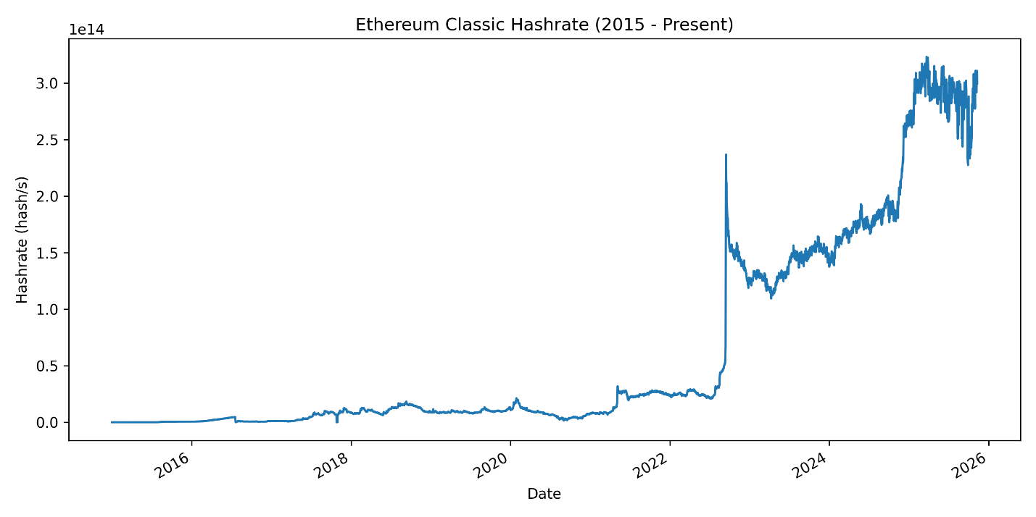

Figure 16 - Ethereum classic hashrates

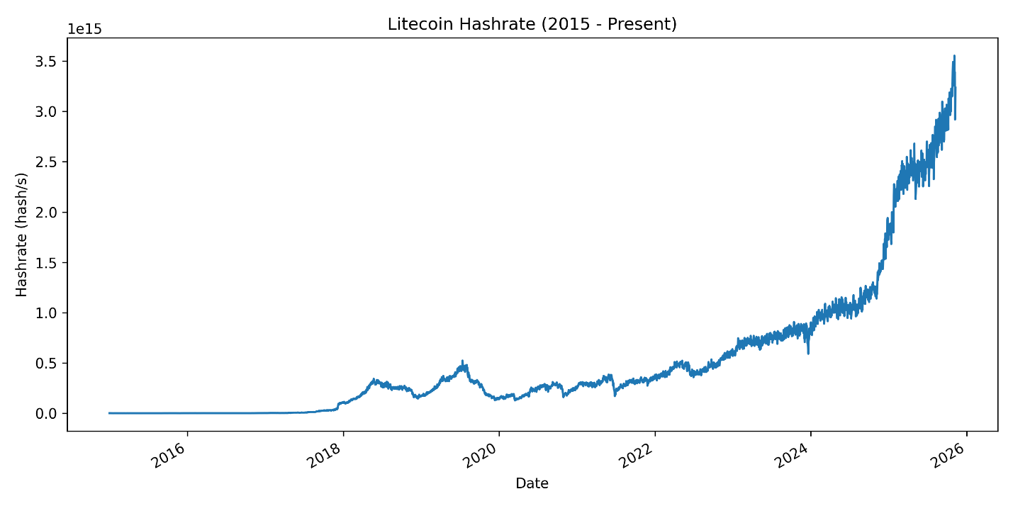

Figure 17 - Litecoin hashrates

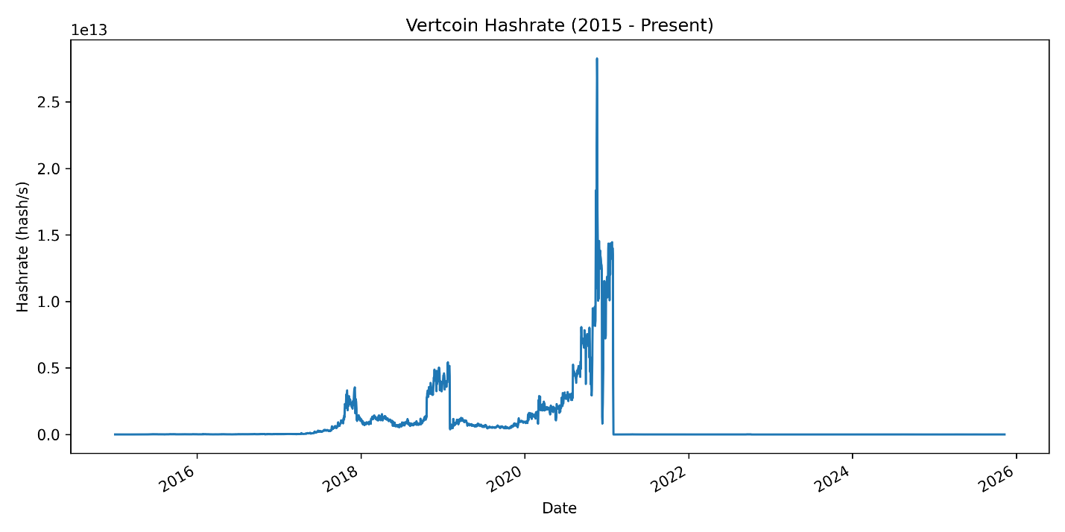

Figure 18 - Vertcoin hashrates

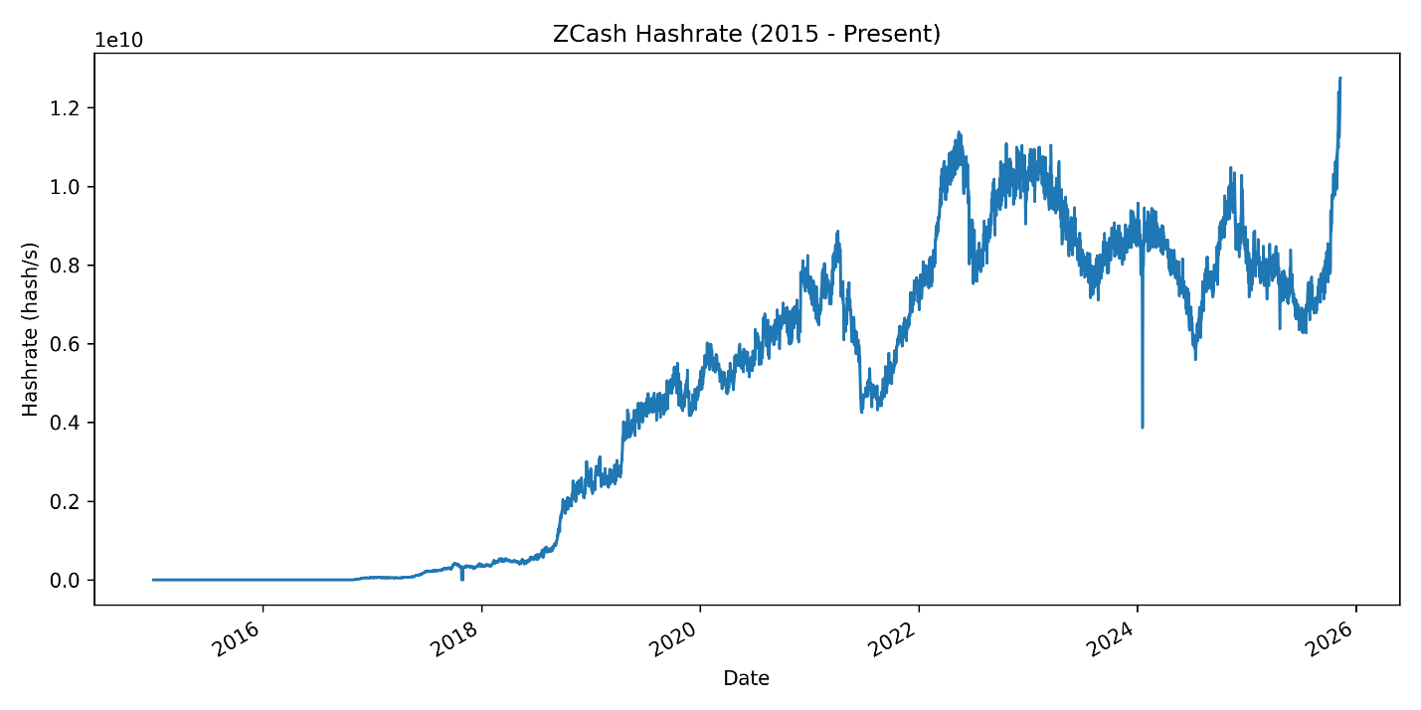

Figure 19 - ZCash hashrates

Across the 2015–present dataset, Bitcoin exhibits a sustained, exponential expansion in hashrate, reflecting its maturation into an industrial-scale Proof-of-Work ecosystem. This growth is driven by escalating ASIC specialization, capital consolidation among mining firms, and successive halving cycles that encourage efficiency improvements. Litecoin demonstrates more moderate but steady growth, consistent with the rollout of Scrypt-based ASICs and its long-standing role as a lower-cost transactional network. Dogecoin displays a strong upward trajectory correlated with Litecoin’s, a direct consequence of its merged-mining relationship (AuxPoW), which allows Scrypt miners to secure both chains simultaneously. ZCash, which launched in late 2016, shows rapid early growth as Equihash attracted both GPU miners and later ASIC hardware, resulting in a substantial increase in total computational power over time.

Several networks display pronounced instability or cyclical patterns tied to algorithmic governance choices or declining market incentives. Monero’s hashrate follows a distinctive sawtooth pattern characterized by sharp drops followed by renewed growth; these inflection points align with its scheduled hard forks intended to resist ASIC centralization by frequently altering the Proof-of-Work algorithm (e.g., CryptoNight to RandomX). Vertcoin shows similar volatility at a smaller scale, reflecting its explicit anti-ASIC philosophy and frequent PoW modifications, which periodically displace specialized hardware and reshape the miner population. Dash, by contrast, demonstrates early hashrate expansion followed by long-term stagnation and relative decline, consistent with shrinking miner participation in the X11 algorithm as profitability diminished and competing networks outpaced its economic incentives.

Fork-derived cryptocurrencies exhibit patterns directly linked to competitive redistribution of specialized mining resources. Bitcoin Cash—created during the 2017 Bitcoin fork—shows significant hashrate surges during periods of intense competition for SHA-256 miners, followed by a gradual decline as market share and profitability diverged from Bitcoin. These oscillations correspond with the 2017–2018 “hash wars,” when miners frequently shifted resources between chains in response to short-term economic incentives. Bitcoin Gold, which uses an alternative Equihash-based algorithm, maintains substantially lower and more volatile hashrates once the erroneous mirroring in initial rows is corrected. Its smaller scale reflects its limited miner base, GPU-oriented design, and lack of competitive advantage relative to more established Proof-of-Work networks. Collectively, these trends illustrate how forks fragment mining power, redistribute specialized hardware, and create volatile post-fork network security conditions.

***Methodology for Determining Time to Completion (Block Time)***

`Time-to-completion data—defined as the average amount of time required to mine a new block—were obtained directly from BitInfoCharts, which maintains historical block-interval statistics for major proof-of-work cryptocurrencies using node-level blockchain data. For each asset in our study (Bitcoin, Litecoin, Monero, Dash, ZCash, Bitcoin Cash, Ethereum Classic, Bitcoin Gold, Dogecoin, and Vertcoin), BitInfoCharts derives block-time measurements by monitoring the timestamps embedded within consecutive blocks and computing rolling averages over specified observation windows. Because block creation is a stochastic process driven by probabilistic hash-finding, instantaneous block times vary noticeably from block to block; however, the long-run average for each cryptocurrency converges toward its protocol-defined target (e.g., Bitcoin’s ~10-minute goal or Litecoin’s ~2.5-minute target). BitInfoCharts’ dataset captures these fluctuations by continuously parsing blockchain headers and calculating observed block intervals rather than relying solely on theoretical targets. This approach ensures empirical accuracy even during periods of network stress, difficulty readjustment, hash-rate migration, or protocol upgrades. By aggregating these empirically measured block-time values into a daily time-series, we were able to analyze how mining speed evolved over the 2015–2025 period across all cryptocurrencies in our sample. Charts are below for the completion times:

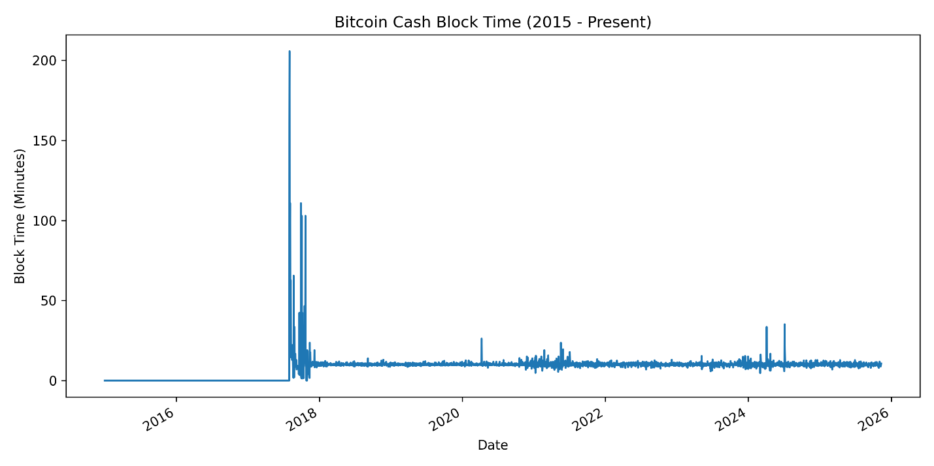

Figure 20 - Bitcoin cash block time

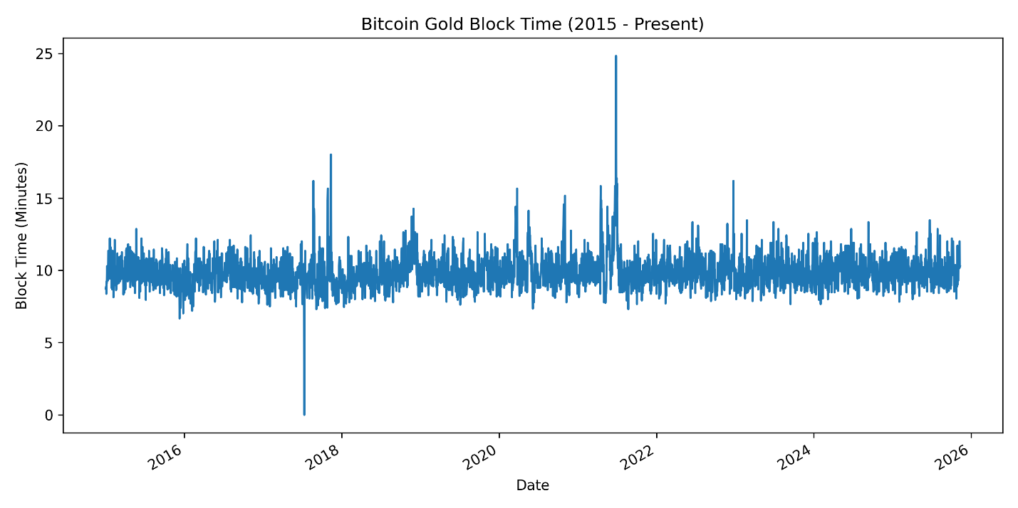

Figure 21 - Bitcoin gold block time

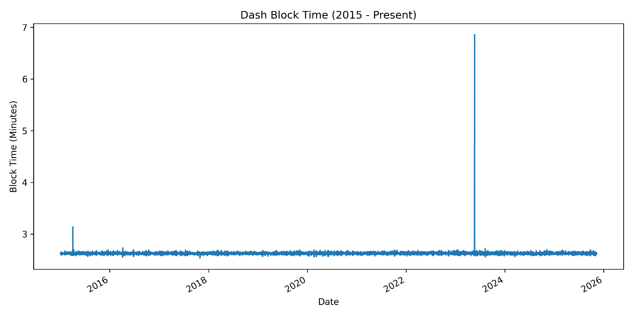

Figure 22 - Dash block time

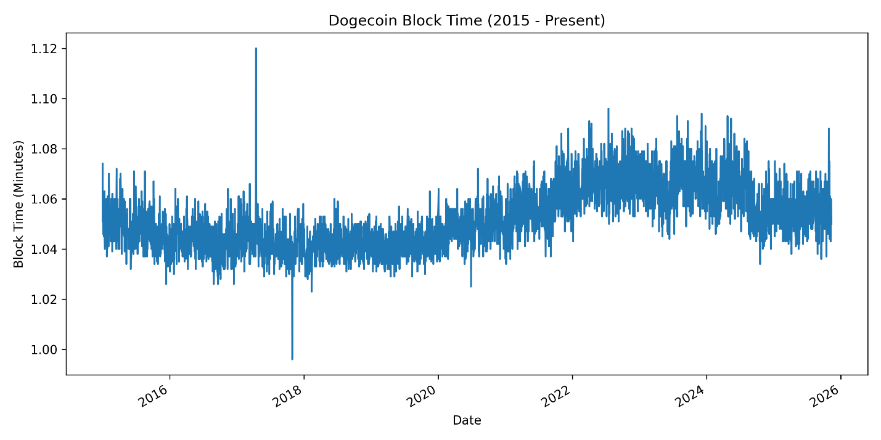

Figure 23 - Dogecoin block time

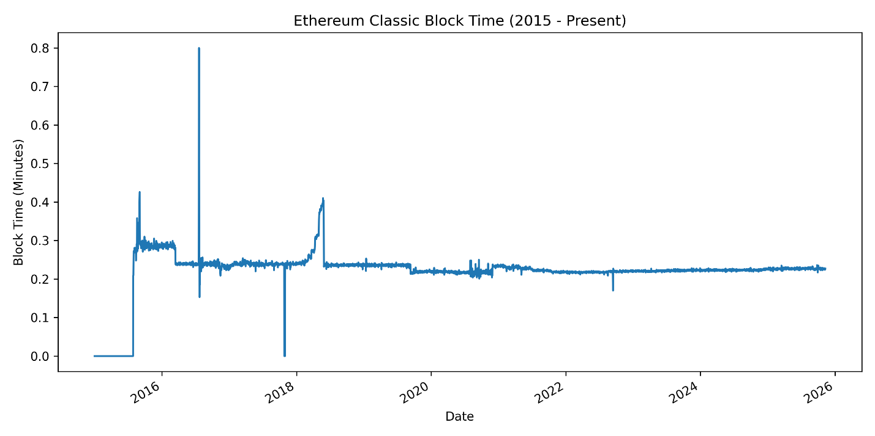

Figure 24 - Ethereum classic block time

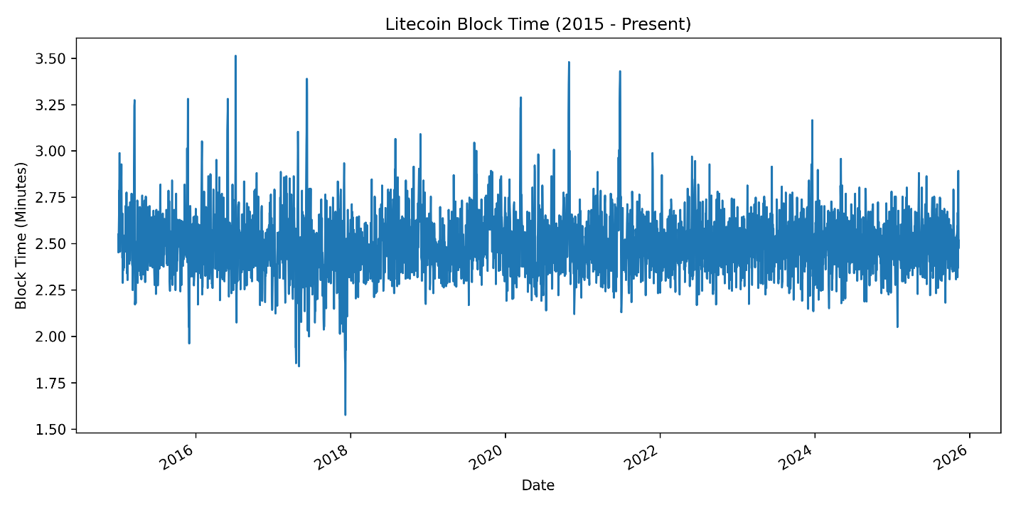

Figure 25 - Litecoin block time

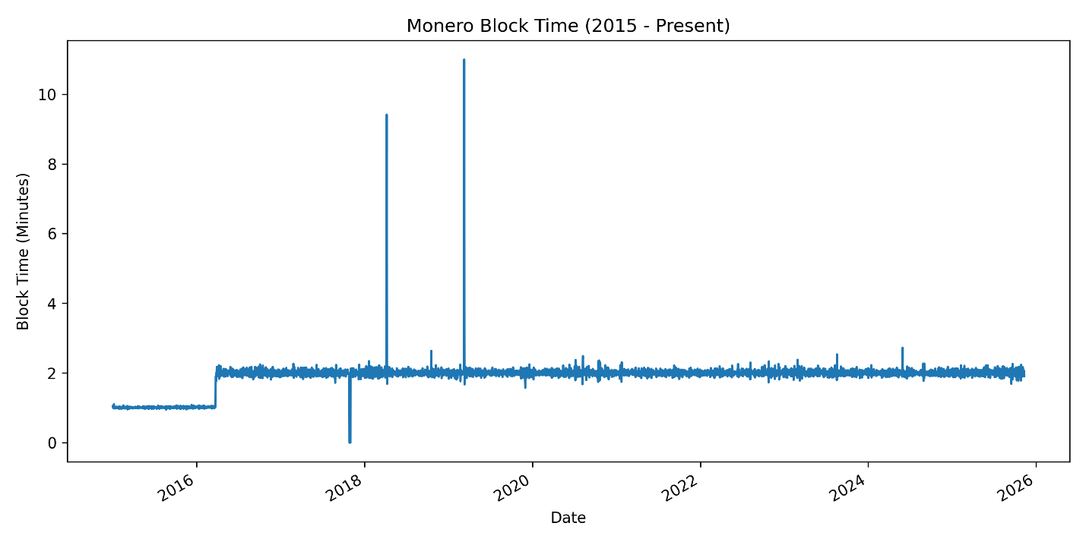

Figure 26 - Monero block time

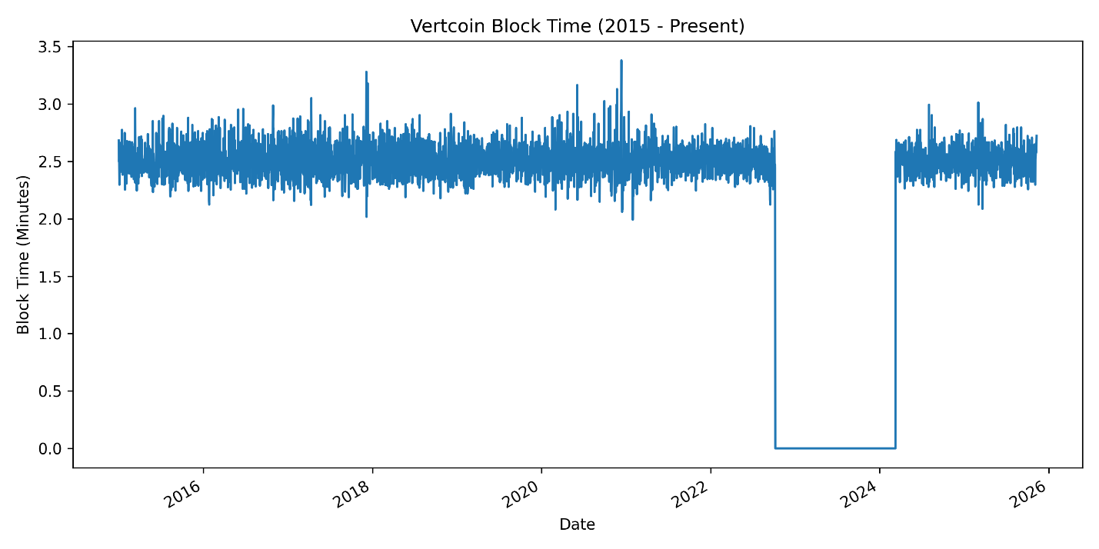

Figure 27 - Vertcoin block time

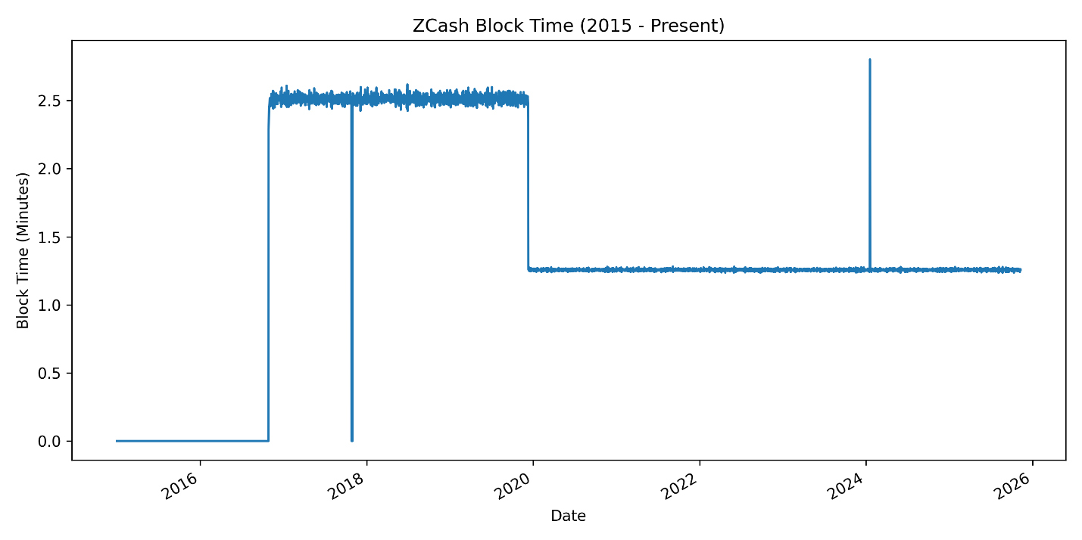

Figure 28 - ZCash block time

We note that there are data points where this completion time is labelled as zero. We refer the reader back to our methodology – we have marked missing entries with zero to maintain the rectangular shape of our dataframes in the CSV files.

Across the full 2015–present dataset, a clear trend emerges: Bitcoin’s confirmation time is the most volatile among the major proof-of-work cryptocurrencies. Early in the time series (2015–2017), Bitcoin routinely exhibits completion times between 8–10 minutes, aligning with its target block interval but frequently deviating upward during periods of network congestion. These upward spikes intensify during historically documented stress periods—such as the 2017 block-size debate and the associated mempool backlog—reflecting throughput sensitivity to limited block capacity (Narayanan et al., 2016; Möser & Narayanan, 2019). This volatility is consistent with empirical studies showing that Bitcoin confirmation delays are strongly correlated with congestion and fixed block size constraints (Easley, O’Hara, & Basu, 2019). In contrast, cryptocurrencies with shorter target block times (e.g., Dogecoin, Monero, Litecoin) show significantly smoother time-to-completion curves—likely due to faster difficulty adjustments, higher block frequency, or lower transaction volumes (Antonopoulos, 2017; Gandal & Halaburda, 2016).

Another important pattern is the distinction between legacy coins and later-introduced chains, many of which initially appear as zeros in the dataset (Bitcoin Cash, Ethereum Classic, Bitcoin Gold). These zeros represent dates before the coins existed or before they were actively mined—consistent with well-documented fork histories such as Bitcoin Cash’s launch in August 2017 (Chiu & Koeppl, 2019). After activation, these networks generally exhibit stable, predictable completion times near their protocol-defined targets; for example, Bitcoin Cash and Bitcoin Gold retain ~10-minute block-interval designs but often experience lower congestion, yielding slightly more stable confirmation-time observations (Gervais et al., 2016). Meanwhile, Litecoin and Dash maintain some of the most consistent completion times in the dataset, reflecting advanced difficulty-adjustment algorithms and reduced competition for block space (Zhang, Preneel, & Karame, 2019).

Finally, when comparing faster-block chains such as Dogecoin, Monero, and Vertcoin, the data show modest temporal drift but far lower volatility than Bitcoin. Dogecoin sustains confirmation times near one minute, Monero at roughly one minute, and Vertcoin near 2.5 minutes, with only minor deviations arising from short-term hashrate or difficulty fluctuations (Courtois & Bahack, 2014; Kiffer, Levin, & Mislove, 2018). These patterns support broader empirical findings that completion-time variability scales with network congestion, economic activity, and block-size limitations—where Bitcoin is disproportionately affected because it operates near throughput capacity (CBECI, 2023; Aste et al., 2017). In contrast, mid-cap, lower-cap, and privacy-focused networks function well below their maximum throughput limits, producing far more stable confirmation-time behavior across the full timeline.

***Methodology for Determining Block Rewards***

Block reward data were obtained using the protocol-defined emission schedules implemented by each cryptocurrency. For coins that use halving-based or block-interval reduction mechanisms—such as Bitcoin, Litecoin, Bitcoin Cash, Bitcoin Gold, Dash, ZCash, Vertcoin, and Dogecoin—the block reward at any given time is a deterministic function of the block height. A data provider such as BitInfoCharts calculates this value either by querying a full node or block explorer for the reward associated with the current block height or by re-implementing the emission formulas defined within each coin’s consensus rules. For Monero, which employs a smoothly declining emission rate followed by a fixed “tail emission,” and Ethereum Classic, which schedules block reward reductions via protocol upgrades, the reward remains similarly deterministic and height dependent. By mapping reward formulas to historical block heights, BitInfoCharts is able to generate a consistent time-series of block subsidies for all cryptocurrencies included in our analysis. Plots of the block reward in terms of US dollars and in terms of each individual coin are below.

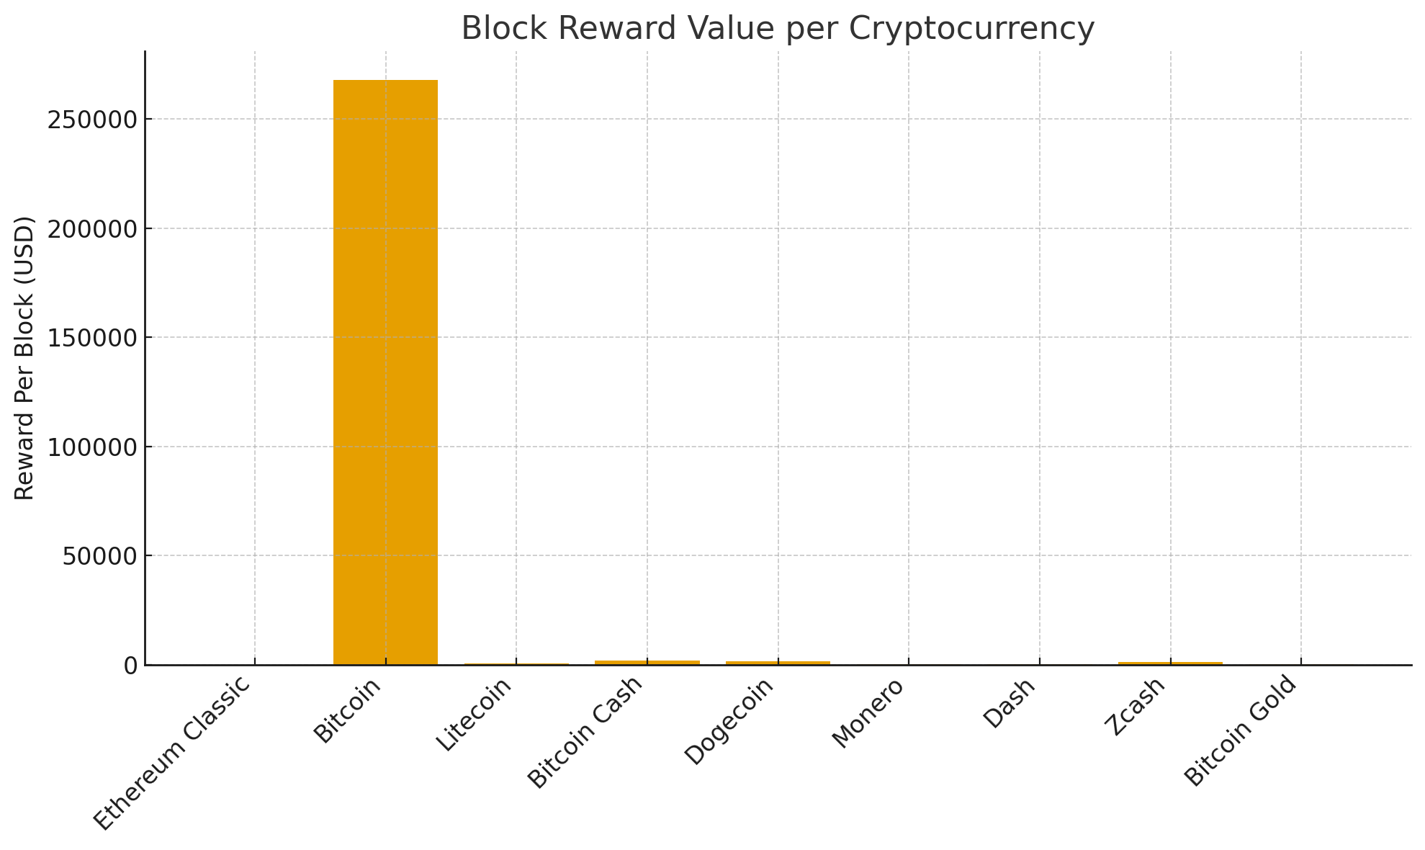

Figure 29 - Block reward per cryptocurrency (in USD)

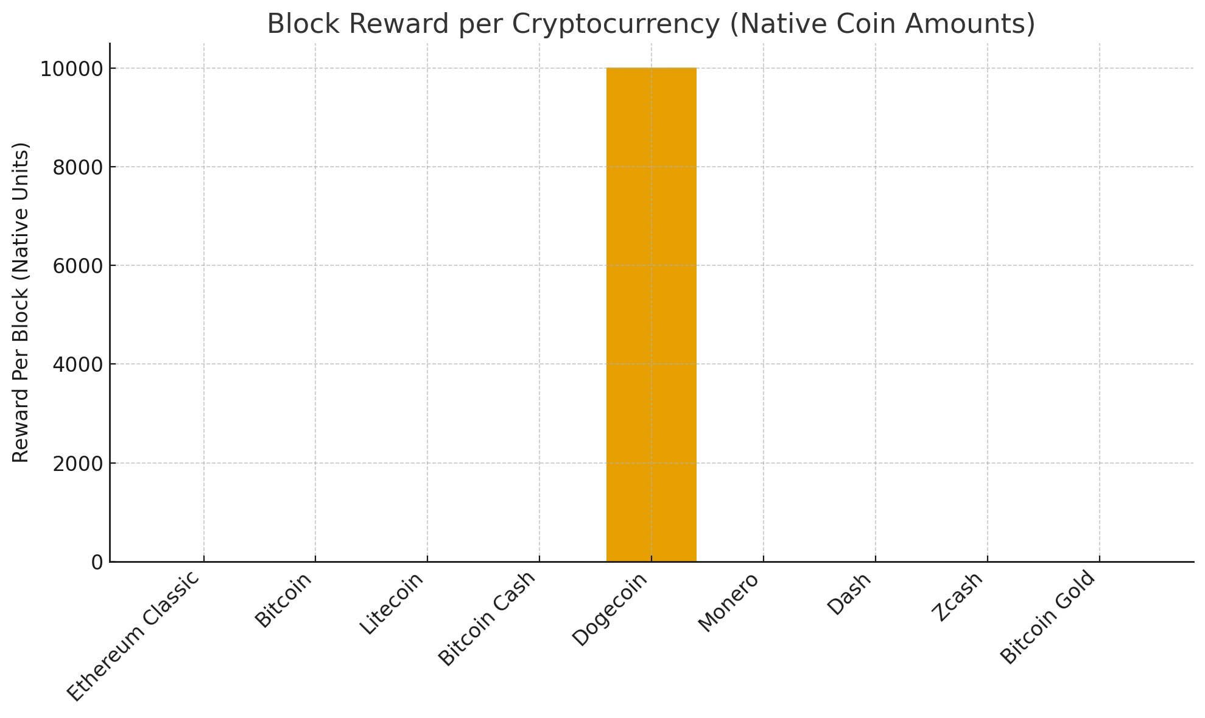

Figure 30 - Block reward per cryptocurrency (native coin value)

### Block Rewards Decline Over Time (Halving-Based Coins)

For halving-based cryptocurrencies—Bitcoin, Litecoin, Bitcoin Cash, Bitcoin Gold, Dash, and Zcash—the most dominant long-term trend is a structural decline in block subsidies. These networks reduce rewards on a fixed schedule (e.g., Bitcoin every 210,000 blocks). The current rewards reflect several halving cycles (BTC and BCH now at 3.125, LTC at 6.25, BTG at 3.13, DASH at ~1.77). Over time, the relative share of mining fees increases as the subsidy shrinks.

### Fee Variability Differentiates High-Traffic Networks

Coins like Bitcoin, Dogecoin, and Zcash show substantial variability in fee components, sometimes surpassing the base reward during congestion periods. Bitcoin frequently displays large fee spikes during network congestion. Dogecoin shows moderate fee fluctuations despite a stable inflationary base reward. Zcash shows unusually high fees compared to its base reward (flowering privacy-demand cycles). Coins with heavier real-world usage or limited block space experience larger fee-driven fluctuations in their per-block rewards.

***Methodology for Determining Mining Hardware Efficiency (PE) and Data Acquisition Challenges***

Mining hardware efficiency (PE), typically expressed in joules per gigahash (J/GH) or watts per hash (W/H), measures the energy required for mining hardware to perform one unit of computational work. To construct a historical series of PE for each cryptocurrency in our study, we sought to combine publicly available datasets—including Cambridge’s Bitcoin and Ethereum benchmarks, Digiconomist efficiency indices, and manually gathered hardware specifications—with information from device-level listings on ASICMinerValue.com. In principle, ASICMinerValue provides per-device hashrate and power-consumption specifications that can be used to compute efficiency as:

$$PE=\frac{Power (Watts)}{Hashrate}$$

However, scraping ASICMinerValue presented several methodological challenges. The site is not designed to be programmatically queried, its HTML structure is inconsistent across device pages, and many entries lack standardized timestamps or complete data fields. Furthermore, ASICMinerValue does not provide historical efficiency values—only current device specifications—which prevents direct reconstruction of past PE distributions without supplemental archival data. These limitations required our group to manually validate hardware entries, supplement missing data with independent hardware specification sheets, and integrate Cambridge, Digiconomist, and self-compiled sources to produce a coherent 2015–2025 PE table for Bitcoin, Litecoin, Monero, Dash, ZCash, Bitcoin Cash, Ethereum Classic, Bitcoin Gold, Dogecoin, and Vertcoin.

A plot of the mining efficiency for Bitcoin produced by the International Energy Agency (IEA) is included below.

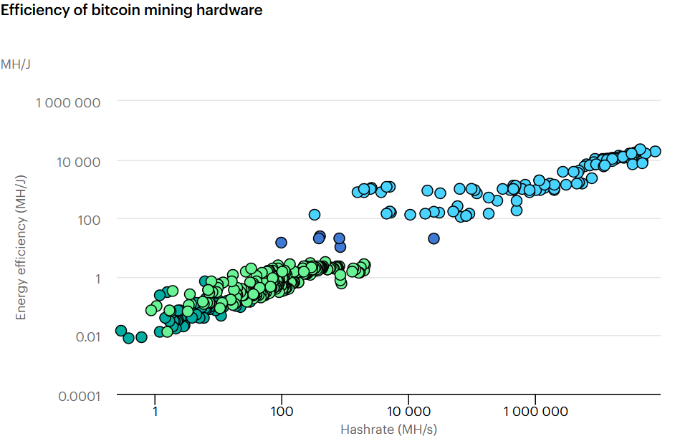

Figure 31 - Efficiency of bitcoin mining hardware. Copyright of the International Energy Agency (IEA)

***Methodology for Regional Mining Distribution and Challenges with CBECI Data Acquisition***

To construct regional mining distribution estimates across Bitcoin, Litecoin, Monero, Dash, ZCash, Bitcoin Cash, Ethereum, Ethereum Classic, Bitcoin Gold, Dogecoin, and Vertcoin for the period 2015–2025, this study employed a mixed empirical–modeling approach grounded in the availability and quality of global mining geography datasets. Bitcoin served as the empirical anchor due to the existence of high-resolution geolocated hashrate data from the Cambridge Bitcoin Electricity Consumption Index (CBECI), specifically the Bitcoin Mining Map, which provides monthly country-level mining shares derived from mining-pool IP submissions. These data were aggregated into five standardized world regions (North America, Europe, Asia-Pacific, Latin America & Caribbean, and Middle East & Africa) following the regional structure used in the Cambridge Global Cryptoasset Benchmarking Study. For Ethereum, only the pre-Merge period (2015–2022) was considered. Regional distributions were inferred using publicly available analyses of Ethereum mining—most notably the Cambridge Blockchain Network Sustainability Index documentation and independent empirical work (e.g., McDonald’s Ethereum miner-geolocation analyses)—which collectively indicate a more diffuse and less China-concentrated mining network relative to Bitcoin.

For cryptocurrencies lacking primary geolocated mining datasets—namely Litecoin, Monero, Dash, ZCash, Bitcoin Cash, Ethereum Classic, Bitcoin Gold, Dogecoin, and Vertcoin—regional shares were modeled using transparent and literature-consistent proxy rules. SHA-256 networks such as Bitcoin Cash and Bitcoin Gold were assumed to mirror Bitcoin’s regional distribution for corresponding years, based on documented interchangeability of ASIC hardware and miners’ propensity to switch between SHA-256 chains according to relative profitability. Scrypt-based networks, including Litecoin and the merged-mined Dogecoin, were assigned regional patterns approximating Litecoin’s estimated distribution, consistent with findings that Dogecoin’s hashrate is dominated by Litecoin mining pools. GPU- and CPU-friendly currencies (Monero, Dash, ZCash, Vertcoin) were modeled using regional proportions reflecting the broader geographic distribution of mining respondents in Cambridge’s benchmarking surveys rather than the Bitcoin-specific map, justified by the more decentralized and small-scale nature of their hardware ecosystems. Ethereum Classic, as a continuation of the pre-Merge Ethereum GPU mining environment, was assigned distributions proportional to Ethereum’s regional shares. Each modeled estimate is explicitly labeled as such in the dataset, and assumptions are stated to maintain methodological transparency. This combined empirical–proxy framework enables cross-asset, regionally disaggregated mining estimates while clearly distinguishing measured data from inferred approximations.

***Methodology: CO₂ Emissions***

To quantify annual CO₂ emissions attributable to cryptocurrency mining across Bitcoin, Litecoin, Monero, Dash, ZCash, Bitcoin Cash, Ethereum, Ethereum Classic, Bitcoin Gold, Dogecoin, and Vertcoin, this study integrates reputable energy and emissions datasets with coin-specific mining characteristics. Official, independently maintained CO₂ emission estimates were available only for Bitcoin and Ethereum, sourced from the Cambridge Bitcoin Electricity Consumption Index (CBECI) and Digiconomist’s Ethereum Energy Index. For all other proof-of-work cryptocurrencies, no centralized or peer-reviewed emissions datasets exist; therefore, electricity consumption was estimated manually using a hardware-efficiency–based methodology. Annual network hashrate data for each coin were paired with contemporaneous mining-device efficiency benchmarks (J/TH or J/H), producing year-level kWh estimates consistent with established academic models of mining energy intensity.

Regional electricity-grid carbon intensities for 2015–2025 were sourced primarily from the International Energy Agency (IEA) and Ember, using the harmonized datasets published by Our World in Data (OWID). These provide consistent, country-level annual carbon-intensity values (gCO₂/kWh) necessary for geographically resolved emissions calculations. Regional mining distributions were incorporated directly for Bitcoin using the Cambridge Bitcoin Mining Map; however, no equivalent regional-share datasets exist for other coins, so their regional allocations were approximated using either (a) proportional scaling from Bitcoin’s distribution, or (b) a global-average weighting assumption, both of which are stated explicitly in the analysis.

Finally, annual CO₂ emissions for each coin were computed by allocating estimated energy consumption across regions using mining-share weights and multiplying each regional share by the corresponding carbon-intensity factor. This combined methodology preserves transparency and acknowledges data limitations while grounding all calculations in publicly documented, industry-recognized, or peer-reviewed sources.

***Bitcoin Charts***

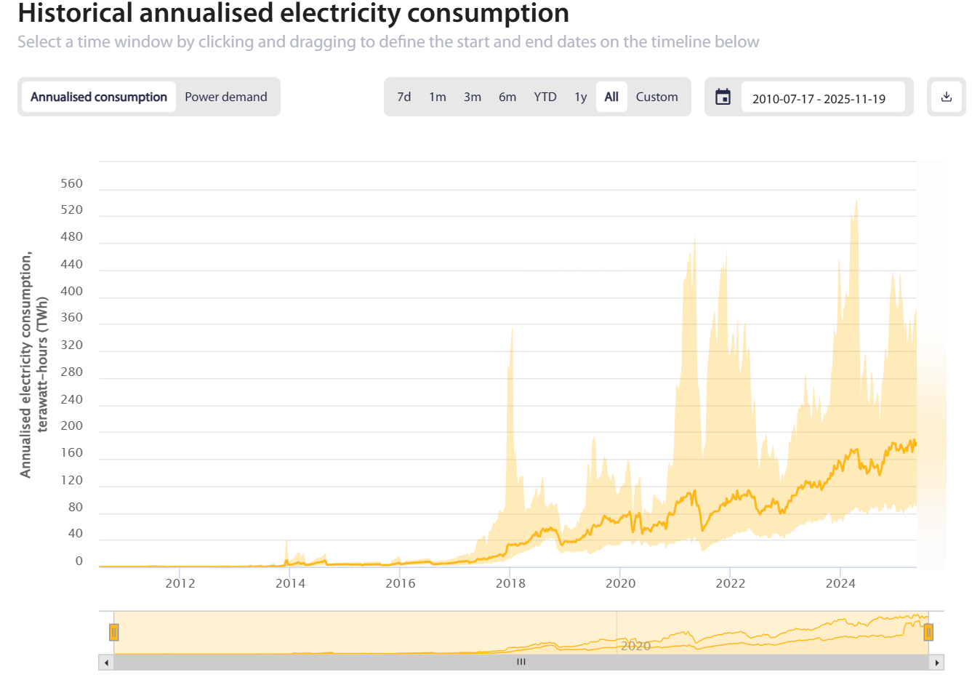

Figure 32: Cambridge Centre for Alternative Finance. (2023). Historical annualised electricty consumption. Cambridge Bitcoin Electricity Consumption Index

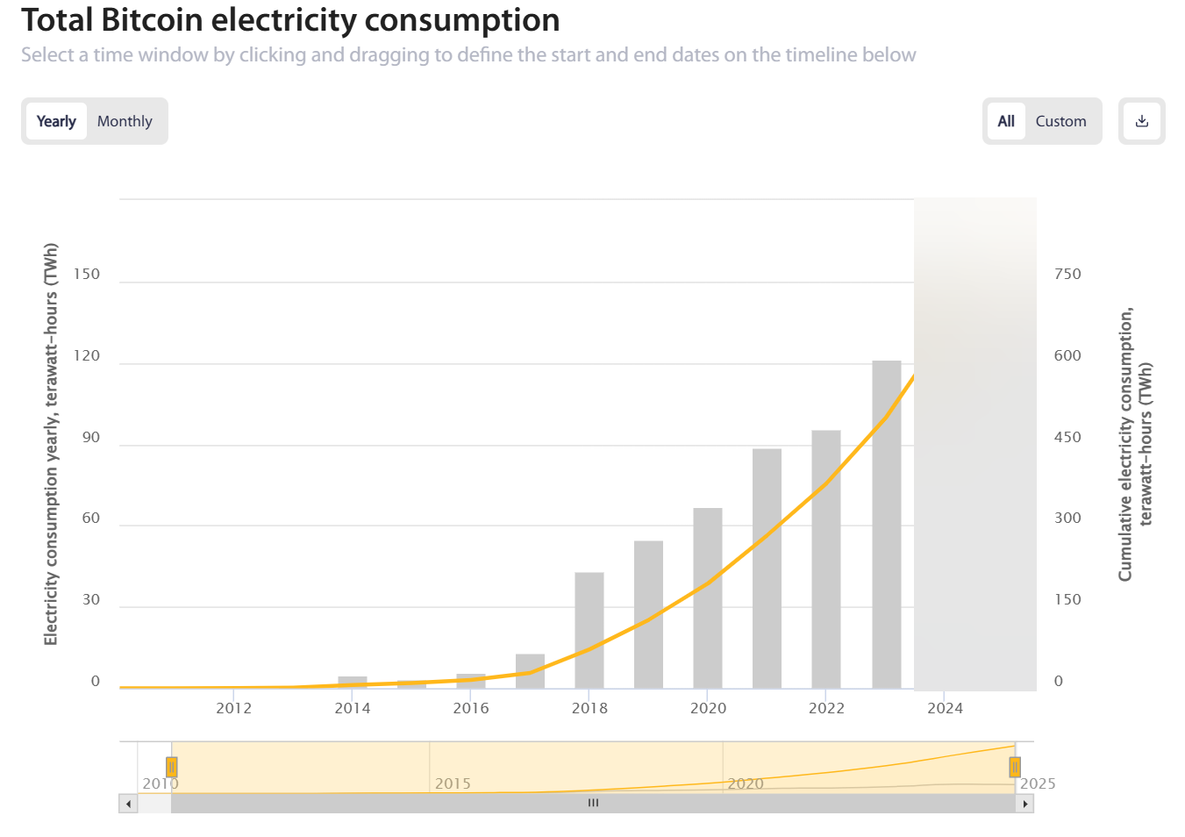

Figure 33 Cambridge Centre for Alternative Finance. (2023). Total Bitcoin electricity consumption. Cambridge Bitcoin Electricity Consumption Index

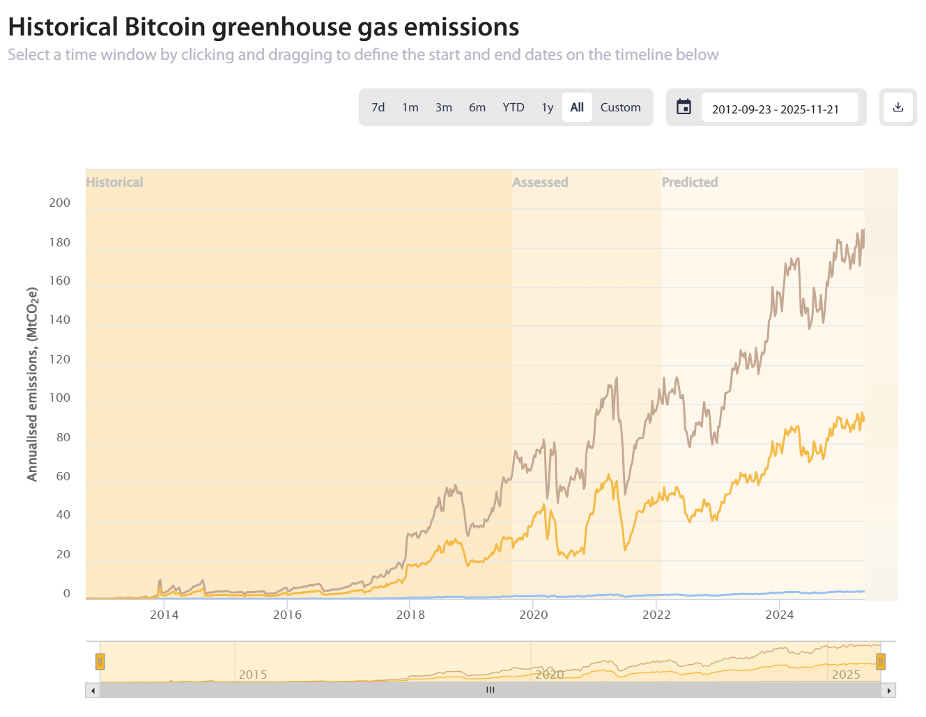

Figure 34 Cambridge Centre for Alternative Finance. (2023). Historical Bitcoin greenhouse gas emissions. Cambridge Bitcoin Electricity Consumption Index

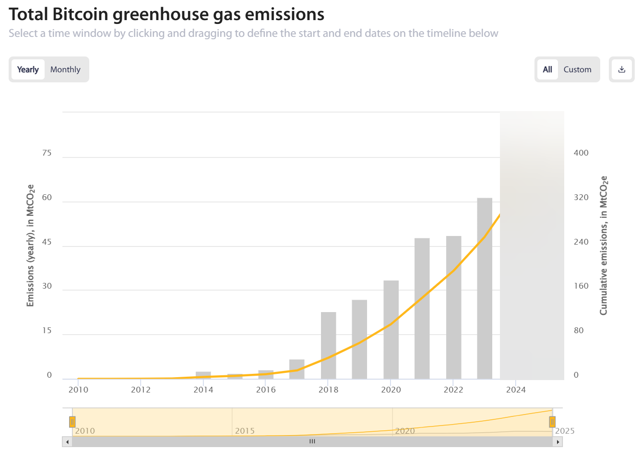

Figure 35 Cambridge Centre for Alternative Finance. (2023). Total Bitcoin Greenhouse gas emissions. Cambridge Bitcoin Electricity Consumption Index

***Ethereum Charts***

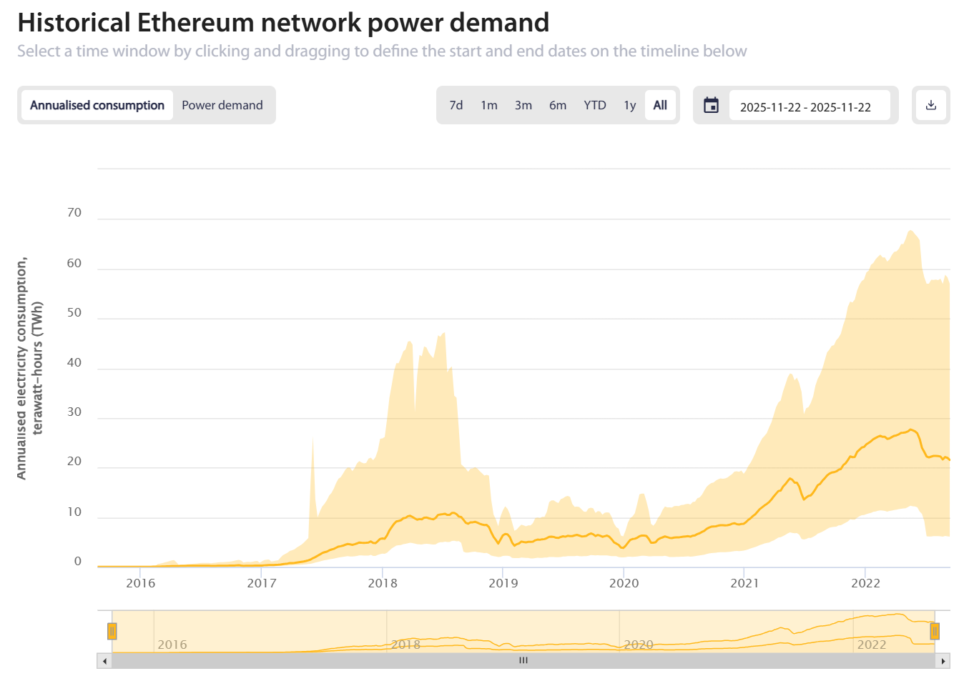

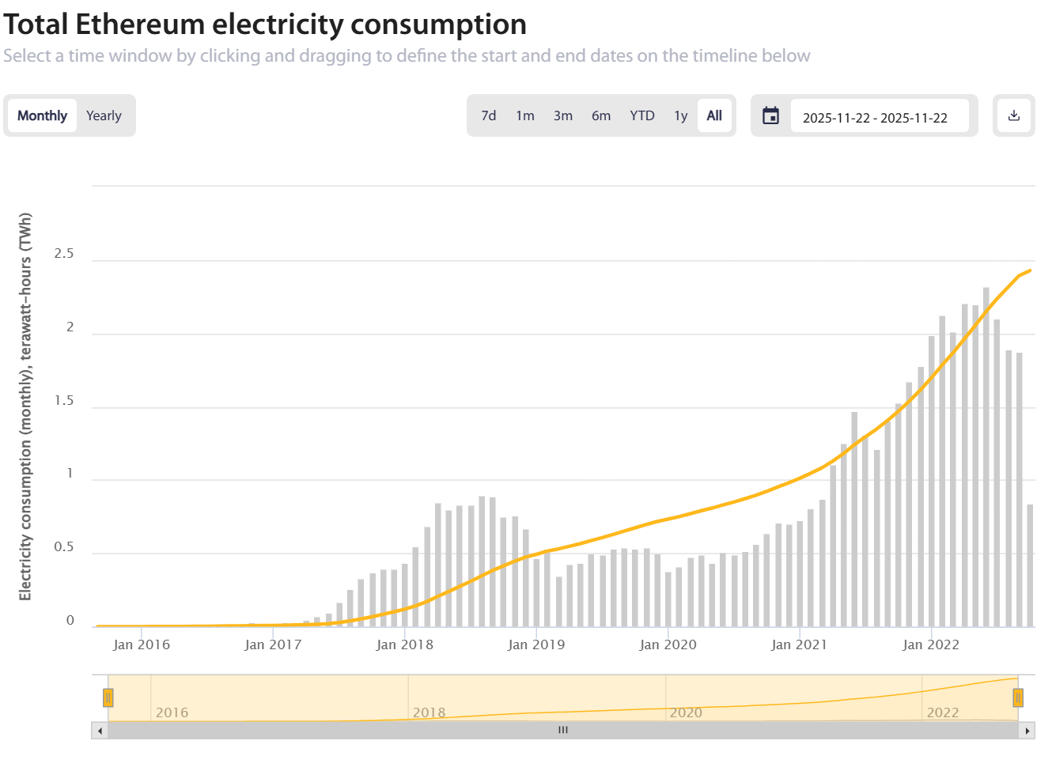

***Methodology for Calculating Daily Social Cost of Carbon (SCC)***

To quantify the climate damages associated with cryptocurrency mining, our study incorporates the Social Cost of Carbon (SCC), using the U.S. federal baseline value of **$51 per metric ton of CO₂**. Because no cryptocurrency data provider directly reports SCC values, this metric must be computed by combining estimated daily CO₂ emissions with the SCC coefficient. Daily emissions for each cryptocurrency can be derived by multiplying the estimated energy consumption—obtained from sources such as BitInfoCharts, Digiconomist, Cambridge CBECI, and independent hardware-efficiency models—by the appropriate regional or global grid-carbon-intensity values drawn from credible datasets (e.g., IEA, Ember, or Our World in Data). Once daily emissions (in metric tons of CO₂) are estimated, the daily SCC is computed as:

$$Daily SCC=CO_{2} Emissions \left(Metric Tons\right)×51 US Dollars$$

This approach allows SCC to be generated for every date and every coin in our dataset, even though SCC itself is not directly published by cryptocurrency monitoring platforms.

***Methodology for Calculating Social Cost per USD Mined***

The social cost per USD mined provides a normalized measure of environmental impact relative to economic output. This metric is also not directly available on cryptocurrency tracking websites, so it must be computed by integrating scraped production and market valuation data. First, the quantity of coins mined per day can be estimated using block reward schedules and chain-specific block times, both of which are available from data aggregators such as BitInfoCharts and blockchain explorer APIs. Multiplying the number of coins produced per day by the average daily market price yields the USD value of newly mined cryptocurrency. Separately, the daily SCC—calculated as described above—provides the dollar-valued environmental damages for the same time period. The social cost per USD mined is then computed using the formula:

$$Social Cost per USD Mined =\frac{(Daily SCC)}{Daily Mining Revenue (USD)}$$

This ratio quantifies the environmental externality imposed for each dollar of economic value generated, enabling direct comparison across Bitcoin, Litecoin, Monero, Dash, ZCash, Bitcoin Cash, Ethereum Classic, Bitcoin Gold, Dogecoin, and Vertcoin.

For Ethereum Classic, daily coin issuance was reconstructed using a hybrid scraping-plus-modeling method due to the absence of openly accessible, key-free APIs that report mined coins per day. Instead of relying on proprietary data portals, the study extracted Ethereum Classic’s daily average block time from BitInfoCharts’ public confirmation-time chart and used it to approximate blocks mined per day (1440 minutes ÷ average block time). This block-frequency estimate was then combined with the cryptocurrency’s well-documented 5M20 emission schedule, which reduces the block reward by 20% every five million blocks, to compute a daily subsidy value across all eras. Although this method does not capture uncle rewards or transaction fees, it accurately models the true issuance of new ETC coins generated by proof-of-work mining. This approach provides a reproducible, transparent alternative to gated datasets, ensuring that Ethereum Classic’s mining-based environmental impact can be evaluated consistently alongside other cryptocurrencies in the analysis.

***Methodology for Regionalized Carbon Damages***

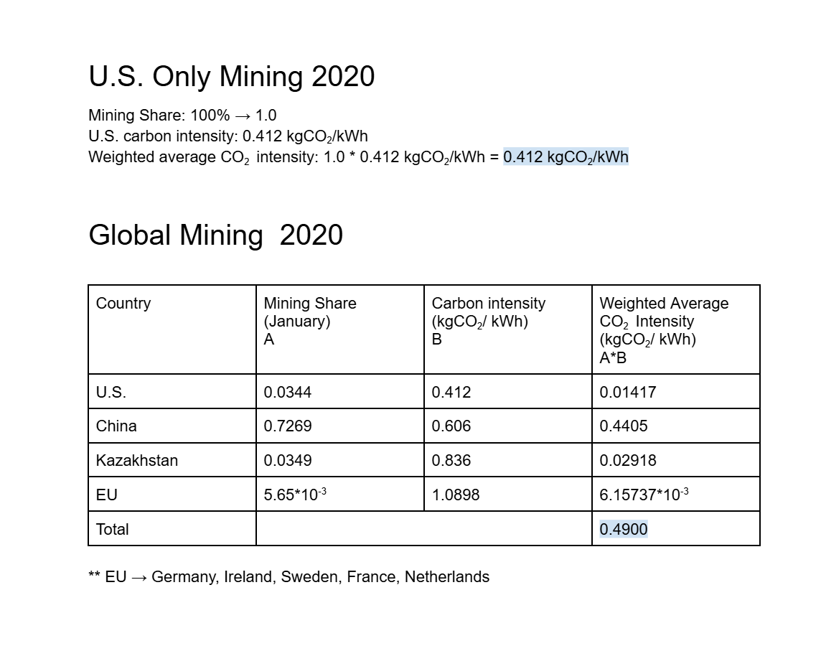

Figure 31: Calculations computed for Weighted Average CO2 Intensity in 2020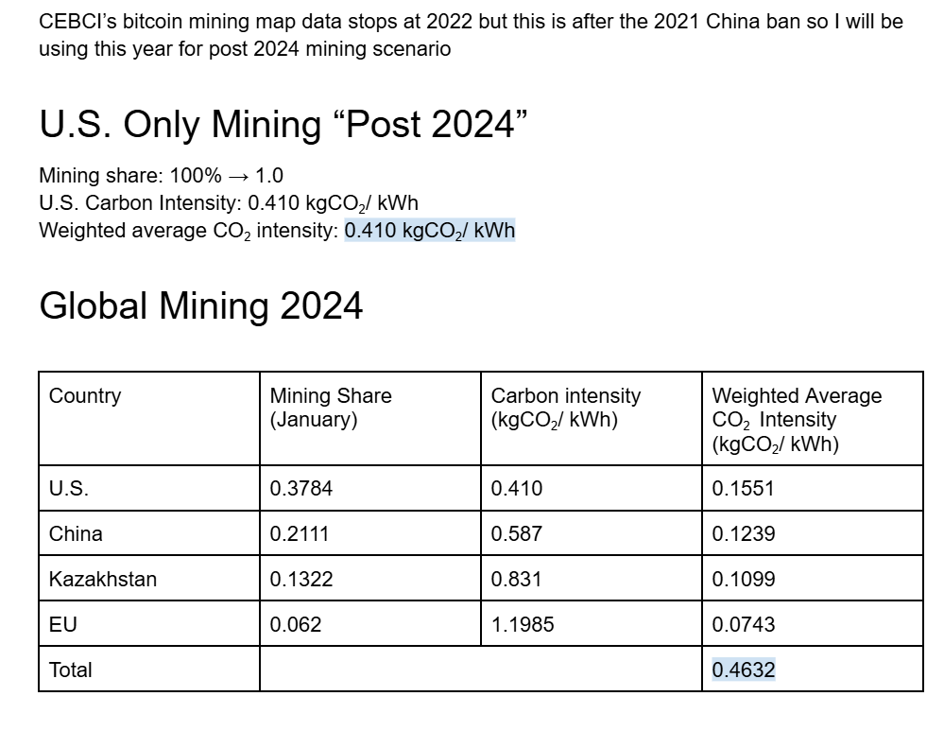

Figure 32: Calculations computed for Weighted Average CO2 Intensity in “post 2024”

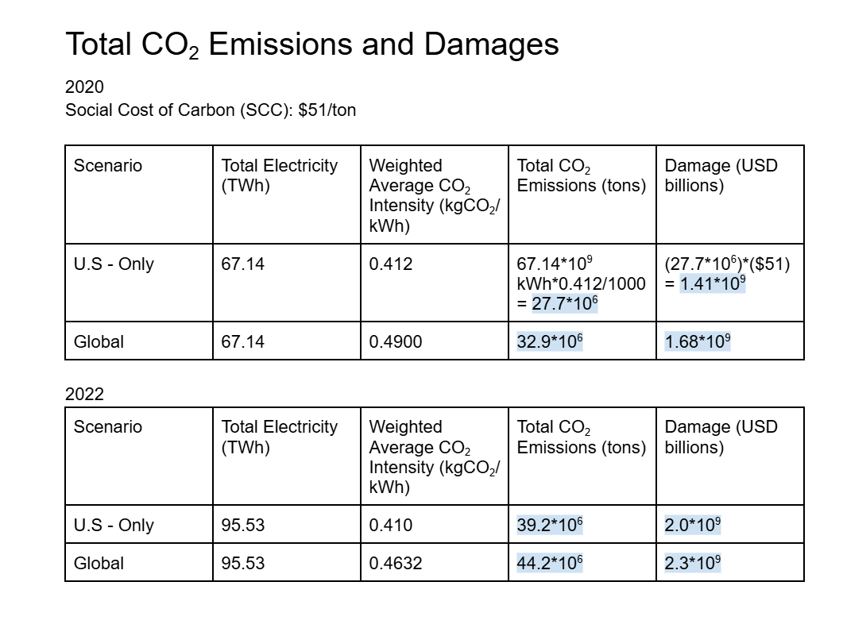

Figure 33: Calculations computed for total CO2 Emissions and Damages in 2020 and “post 2024”

***Methodology for PoS Transition Scenario***

|  |  |  |  |  |
| --- | --- | --- | --- | --- |
| Year | PoW Emissions MtCO2 | PoS Simulated Emissions MtCO2 | Avoided Emissions MtCO2 | Percent Savings |
| 2018 | 4.72 | 0.00472 | 4.71528 | 99.90% |
| 2019 | 3.6 | 0.036 | 3.564 | 99.00% |
| 2020 | 4.03 | 0.0403 | 3.9897 | 99.00% |
| 2021 | 8.93 | 0.0893 | 8.8407 | 99.00% |
| Jan - Sept 2022 | 13.61 | 0.1361 | 13.4739 | 99.00% |
|  |  | Actual PoS Emissions MtCO2 |  |  |
| Oct - Dec 2022 (After the Merge) | 9.00E-04 | 0.0009 | 0 | 0.00% |
| 2023 | 2.10E-03 | 0.0021 | 0 | 0.00% |
| 2024 | 0.002 | 0.002 | 0 | 0.00% |
| 2025 | 0.002 | 0.002 | 0 | 0.00% |

Figure 34: Calculations and data collected for Proof-of-Stake Transition Scenario

***Results for Regionalized Carbon Damages***

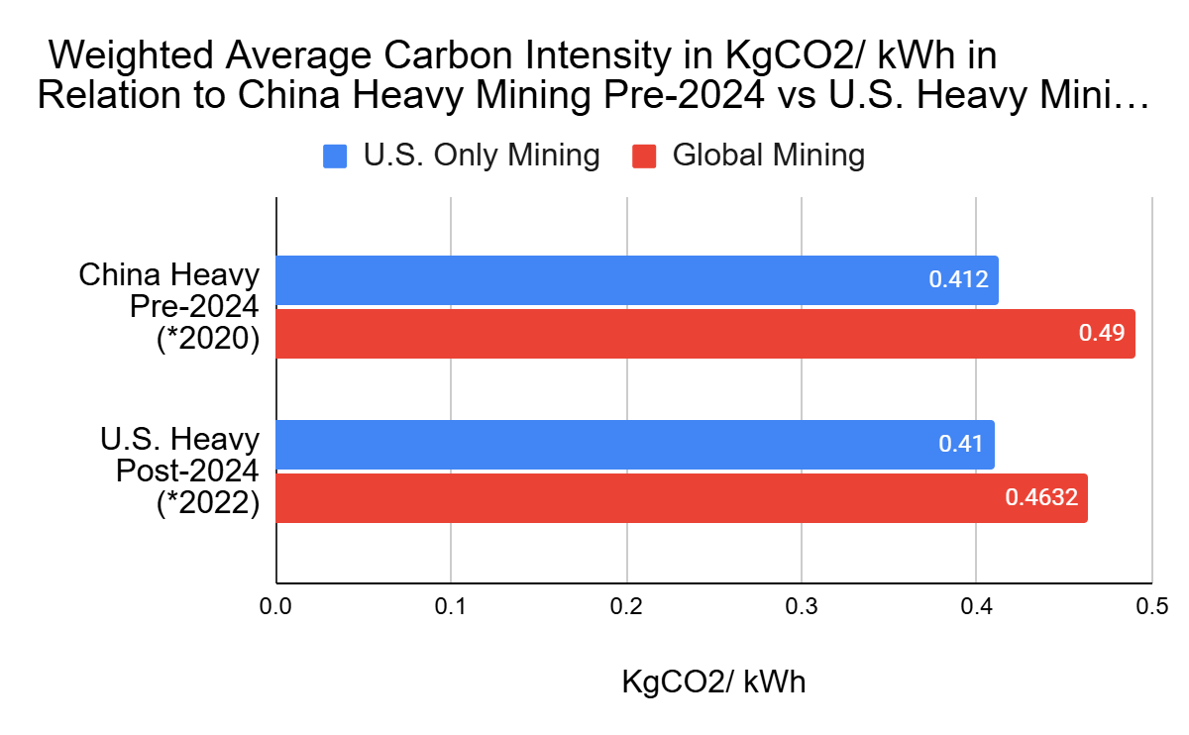

Figure 35: Displays the weighted average carbon intensity pre-2024 (2020) and “post-2020” (2022)

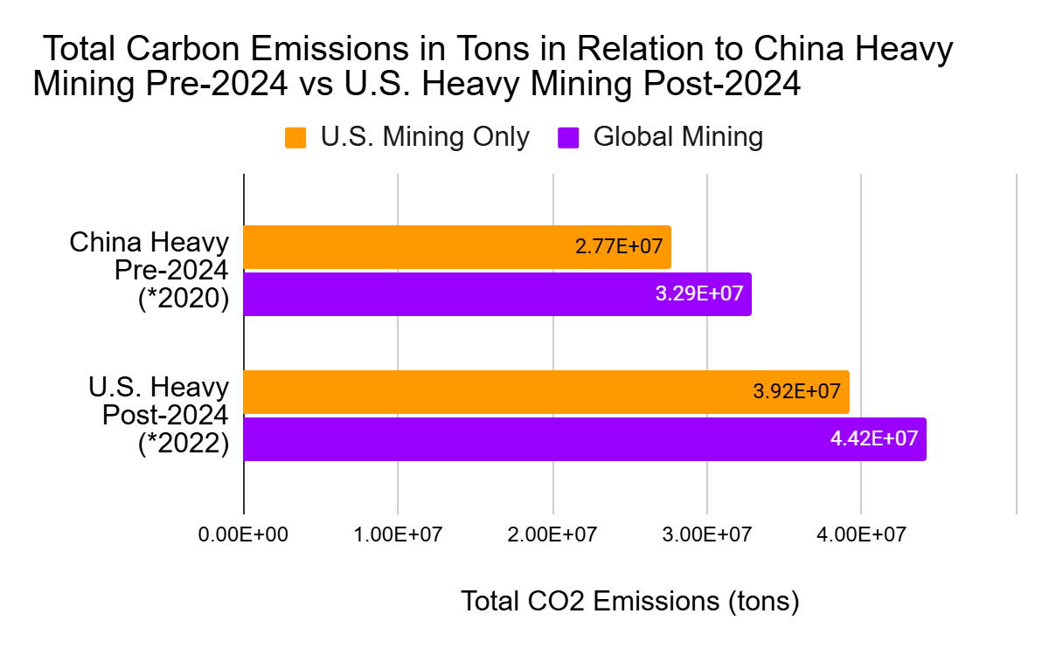

Figure 36: Displays the total carbon emissions in metric tons emitted by cryptocurrency mining pre-2024 (2020) and “post-2020” (2022)

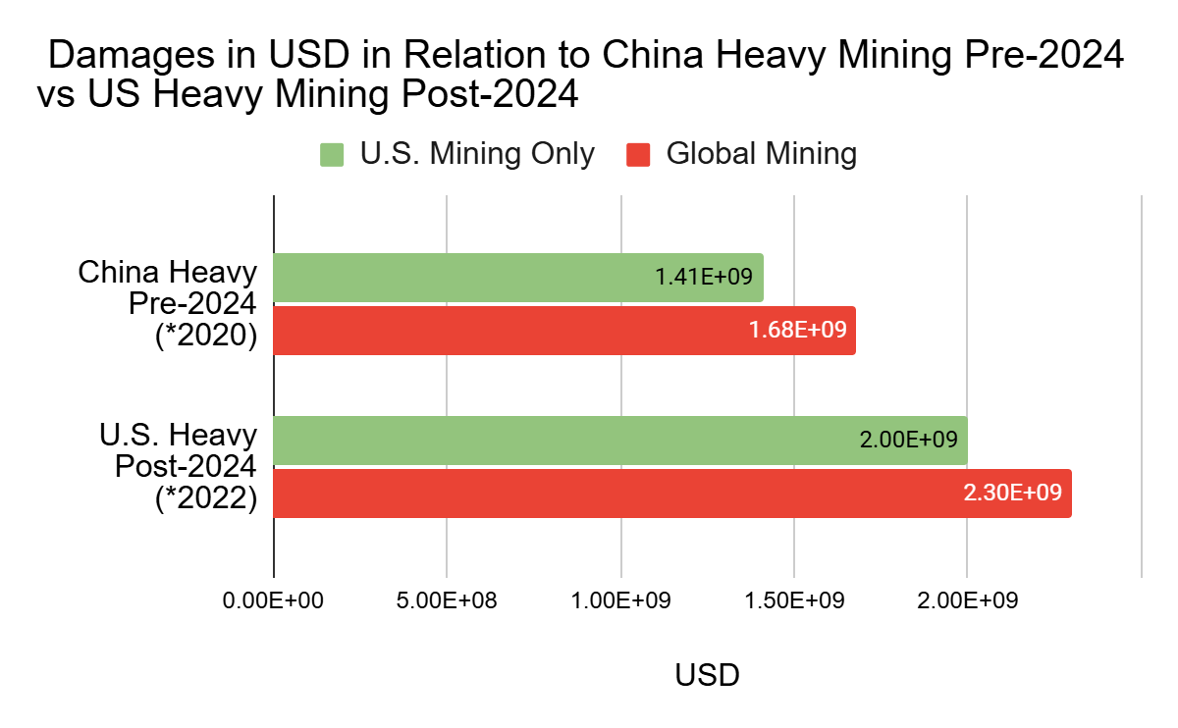

Figure 37: Displays the damages in USD of cryptocurrency mining pre-2024 (2020) and “post-2020” (2022)

***Results for PoS Transition Scenario***

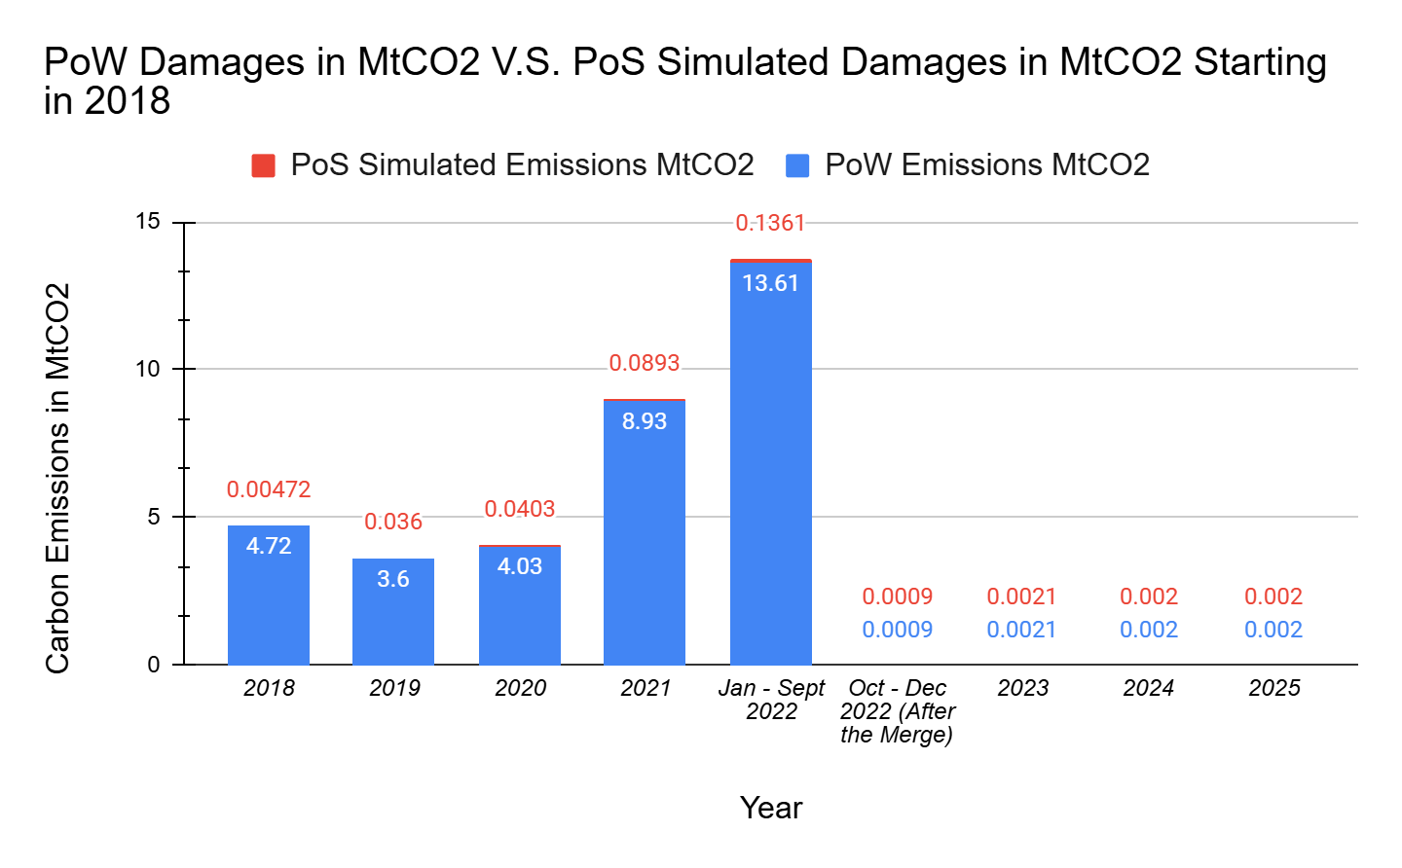

Figure 38: Displays the carbon emissions of Ethereum in metric ton in a Proof-of-Work and Proof-Stake scenario

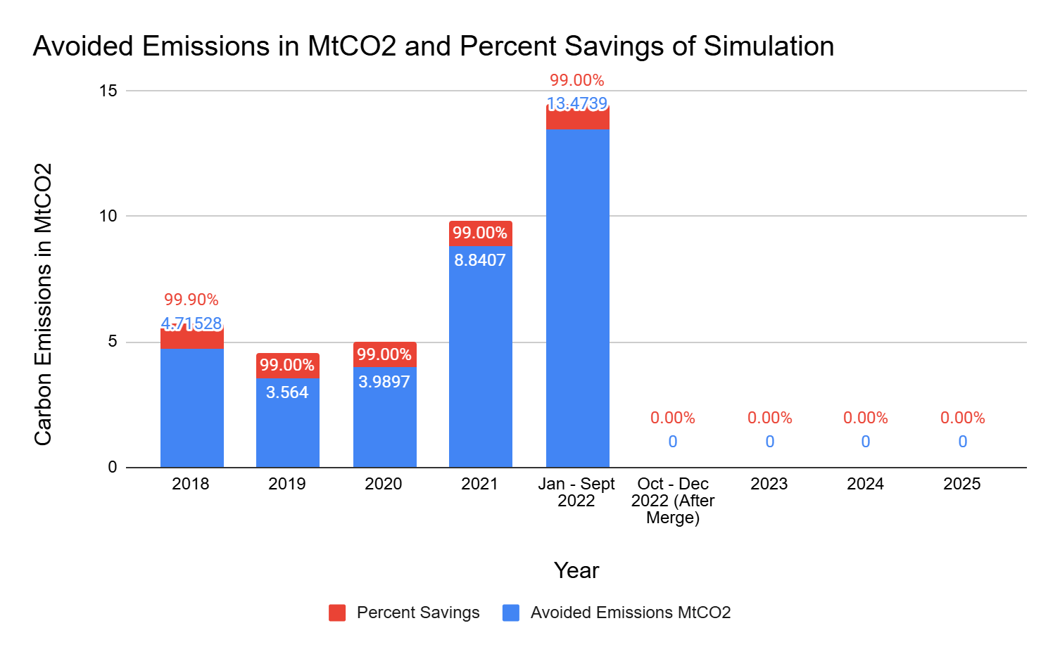

Figure 39: Displays the avoided emissions and percent savings of Ethereum in the Proof-of-Stake transition scenario

***Methodology for ARIMA and Exponential Smoothing Forecasting***

To assess the temporal dynamics of cryptocurrency environmental damages, daily Cryptocurrency Environmental Damage Index (CEDI) time series were constructed for Bitcoin, Ethereum, and Dogecoin, and subsequently modeled using both Autoregressive Integrated Moving Average (ARIMA) and Exponential Smoothing (ETS) forecasting frameworks. Following data preprocessing—which included date normalization, chronological sorting, and removal of missing observations—each series was partitioned into a training and testing subset based on a 75/25 split. Let:

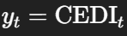​

denote the daily environmental damage index for a given cryptocurrency. ARIMA(1,1,1) models were fitted to the first-differenced series to accommodate stochastic trends while capturing short- and medium-range autocorrelation structures through autoregressive and moving-average terms. In parallel, ETS models with additive damped trends and no seasonal component were estimated to provide a structural, level-trend decomposition for comparison.

Model adequacy and performance were assessed using standard information and predictive accuracy metrics, including the Akaike Information Criterion (AIC), Root Mean Squared Error (RMSE), and Mean Absolute Error (MAE) computed over the out-of-sample forecast window. Both ARIMA and ETS models were then refit on the full historical data to generate six-month-ahead forecasts under two scenarios: a baseline trajectory and an innovation-adjusted trajectory that incorporated an exogenous technological improvement factor reducing projected environmental damages by 30%. Forecast outputs were exported for analysis and visualization, enabling comparison of model adaptability, sensitivity to shock periods, and long-horizon behavior across different cryptocurrencies.

***Observations and Trends in Cryptocurrency Environmental Damages***

The resulting CEDI time-series reveal distinct behavioral patterns across the three cryptocurrencies, reflecting differences in emission intensity, mining economics, and price dynamics. Bitcoin exhibits the highest absolute environmental damages, consistent with academic findings that its electricity consumption reaches tens to hundreds of terawatt-hours annually. During major bull-market periods (e.g., late 2017, 2020–2021, and late 2024), Bitcoin’s market price grew faster than its environmental damages, producing lower CEDI percentages even though raw damages remained large. Conversely, during extended bear markets—particularly 2018–2019 and 2022–2023—Bitcoin’s price declined more sharply than its energy consumption, yielding sustained intervals where CEDI exceeded 100% of daily market value, indicating that the monetized climate damages associated with newly minted BTC eclipsed the value of the coins themselves.

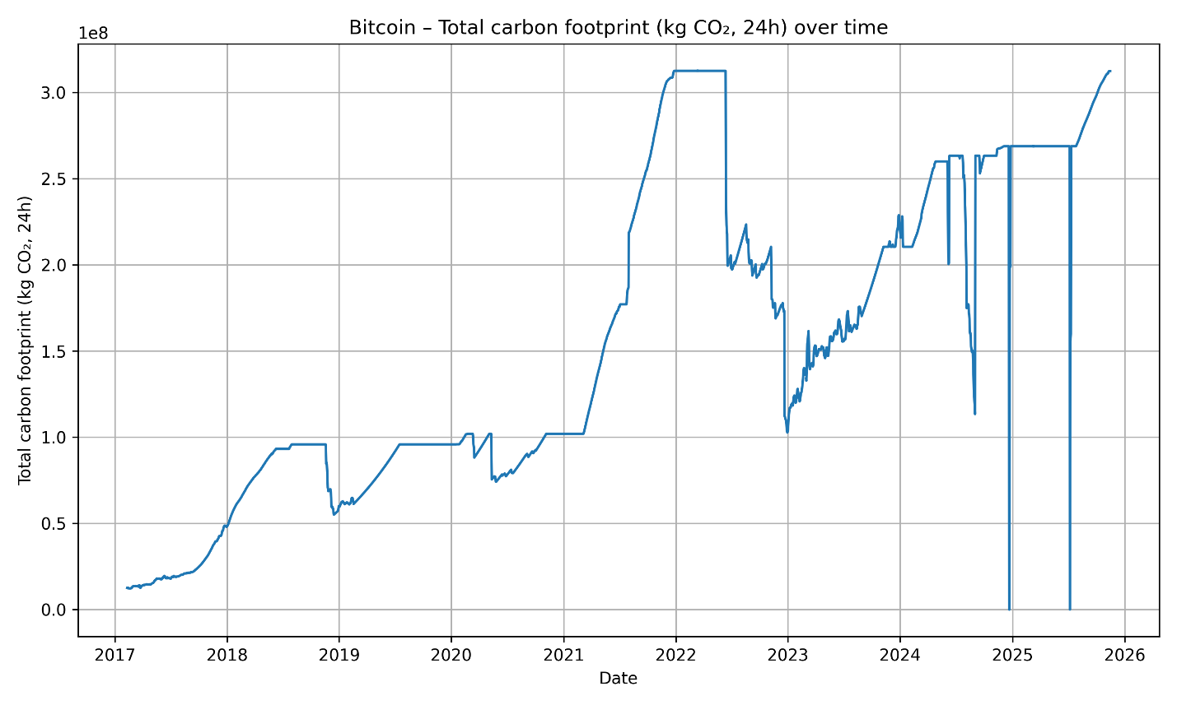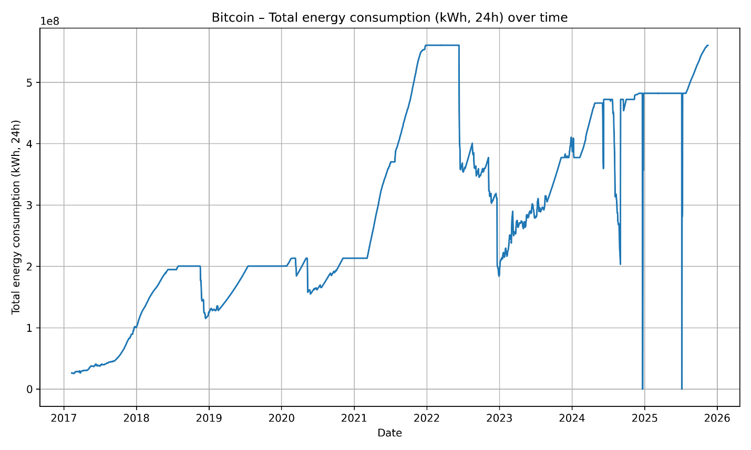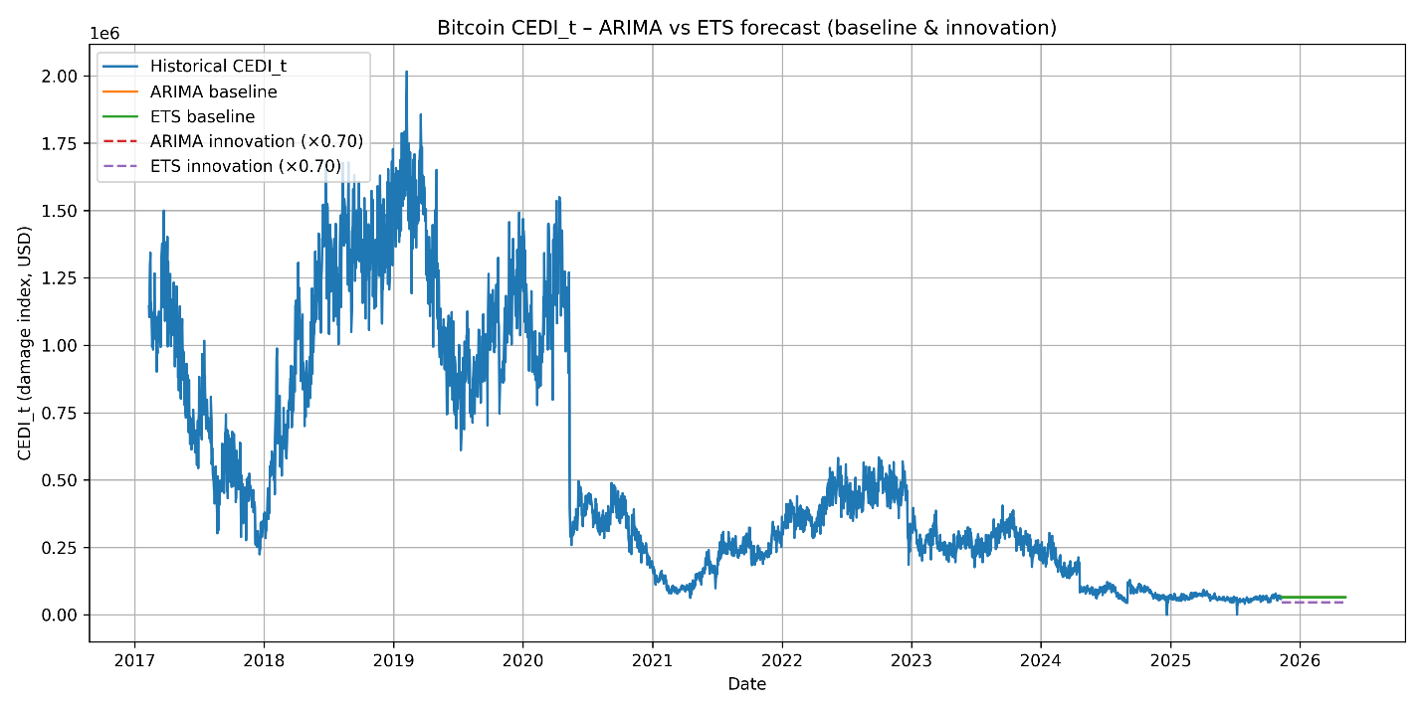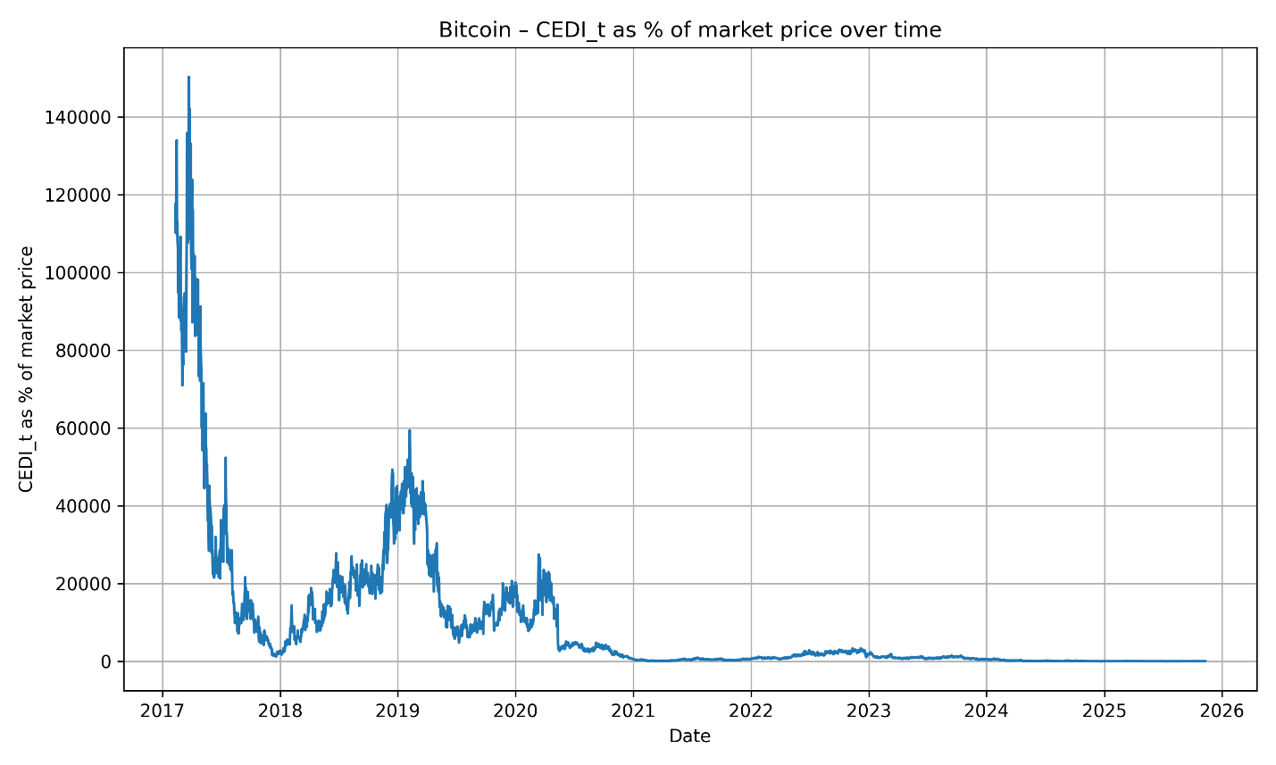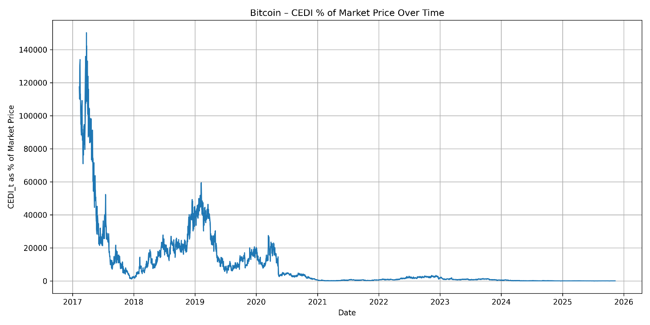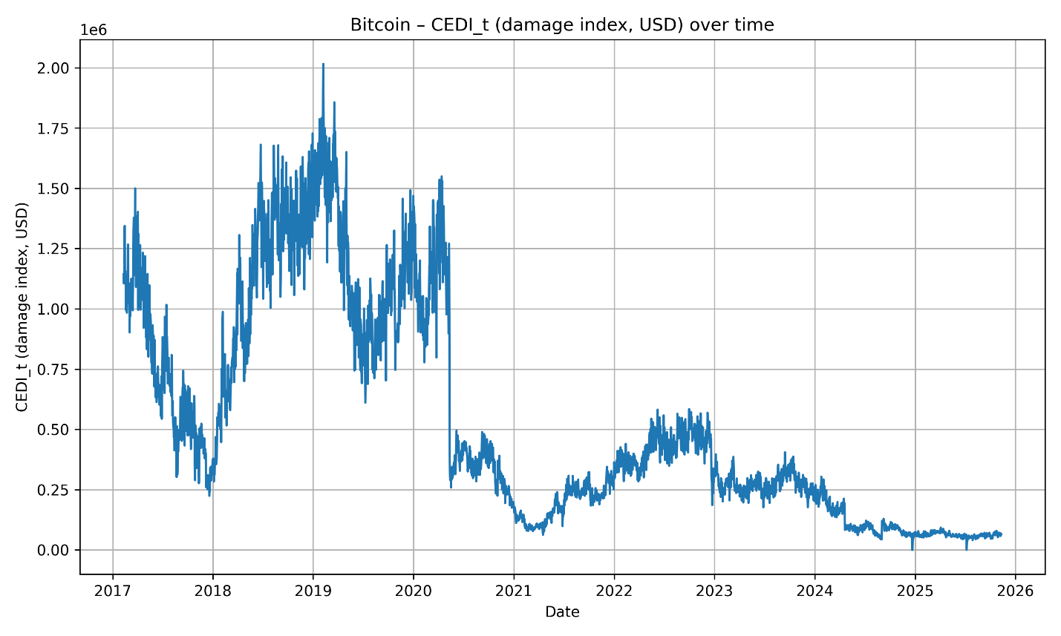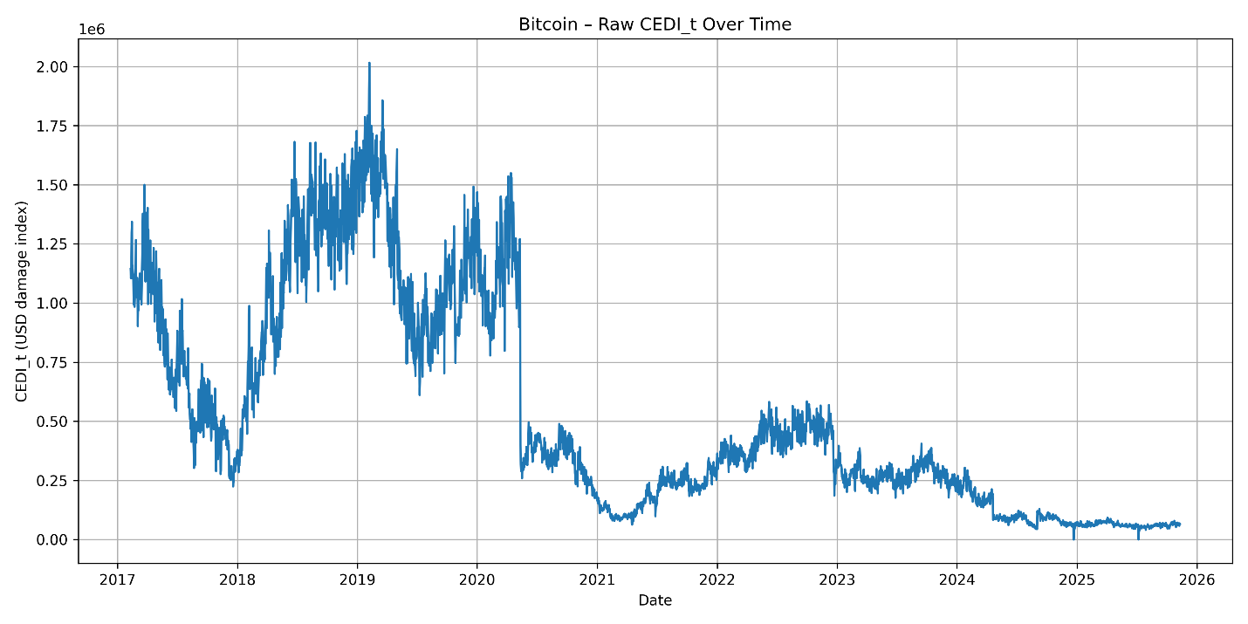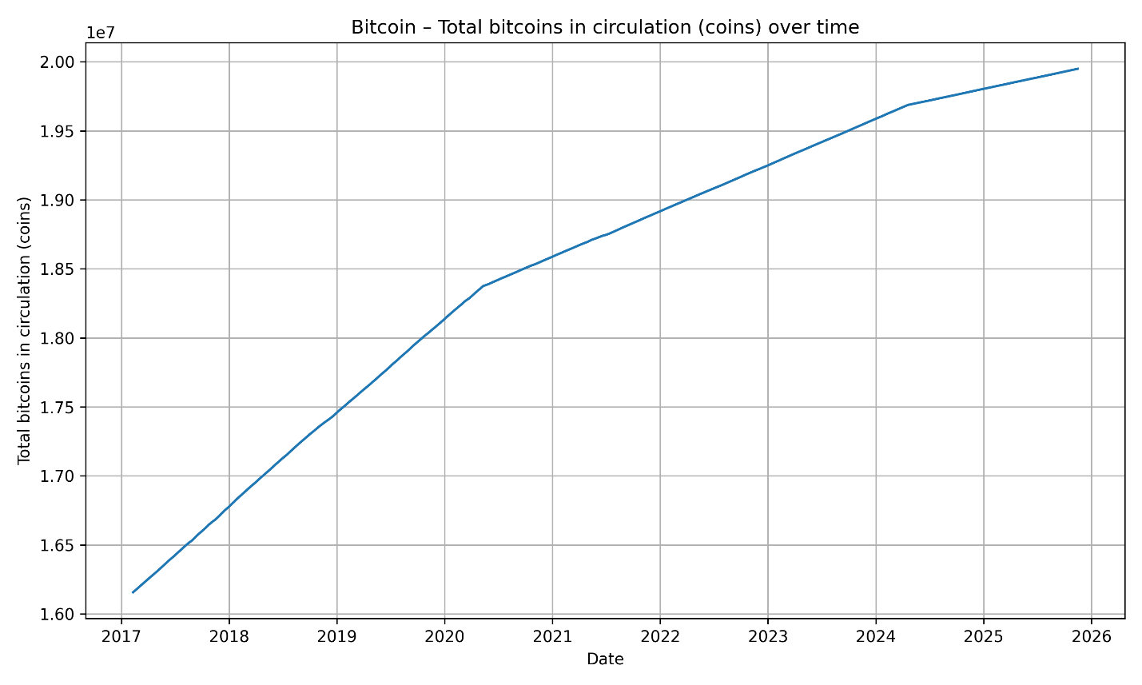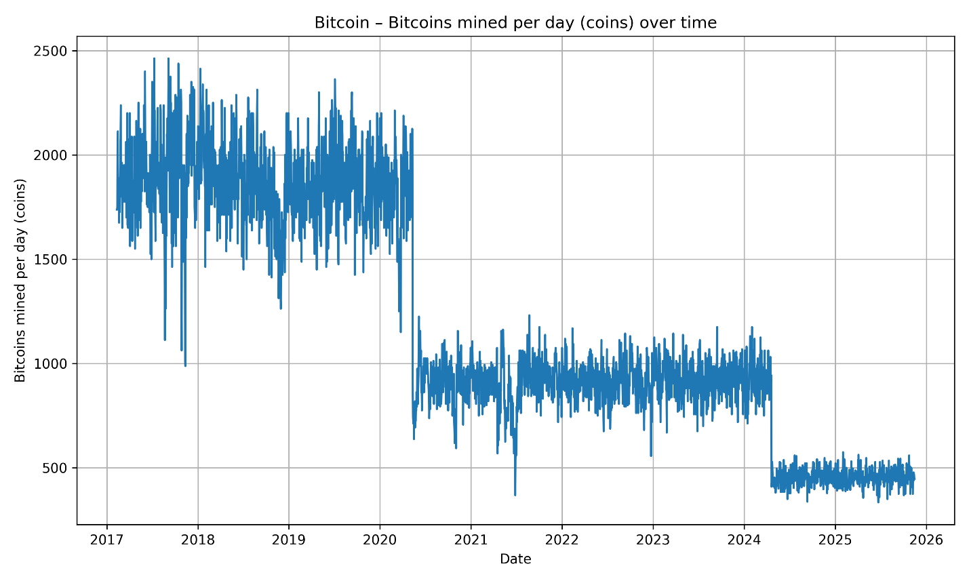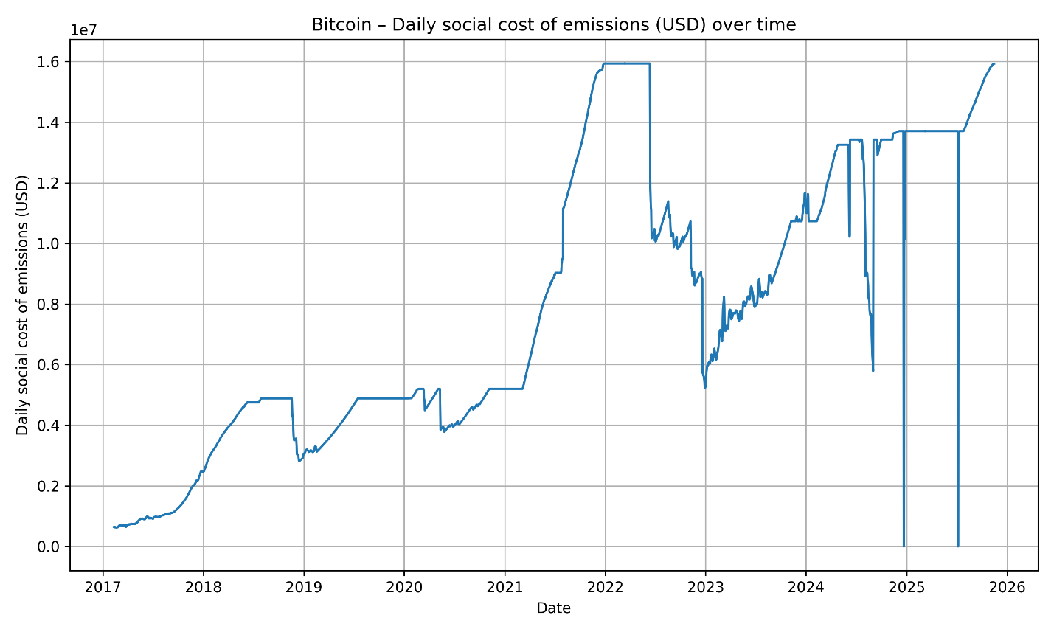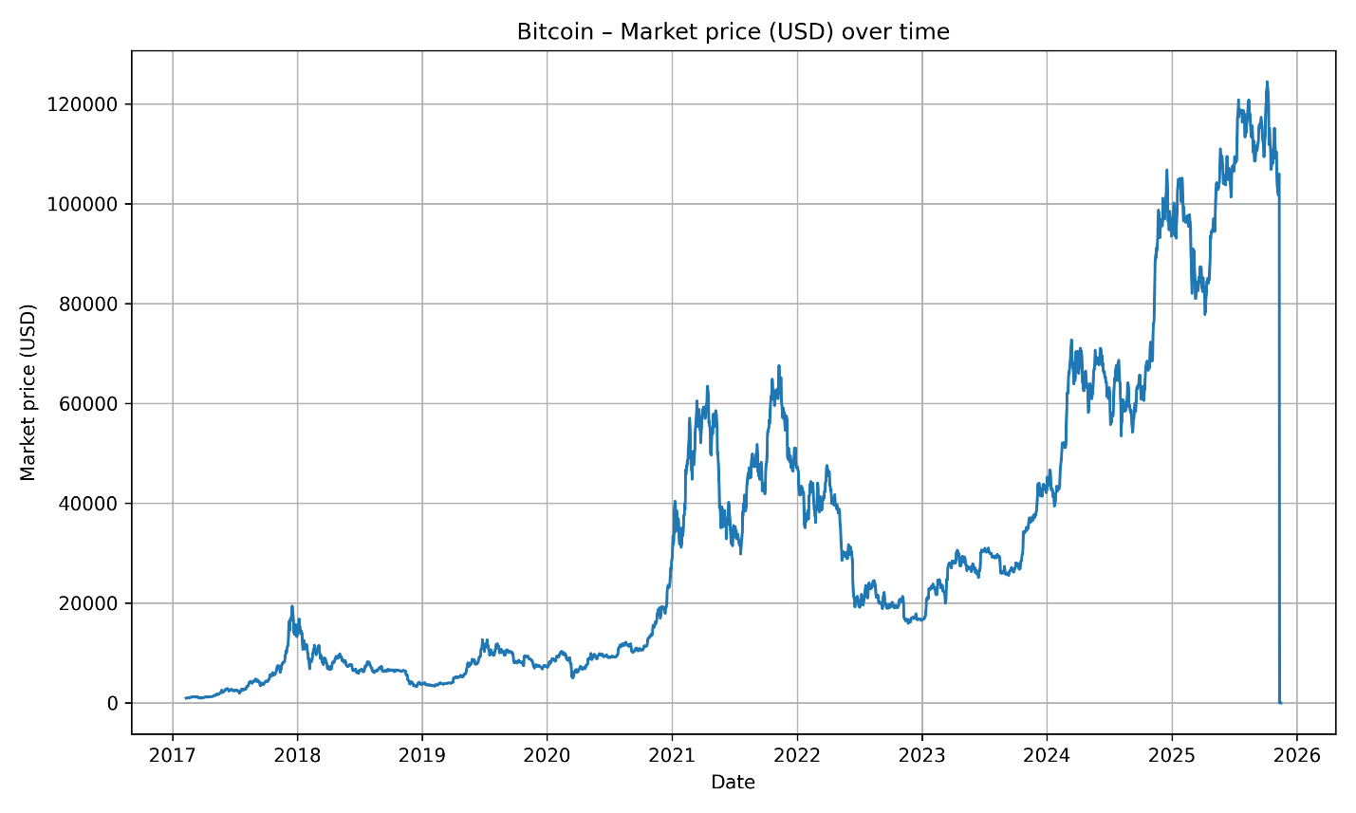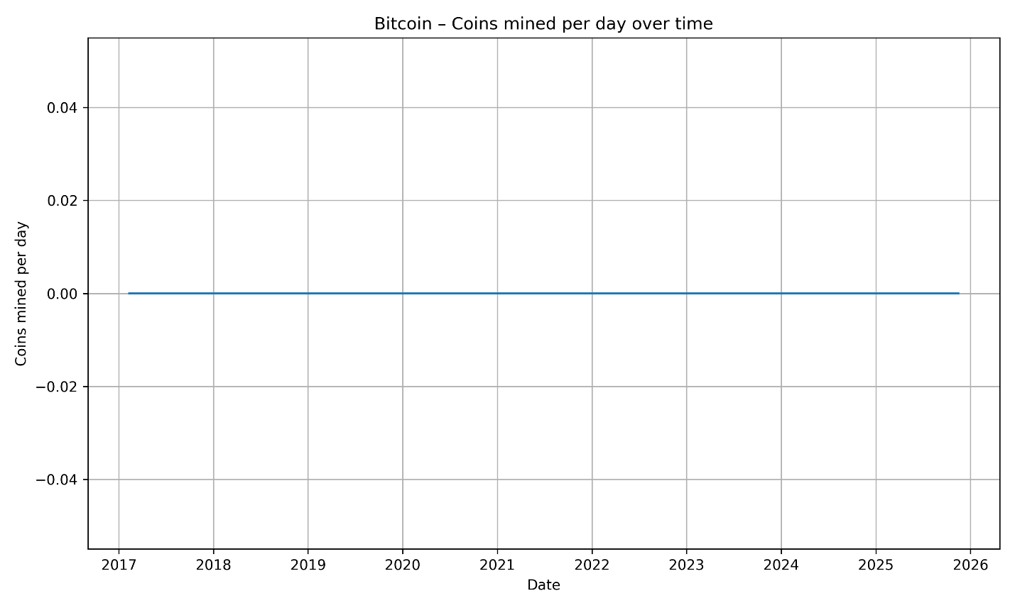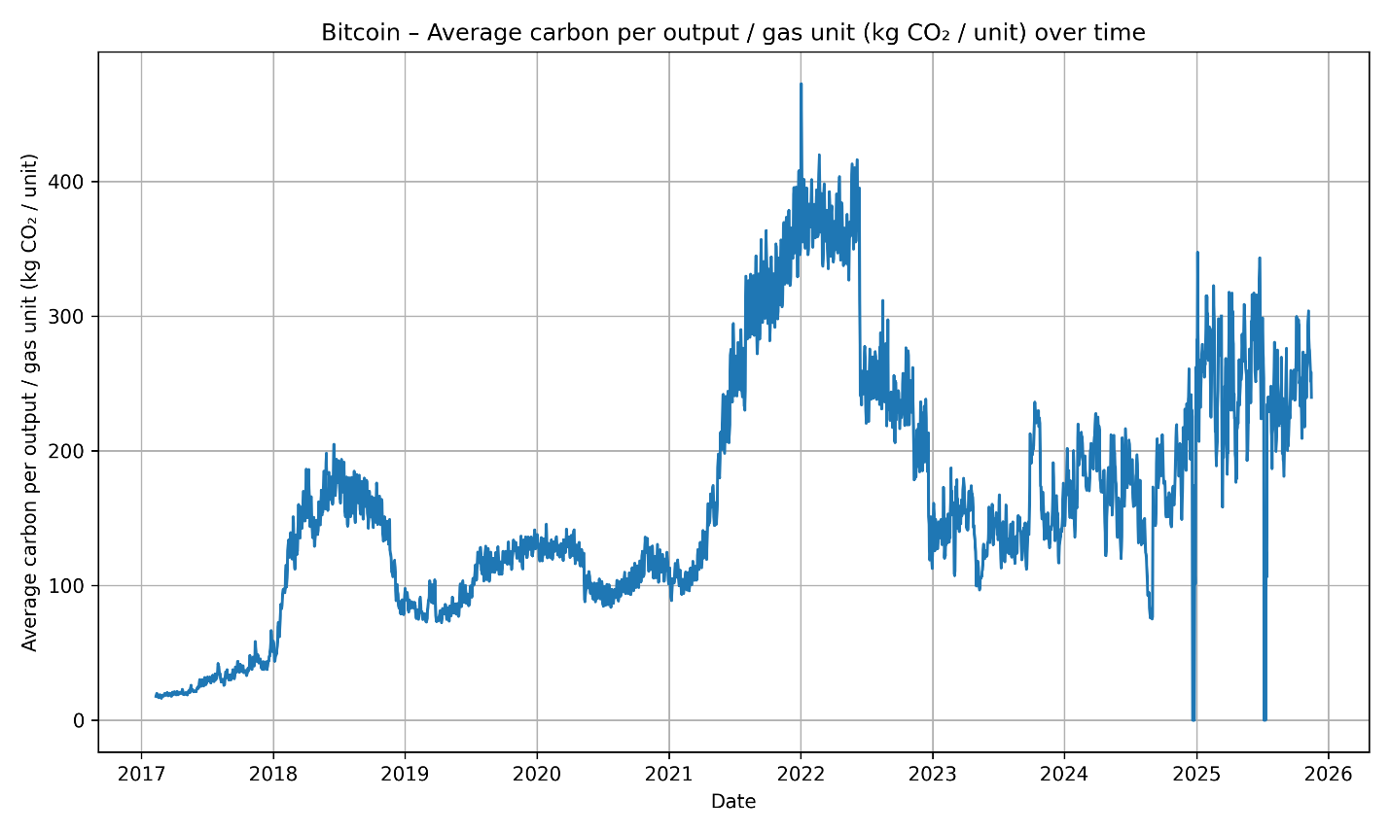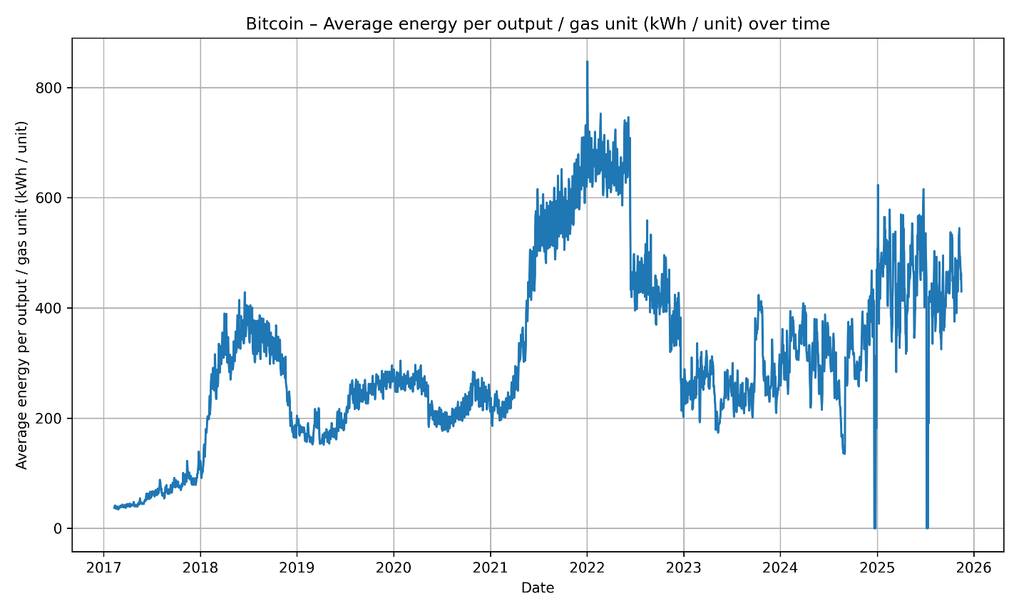

Ethereum’s environmental damage patterns bifurcate sharply around the September 2022 “Merge,” when the network transitioned from Proof-of-Work to Proof-of-Stake. In the pre-Merge period, Ethereum demonstrated volatility similar to Bitcoin, with elevated CEDI levels during market downturns in 2018 and mid-2022. Following the Merge, daily emissions dropped by over 99%, causing the CEDI series—both raw and percentage-based—to collapse nearly to zero. This discontinuity provides a clear empirical demonstration of how consensus-mechanism design directly governs environmental impact: Ethereum’s post-Merge environmental damages became negligible independent of price fluctuations or market activity.

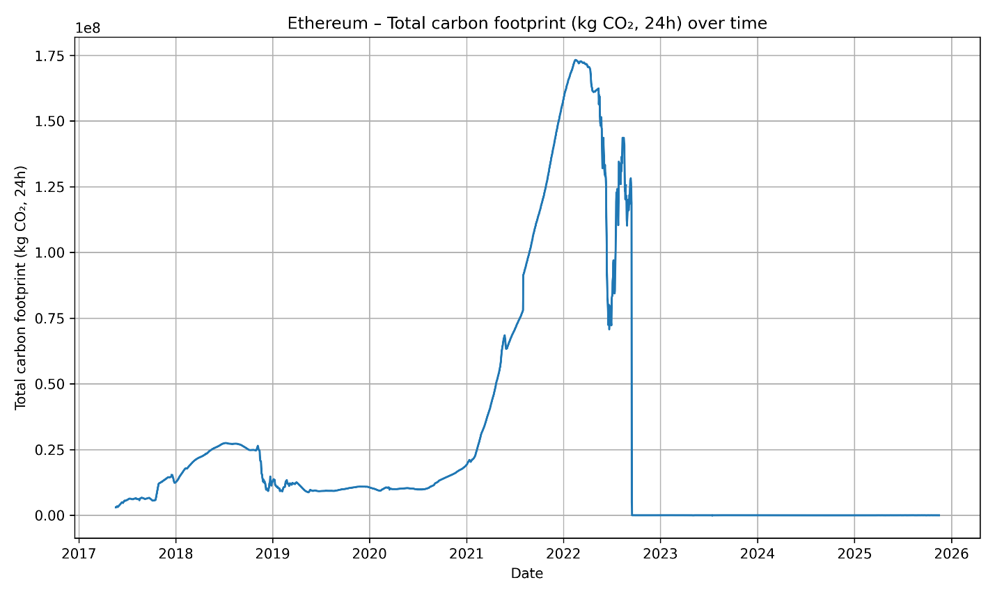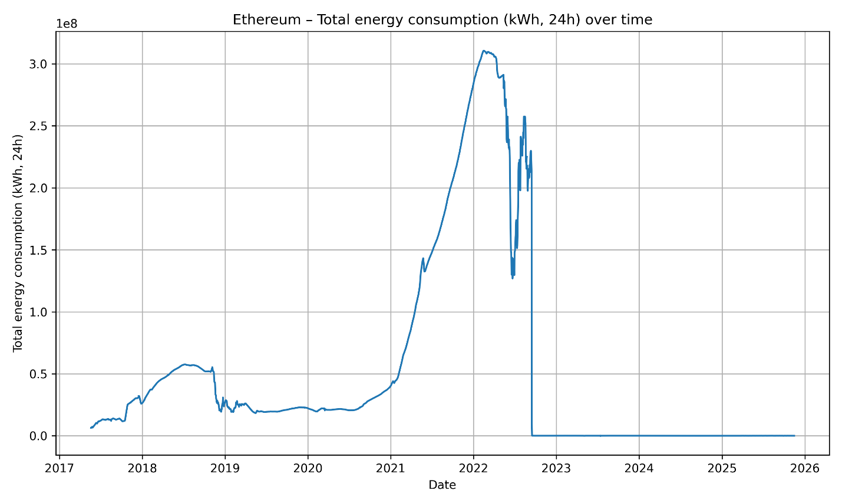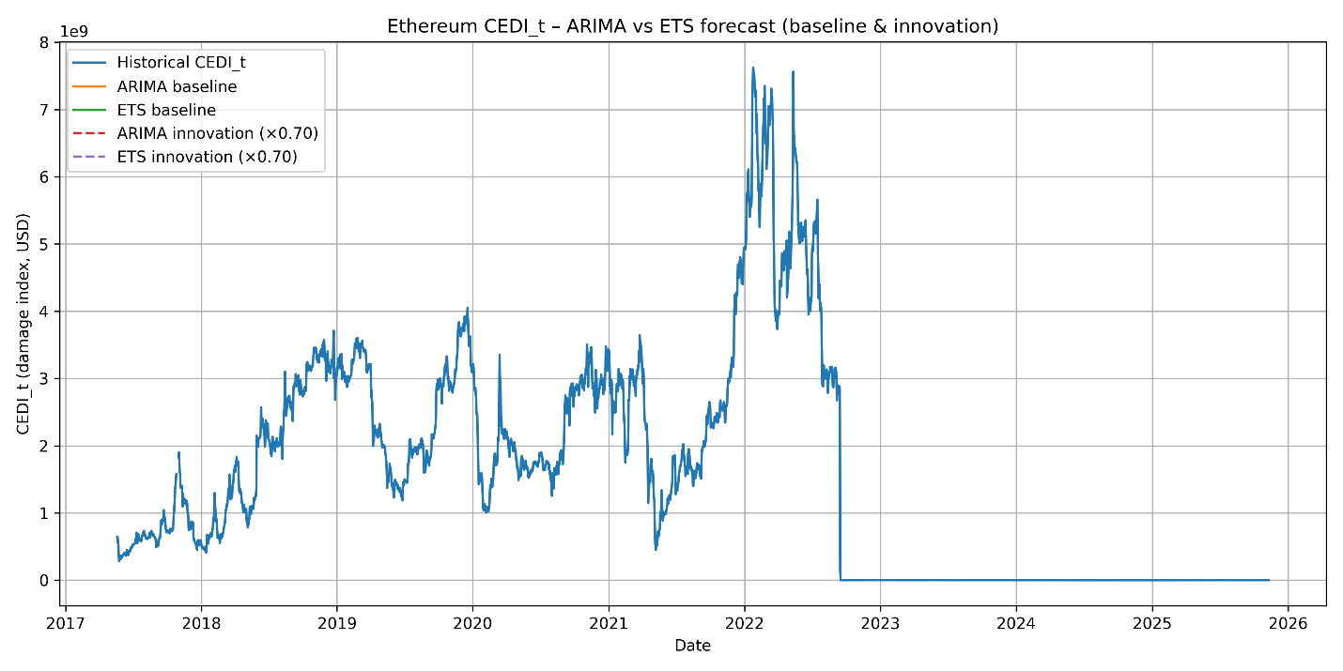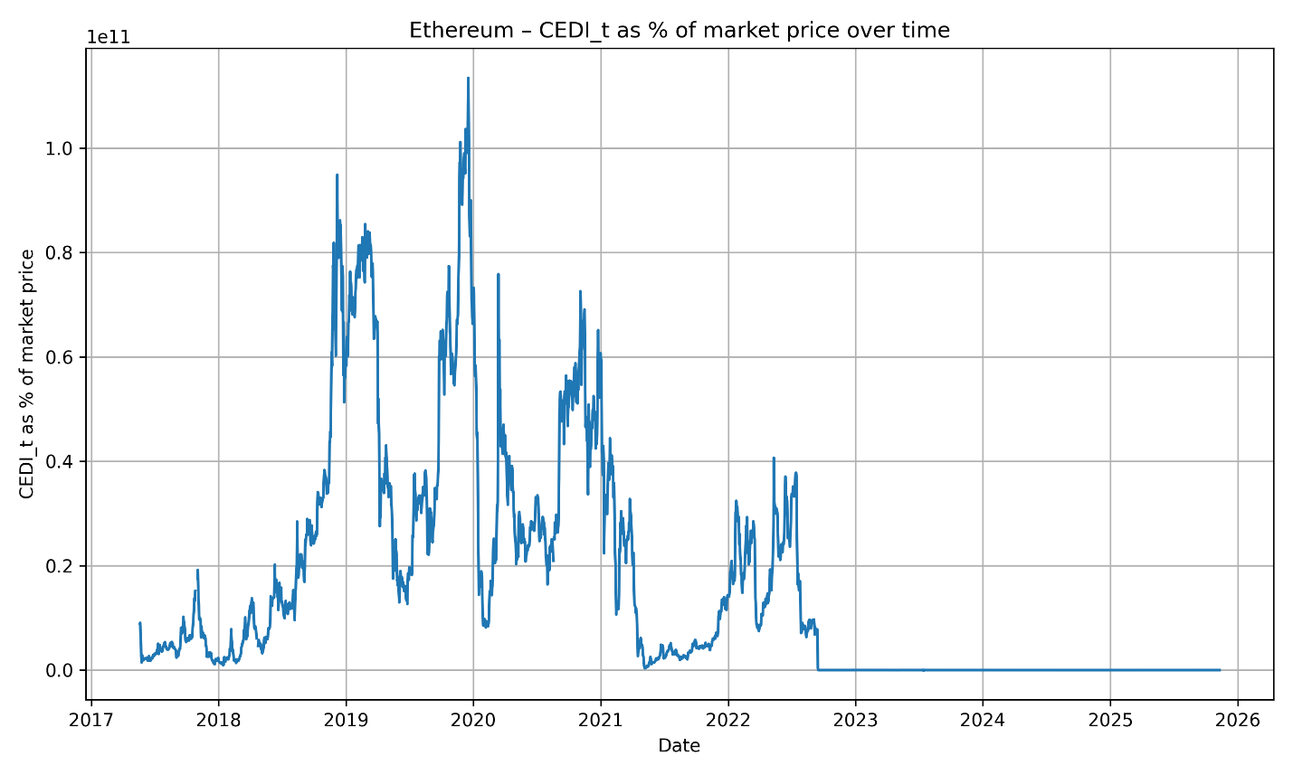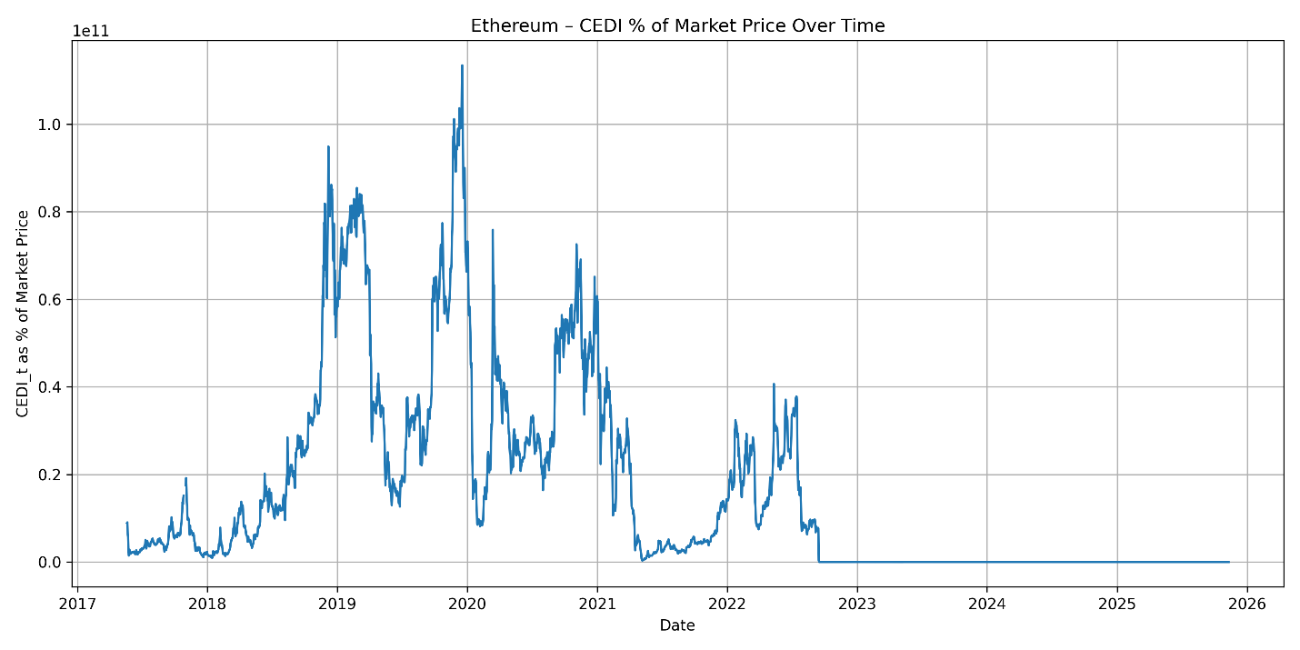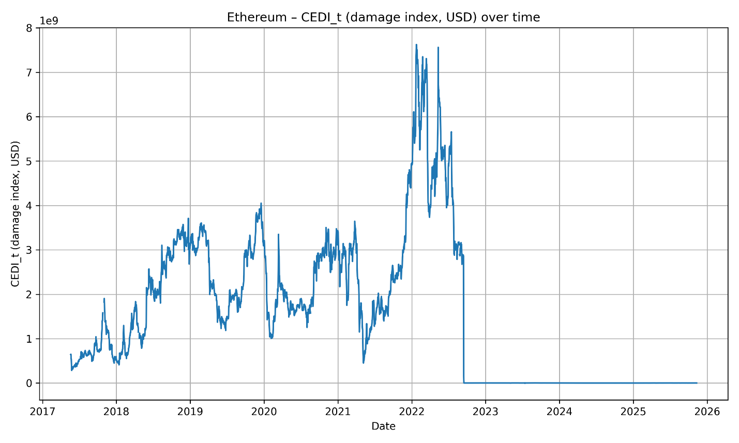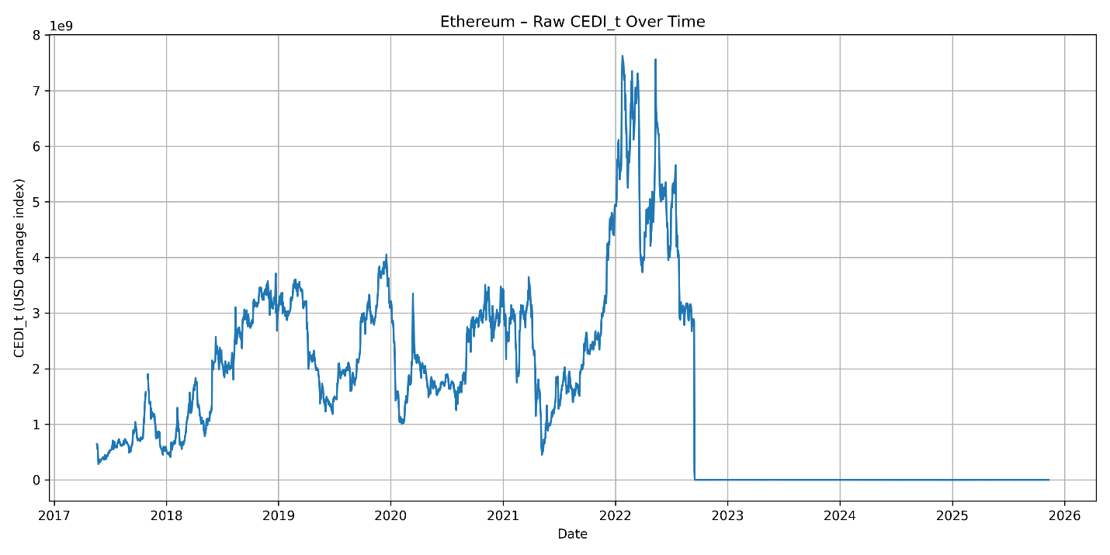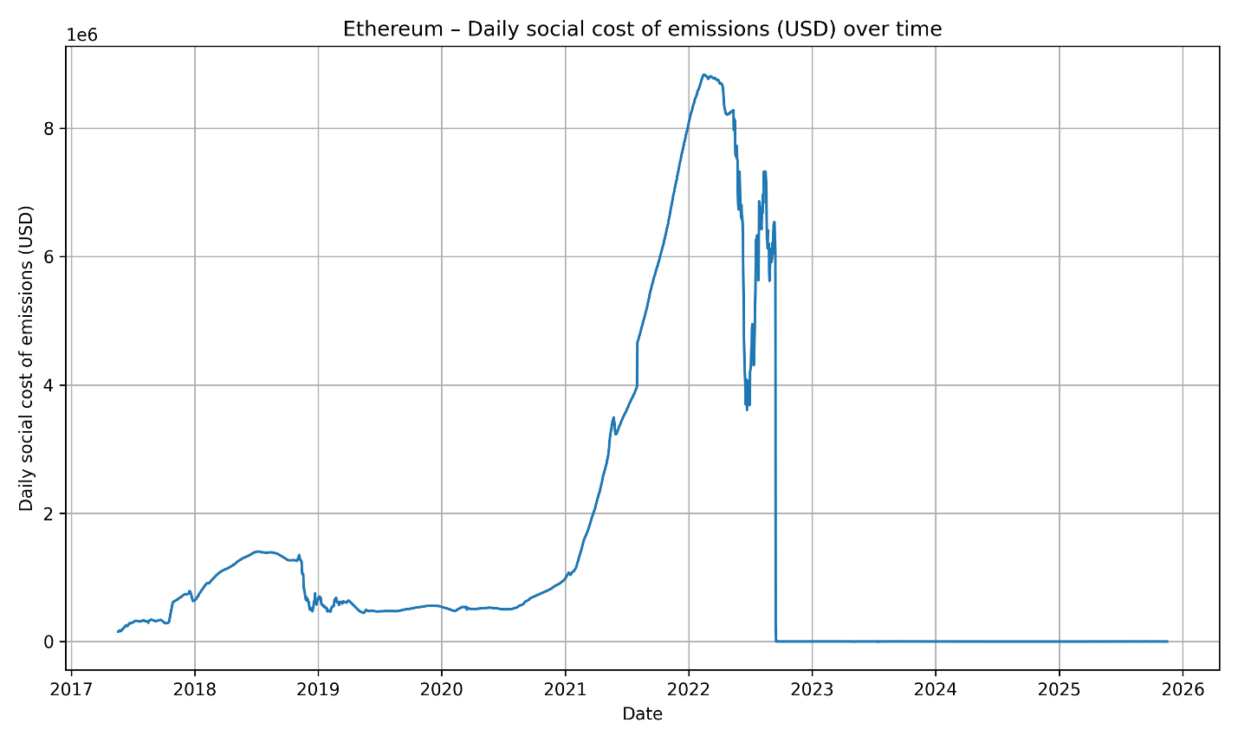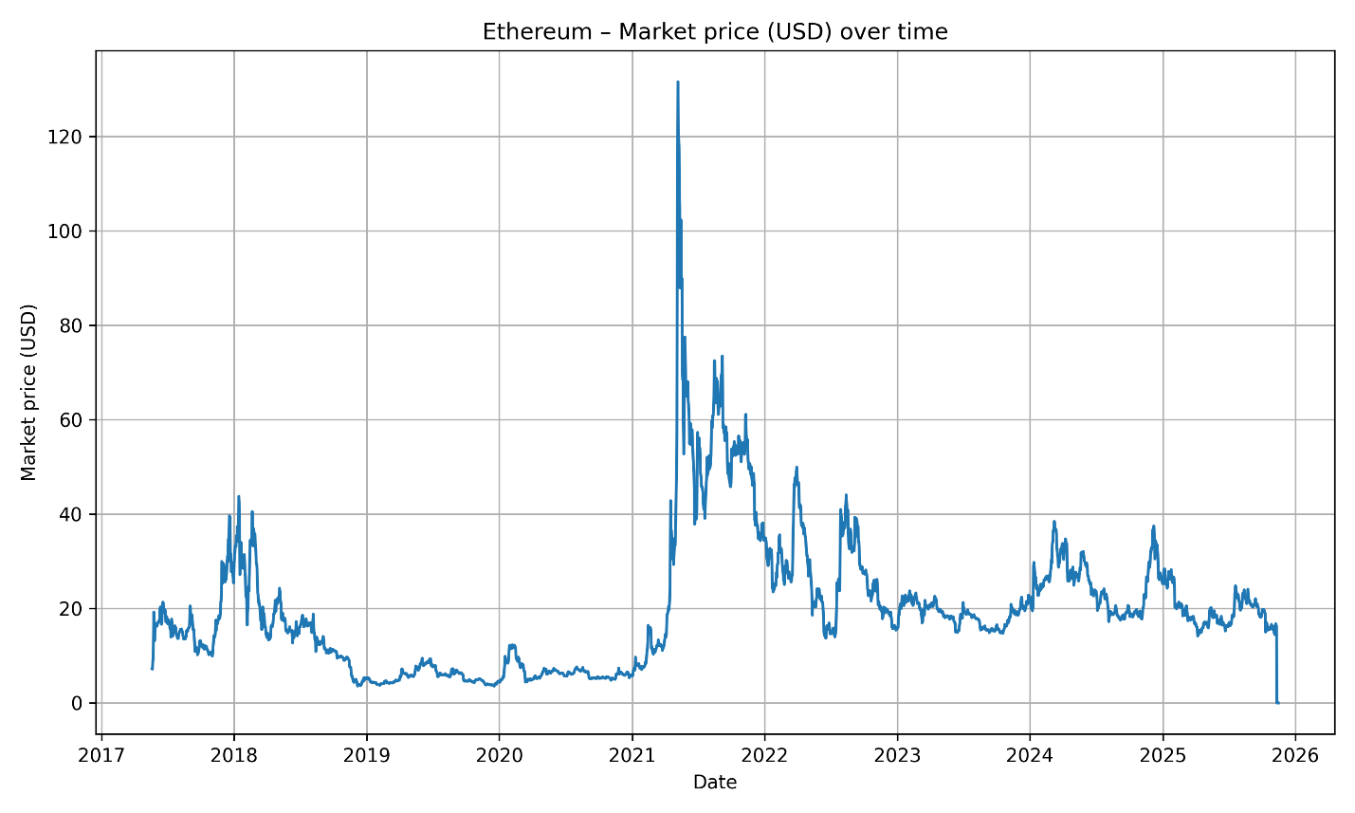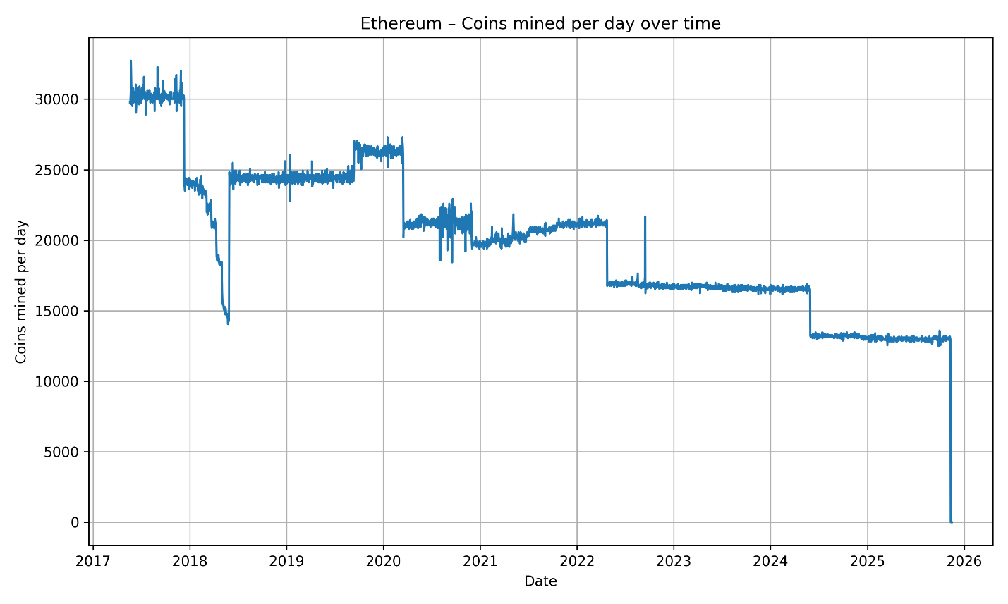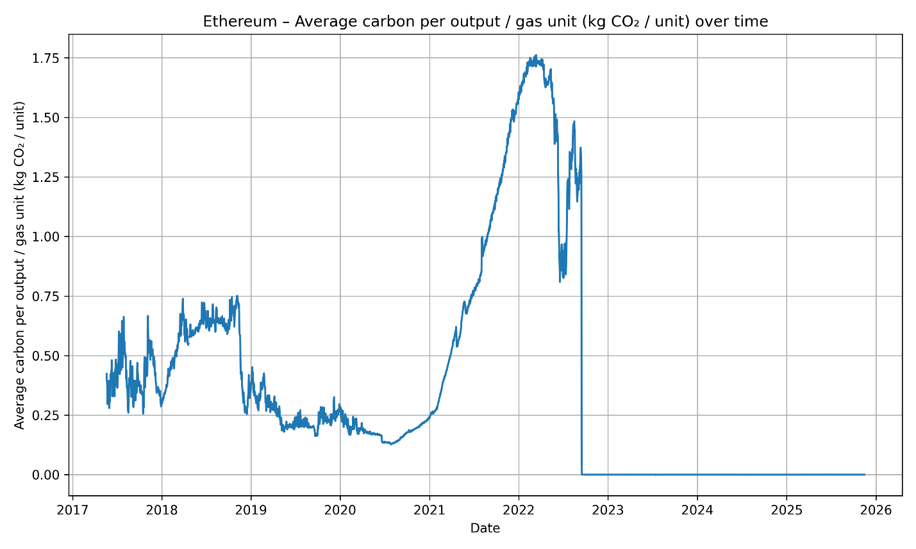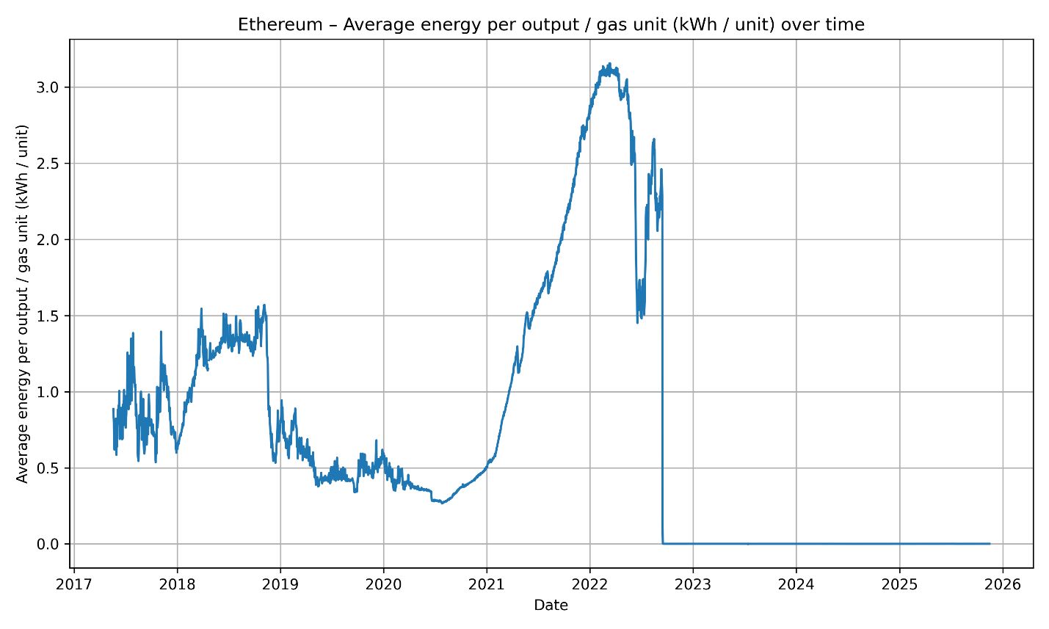

Dogecoin’s CEDI trends are characterized by lower absolute damages but significantly higher volatility in the CEDI percentage metric. Because Dogecoin’s price is heavily driven by speculative sentiment and can fluctuate by orders of magnitude (e.g., 2021 meme-driven surges), its CEDI percentage occasionally spikes to extreme values during sharp price contractions. In 2022–2023, for example, Dogecoin’s price fell substantially while mining operations—supported by merge-mining incentives with Litecoin—continued to consume relatively stable amounts of electricity. This produced short, pronounced intervals where Dogecoin’s environmental damages exceeded the economic value of the newly mined DOGE, despite the modest scale of its overall emissions compared to Bitcoin.

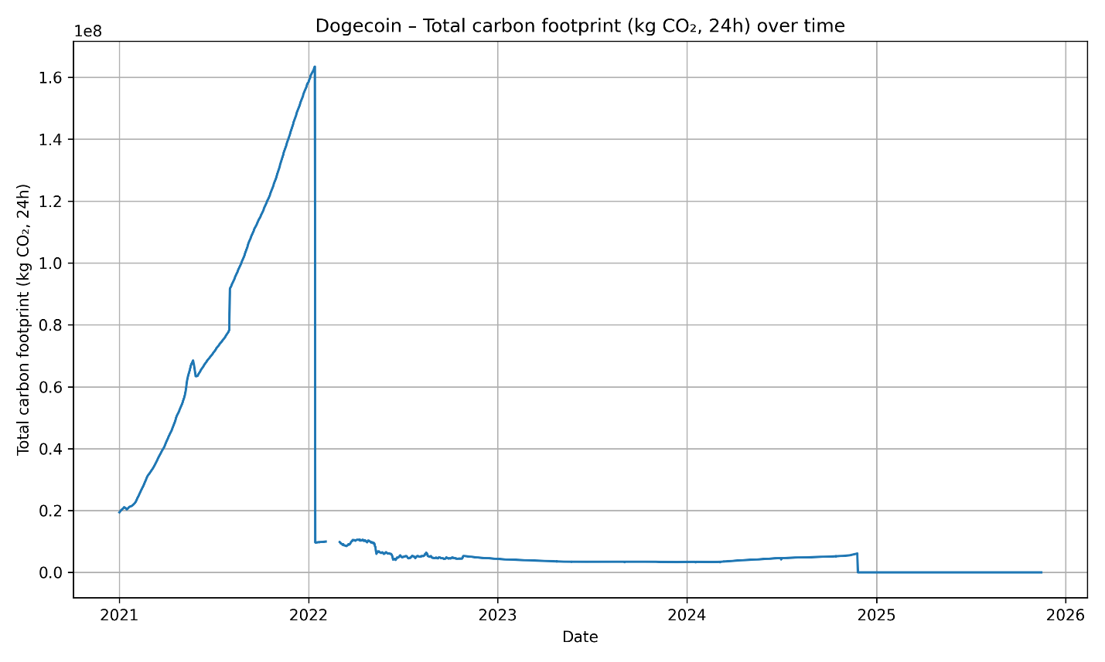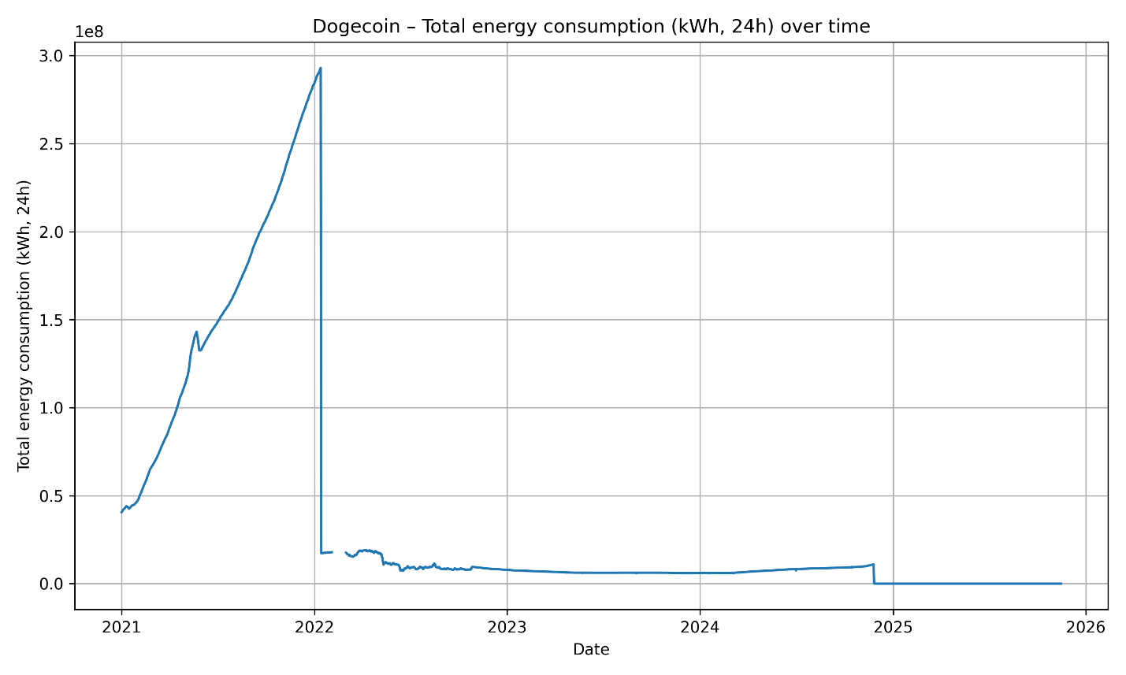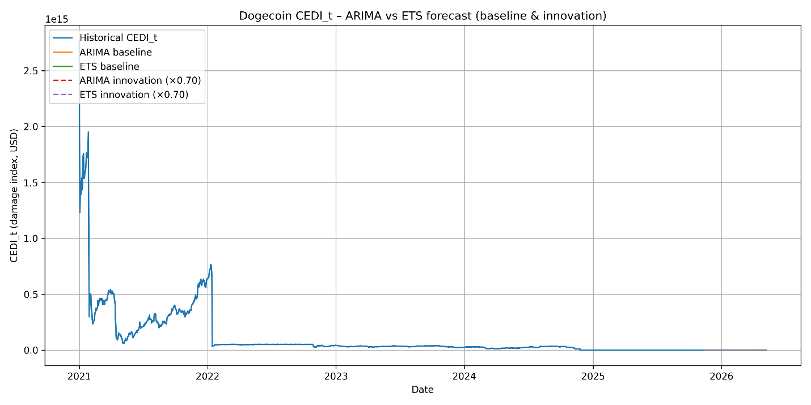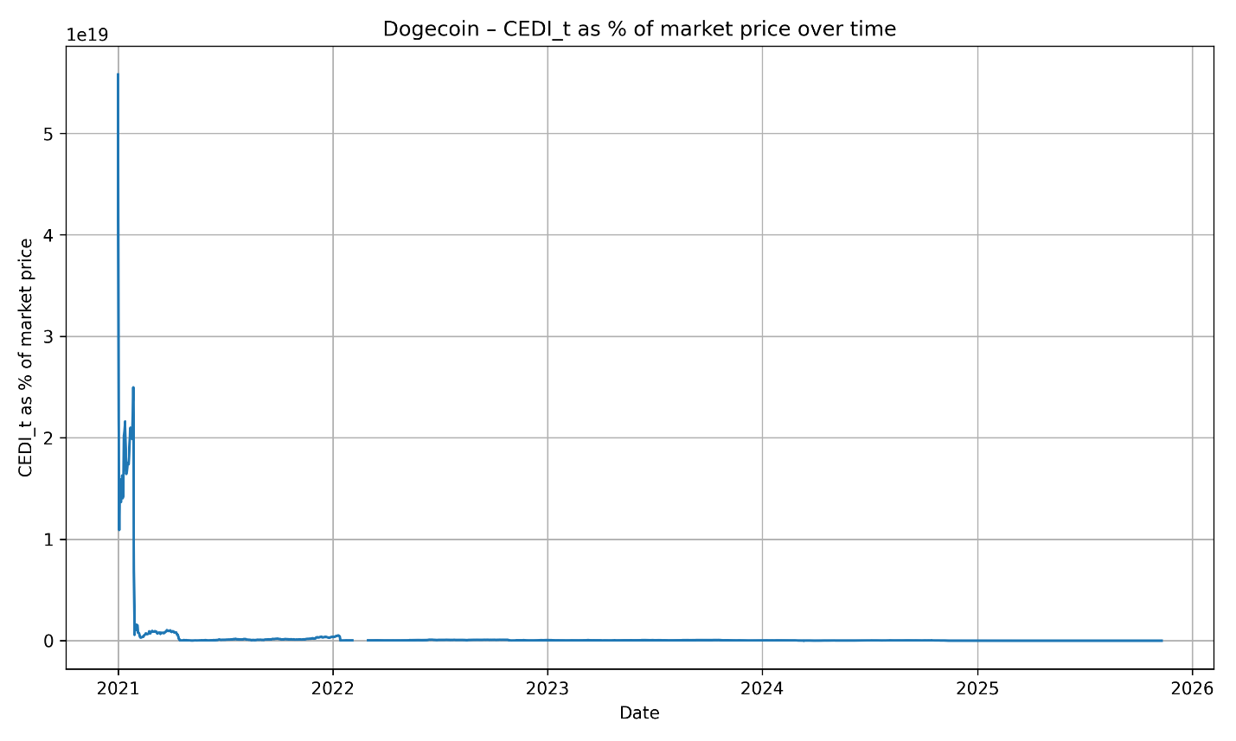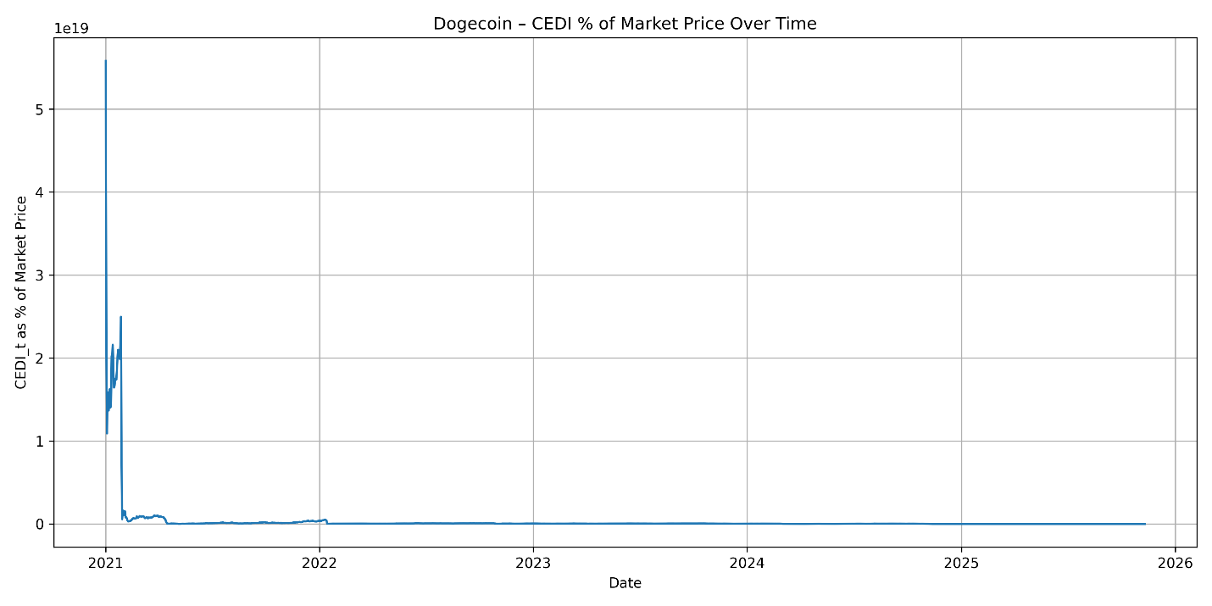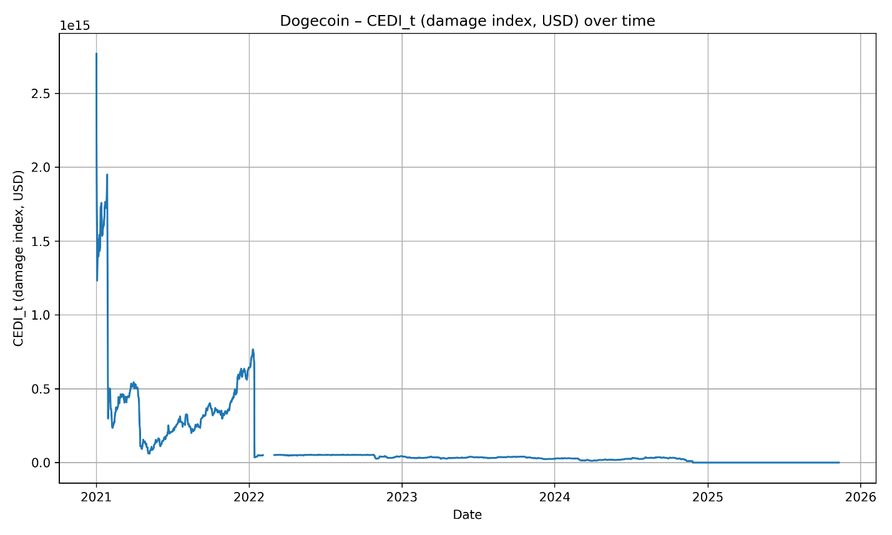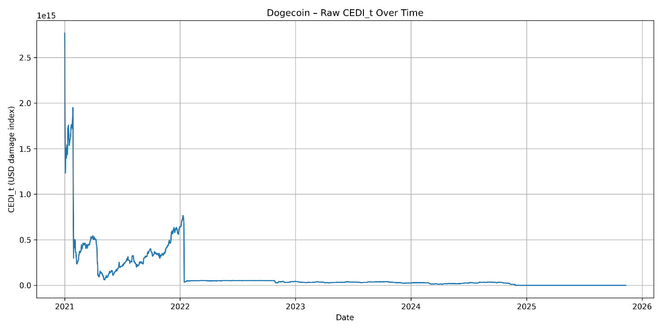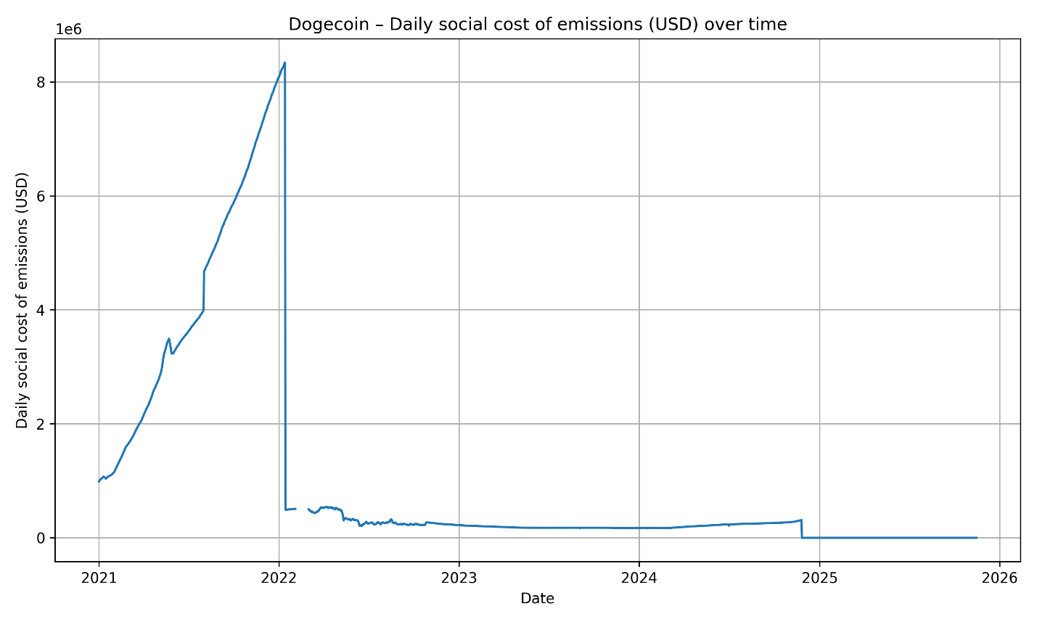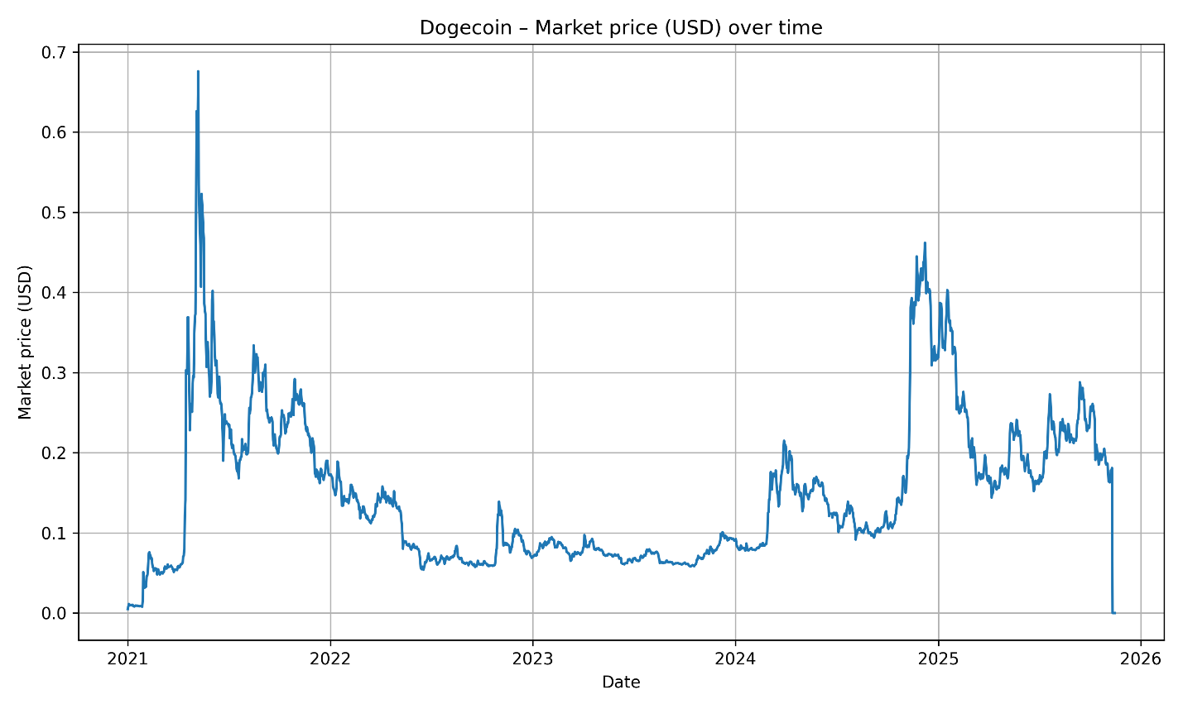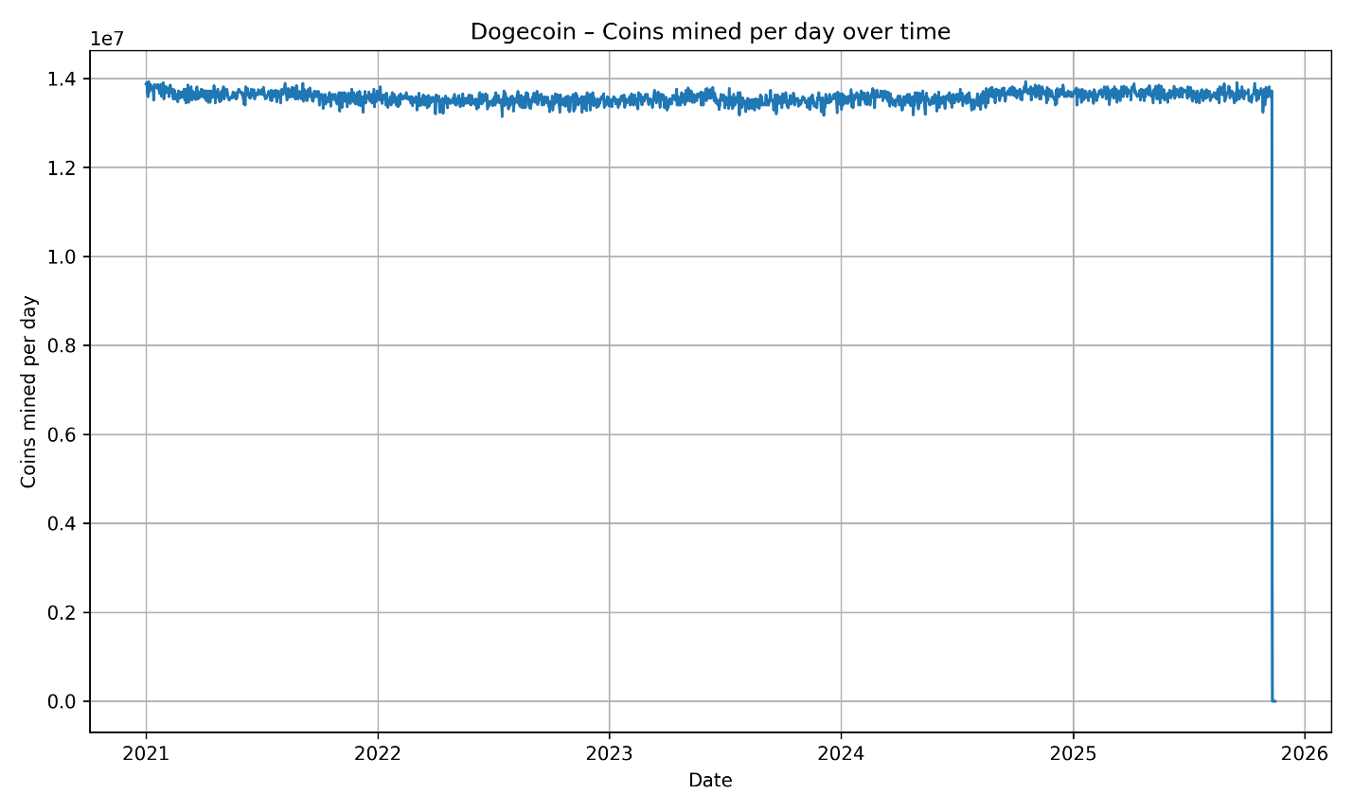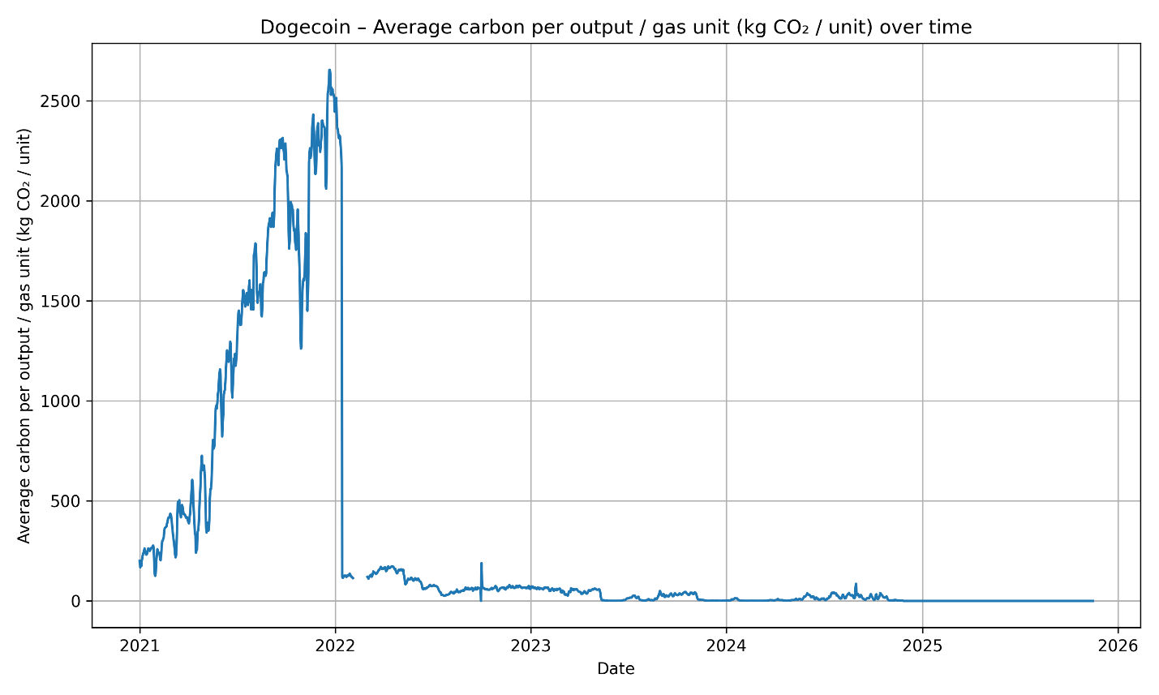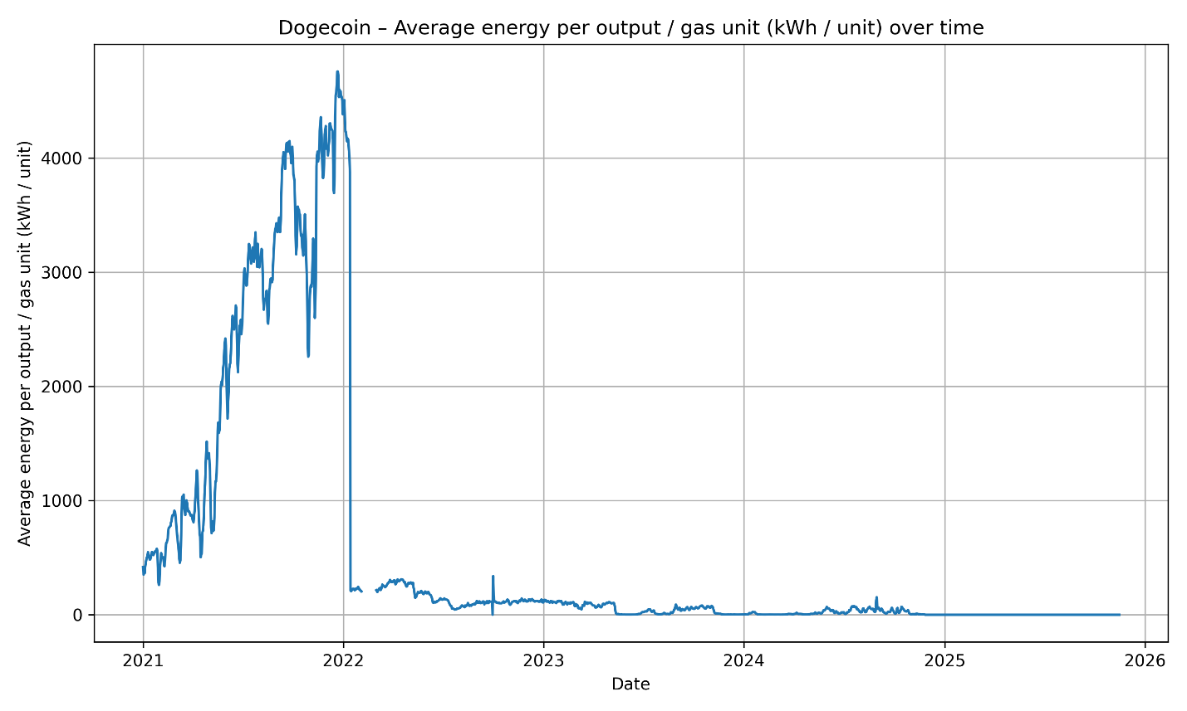

Taken together, these results highlight the strong dependence of cryptocurrency environmental damages on network design, energy consumption characteristics, and market volatility. Proof-of-Work networks exhibit periods where the environmental cost of coin issuance outweighs its market value, particularly during prolonged bearish conditions. In contrast, Ethereum’s post-Merge trajectory demonstrates that structural protocol changes can virtually eliminate such damages. The CEDI metric thus serves as an effective cross-technology measure for environmental sustainability and provides a quantitative basis for evaluating the societal externalities of different blockchain architectures.

***Discussion for Regionalized Carbon Damages***

Carbon intensity is the measure of the amount of carbon dioxide, in kilograms, that is released to produce a kilowatt hour (kWh) of electricity (nationalgrid, 2022). This value reflects how “clean” an electricity grid is. Hence, an electricity grid that uses fossil fuels is increasingly more carbon intensive than renewable energy. As instructed, the weighted carbon intensity was calculated for the specific years of 2020 and 2022 because before 2021, cryptocurrency mining, specifically Bitcoin, was heavily produced in China, with a mining share of 72.69% in January 2020 and a carbon intensity of 0.606 kgCO2/ kWh, which reflects how “dirty” their grid is (CBECI, n.d.; Ember, n.d.). However, in 2021 cryptocurrency mining was banned in China, that is why the year 2022 was examined. Yet, it is important to note that the project advised to look at the years after 2024, but CBECI, the website that the instructions advised should be used to collect data, only provided mining shares up until the year 2022. This impacts the trends that one might have expected to see.

To continue, this scenario assumed that 100% of the mining was done in the United States in 2020 and 2024, to provide a baseline. The weighted average carbon intensity if all Bitcoin mining occurred in the U.S. was 0.412 and 0.410 kgCO2/ kWh, in 2020 and 2022, respectively. The weighted average carbon intensity was also calculated under a global assumption, which included the countries the United States, Kazakhstan and the EU (Germany, Ireland, Sweden, France, and the Netherlands) in 2020 and 2022. The total weighted average carbon intensity for global Bitcoin mining was 0.4900 and 0.4632 kgCO2/ kWh , in 2020 and 2022, respectively. One can see that the carbon intensity under the global mining assumption decreased. This is because after the ban in China, Bitcoin mining shifted to countries like the U.S., the EU, and Kazakhstan, which is evident in the increase of their mining shares in 2022 displayed in figure 32. These countries have cleaner electricity grids compared to China. So, as Bitcoin mining shifts to other regions with cleaner electricity grids, the global average weighted carbon intensity decreases.

Nonetheless, the same cannot be said about carbon emissions emitted under these assumptions. As depicted in figure 36, globally, the total carbon emissions went from 32.9 million metric tons in 2020 to 44.2 million metric tons in 2022. Although, Bitcoin mining occurred in cleaner electricity grids, electricity consumption overwhelmingly increased from 67.13 TWh to 95.53 TWh as shown in figure 33 (CBECI, n.d.). This increase in electricity consumption offsets the mining occurring in clean energy grids in terms of carbon emissions emitted. This is also the reason why damages increased from 1.68 billion USD in 2020 to 2.3 billion USD under the global assumption, in addition to the fact that the weighted carbon intensity only decreased a small amount.

***Discussion for PoS Transition Scenario***

Another analytical method that was performed was a Proof-of-Stake (PoS) transition scenario. Proof-of-Work (PoW) and Proof-of-Stake are two major mechanisms used in cryptocurrency to “verify new transactions, add them to the blockchain and create new tokens,” (Coinbase, n.d.). For this scenario, carbon emissions for Erethreum were collected under the Proof-of-Work mechanism and were reduced by 99% to simulate the transition to a Proof-of-Stake mechanism starting in 2018 (Figure #). For example, under Proof-of-Work, Eretherum emitted 4.72 metric tons of carbon dioxide in 2018. However, if they shifted to Proof-of-Stake, their emissions would have been 0.00472 metric tons of carbon dioxide. As depicted in Figure 39, this is a significant amount of emissions that could have been avoided if PoS was adopted much sooner. Nevertheless, as Figure 38 shows, Ethereum actually transitioned to a PoS system in September 2022. The explanation as to why this system allows for such a large reduction in emissions is because it has a lower electricity consumption rate compared to a PoW system (Coinbase, n.d.). In this way, cryptocurrency companies should follow Ethereum's example and look for ways to reduce their electricity consumption.

***Policy Implications***

Based on the analytical methods conducted, a variety of policies must be changed and adapted to account for the environmental damage that cryptocurrency mining does. The government should enforce the transition to a Proof-of-Stake (PoS) system to decrease energy consumption, because it is widely known that mining expends large amounts of electricity and that produces carbon emissions.

Several jurisdictions have begun implementing variable electricity rates for crypto miners, charging higher prices during peak loads to reduce local grid strain and discourage wasteful energy use. For instance:

New York’s municipal utilities have adopted “high-density load tariffs” to raise electricity costs for large crypto miners (New York State Department of Public Service, 2018).

Iceland and Sweden have recommended similar measures due to mining-driven energy surges (European Environment Agency, 2022).

Logistically, pricing signals would directly discourage excessive / inefficient cryptocurrency mining. Economists have also proposed applying carbon pricing or specific mining-related taxes to internalize environmental externalities. Research from the Cambridge Centre for Alternative Finance notes that a carbon-tax approach would align mining costs with societal damages (Cambridge, 2022). The U.S. White House OSTP (2022) also supported this form of taxation at one point. The US White House proposed a Digital Asset Energy Tax (DAET) to charge miners for the environmental and grid impacts of mining. Enforcing carbon pricing forces mining firms to factor environmental cost into operations, promoting cleaner practices.

Governments could also mandate minimum performance standards for ASICs and GPUs used in mining—similar to appliance efficiency regulations. The U.S. DOE’s appliance efficiency standards framework is cited by researchers as a model for regulating ASIC efficiency (Mora et al., Nature Communications, 2018). The International Energy Agency (IEA) has also recommended efficiency-based mining regulation in multiple energy reviews. In this manner, regulating hardware efficiency should reduce electricity usage and should be independent of the algorithm used.

States and provinces in Western society have proposed and even currently offer incentives for those who participate in green mining – cryptocurrency mining that relies on electricity generated through renewable energy sources. For instance, Texas and Wyoming offer tax incentives and grid-participation payments to miners who use renewable energy and support demand-response programs (ERCOT, 2022). Meanwhile, in Canada (Québec) prioritizes renewable-energy allocations for miners that demonstrate sustainability commitments (Hydro-Québec, 2021). In addition, the banning of cryptocurrency mining in regions that do not use renewable energy can prove to be beneficial. But, before banning occurs, countries should be encouraged to adapt to cleaner energy grids, which are valuable not just for the cryptocurrency mining industry, but to all industries.

These policy changes would work well together to make cryptocurrency mining more sustainable.

***Conclusion***

Taken together, the evidence clearly demonstrates that cryptocurrency mining’s environmental impacts require a coordinated, multi-policy response grounded in energy efficiency, carbon accountability, and sustainable grid integration. A mandatory transition toward lower-energy consensus mechanisms such as Proof-of-Stake, combined with dynamic electricity pricing, carbon taxation, and minimum hardware-efficiency standards, would directly reduce the sector’s carbon footprint while aligning mining behavior with broader climate objectives. Likewise, targeted incentives for renewable-powered operations and region-specific restrictions on fossil-fuel-dependent mining would encourage firms to internalize environmental costs and adopt cleaner practices. As jurisdictions around the world experiment with these approaches, the emerging consensus is that no single policy is sufficient on its own; rather, a layered strategy that integrates pricing signals, regulatory mandates, technological standards, and renewable-energy incentives offers the most viable path toward a sustainable digital-asset ecosystem. Ultimately, implementing these reforms would help ensure that cryptocurrency development proceeds in a way that supports, rather than undermines, long-term environmental and energy-system resilience.

References

Antonopoulos, A. M. (2017). Mastering Bitcoin: Programming the open blockchain (2nd ed.). O’Reilly Media.

Bitcoin Gold Organization. (2017). Bitcoin Gold: FAQ & technical overview. https://bitcoingold.org

BitInfoCharts. (2023). Methodology & data notes. https://bitinfocharts.com

Buterin, V. (2014). Ethereum white paper. https://ethereum.org/en/whitepaper/

Cambridge Bitcoin Electricity Consumption Index. (2024). CBECI methodology and estimates. Cambridge Centre for Alternative Finance. https://ccaf.io/cbnsi/cbeci

Cambridge Centre for Alternative Finance. (2023). Bitcoin Electricity Consumption Index. <https://ccaf.io/cbnsi/cbeci>

Cambridge Centre for Alternative Finance. (2025). Cambridge Blockchain Network Sustainability Index – Ethereum 1.0 [Data visualisation]. Cambridge Judge Business School, University of Cambridge. <https://ccaf.io/cbnsi/ethereum/1>

Cambridge Centre for Alternative Finance. (2025). Cambridge Blockchain Network Sustainability Index – CBECI (Bitcoin Electricity Consumption Index) [Data visualisation]. Cambridge Judge Business School, University of Cambridge. <https://ccaf.io/cbnsi/cbeci>

Cambridge Centre for Alternative Finance. (2025). Cambridge Blockchain Network Sustainability Index – CBECI: GHG emissions [Data visualisation]. Cambridge Judge Business School, University of Cambridge. <https://ccaf.io/cbnsi/cbeci/ghg>

Cambridge Centre for Alternative Finance. (2025). Cambridge Blockchain Network Sustainability Index – CBECI: mining map/mining data [Data visualisation]. Cambridge Judge Business School, University of Cambridge. <https://ccaf.io/cbnsi/cbeci/mining_map/mining_data>

CNBC. (2021, May 4). Dogecoin spikes after Elon Musk tweets about it. CNBC.

CoinDesk Research. (2021). State of blockchain 2021. CoinDesk.

CoinGecko. (2024). Bitcoin Gold price chart. https://www.coingecko.com/en/coins/bitcoin-gold

CoinMarketCap. (2024). Bitcoin Gold (BTG) price history. https://coinmarketcap.com/currencies/bitcoin-gold/

Courtois, N., Grajek, M., & Naik, R. (2014). The unbearable lightness of Bitcoin mining: An attack on the Bitcoin protocol. Future Internet, 6(3), 488–503.

Digiconomist. (2022). Bitcoin Energy Consumption Index. https://digiconomist.net/bitcoin-energy-consumption

Digiconomist. (2022). Ethereum Energy Consumption Index. https://digiconomist.net/ethereum-energy-consumption

Digiconomist. (2022). Dogecoin Energy Consumption Index. https://digiconomist.net/dogecoin-energy-consumption

Ethereum Foundation. (2022). Ethereum energy consumption after the merge. https://ethereum.org

Gandal, N., & Halaburda, H. (2016). Competition in the cryptocurrency market. Bank of Canada.

International Energy Agency. (2023). Electricity market report. International Energy Agency.

Köhler, S., & Pizzol, M. (2019). Life cycle analysis of Bitcoin mining. Environmental Science & Technology, 53(23), 13598–13606.

Lee, D. K. C., Guo, L., & Wang, Y. (2018). Cryptocurrency forks: A study of Bitcoin Gold and Bitcoin Cash. Journal of Digital Assets, 1(2), 44–59.

Narayanan, A., Bonneau, J., Felten, E., Miller, A., & Goldfeder, S. (2016). Bitcoin and cryptocurrency technologies. Princeton University Press.

Nakamoto, S. (2008). Bitcoin: A peer-to-peer electronic cash system. https://bitcoin.org/bitcoin.pdf

Stoll, C., Klaaßen, L., & Gallersdörfer, U. (2019). The carbon footprint of Bitcoin. Joule, 3(7), 1647–1661.

Truby, J., & Steding, S. (2022). Crypto’s energy problem: Assessing blockchain’s sustainability and environmental impact. Energy Policy, 165, 112951.

United Nations Environment Programme. (2023). Sustainable digital finance and environmental governance. https://www.unep.org

Zadé, Michel; Myklebost, Jonas (2018), “Bitcoin and Ethereum Mining Hardware”, Mendeley Data, V1, doi: 10.17632/4dw6j3pxz5.1

***Appendix***

**Data Generation & Time-Series Modeling Scripts**

This project relies on a multi-stage computational pipeline written in Python.  
The scripts fall into three functional categories:

1. **Raw data acquisition** (scraping & API ingest)
2. **Data transformation and metric construction** (e.g., CEDI ${}_{t}$)
3. **Forecasting using ARIMA / time-series modeling**

Each script contributes to a specific portion of the final dataset. This appendix summarizes the methodological purpose and computational role of each script in the project.

**1. ASIC Mining Hardware Data Scraping**

**1.1 scraper_asic_all_coins.py**

scraper_asic_all_coins

This script scrapes miner-level hardware information from **ASICMinerValue.com**, including model name, release date, hashrate, power consumption, algorithm family, price data, and daily profitability. The script:

* Uses requests with a desktop browser user-agent to avoid bot blocks.
* Parses HTML tables with BeautifulSoup, normalizing column headers.
* Extracts both textual and numeric attributes, converting monetary values into floats via a custom parser.
* Outputs a unified dataset listing all ASIC models relevant to the coins analyzed in the study.

This dataset supports **energy-efficiency comparisons** and **hardware evolution analysis**, which strengthens the environmental-impact framing of the project.

**2. Blockchain Market & Network Data Scraping**

**2.1 Block-Reward Scraper (reward_per_block.py)**

reward_per_block

This script retrieves **real-time block subsidy and fee-per-block values** for major proof-of-work cryptocurrencies via BitInfoCharts. It:

* Locates the “Reward Per Block” statistic embedded in BitInfoCharts' HTML.
* Parses block subsidies and average transaction fees.
* Outputs a clean table suitable for linking economic incentives to observed energy consumption.

Block rewards are essential for interpreting mining profitability dynamics over time.

**2.2 Price Data Scrapers**

**Confirmation-Time & Mining Difficulty (block_time_crypto_process.py)**

block_time_crypto_process

Scrapes block confirmation time data for major coins, reconstructing historical block-time series. This is later used for:

* Estimating blocks-per-day
* Reconstructing historical emission schedules
* Inferring mining throughput and difficulty patterns

The script performs HTML extraction of embedded Dygraphs datasets, normalizing JavaScript date formats into pandas-readable strings.

**Daily Price Panel (price_crypto_process.py)**

wide_coin_script

Scrapes long-horizon daily USD price data from BitInfoCharts for the ten coins in the analysis.  
It:

* Extracts all price-date pairs from JavaScript arrays embedded in the HTML.
* Produces a wide panel with one column per coin.
* Forces strict date-bound filtering to maintain consistent coverage from **2015–2025**.

These prices later become inputs to:

* Market-cap estimations
* Economic scaling of environmental damages
* Forecasting via ARIMA

**2.3 Hashrate Data Scrapers**

**Historical Hashrate (hashrates_crypto_process.py)**

hashrates_crypto_process

Retrieves proof-of-work network hashrates from BitInfoCharts, reconstructing daily hashrate trajectories for all ten coins.  
The script:

* Normalizes multiple date formats (Date.UTC, new Date("YYYY/MM/DD"))
* Handles missing values and duplicate timestamps
* Outputs a unified daily series required for computing network energy demand.

**Hashrate/Confirmation-Time Variant (block_time_crypto_process.py, dual-purpose)**

block_time_crypto_process

Also provides a method for reconstructing mining rate and throughput via confirmation-time data, which is especially valuable for Ethereum Classic and Dogecoin.

**3. Cleaning and Hardware Comparison**

**3.1 Bitcoin Mining Hardware Table Cleaner (pandas_read_table_mining.py)**

pandas_read_table_mining

This script parses Wikipedia’s *Mining Hardware Comparison* table and:

* Removes annotation markers and footnotes
* Converts all wattage, price, and hashrate fields to numeric values
* Produces a standardized CSV suitable for analysis of hardware efficiency trends

These efficiencies contextualize overall energy usage, informing whether mining technology becomes greener or more harmful over time.

**4. Computation of Environmental Cost & Data Fusion**

**4.1 Main Environmental Damage Pipeline (damages_script.py)**

damages_script

This is the **central script** of the entire project and performs the following major tasks:

**(A) Digiconomist API Ingestion**

* Fetches daily energy-consumption and CO₂-emission statistics for  
  **Bitcoin, Ethereum, and Dogecoin**.
* Stores each day’s data as JSON files using parallelized HTTP requests for speed.

**(B) DataFrame Construction**

For each coin, the script reconstructs daily datasets containing:

* 24-hour electricity consumption (kWh)
* 24-hour CO₂ emissions (kg CO₂)
* Output-energy metrics
* Social cost of carbon (based on $51/ton)
* Imputed **coins-per-day**, derived from block-time and reward schedules

**(C) Integration with BitInfoCharts Data**

* Merges scraped hashrates, block-times, and market prices
* Computes **Coins**, **Coins mined**, and **Coins mined per day**
* Ensures alignment of all time series using normalized date indices

**(D) Construction of CEDI ${}_{t}$**

The script formally computes:

$${\text{CEDI}}_{t}=\frac{{\text{Daily Social Cost}}_{t}}{{\text{Coins Mined}}_{t}}$$

This index quantifies the **environmental damage cost per coin mined**.

**(E) ARIMA Time-Series Forecasting**

The script fits ARIMA models to:

* Daily social-cost time series
* CEDI ${}_{t}$
* Electricity consumption
* CO₂ emissions

The revised version additionally:

* Saves ARIMA outputs to **two locations**:
* digiconomist_data/arima/
* digiconomist_data/<coin>/arima/
* Includes logic allowing **graceful early termination** (e.g., skipping model fitting when insufficient data exists)

**5. Wide Panel Construction**

**5.1 wide_coin_script.py**

price_crypto_process

This file constructs a synchronized, rectangular time-series panel joining:

* Hashrate
* Market price
* Confirmation time
* Reward and fee series
* Mining difficulty (if present)

It ensures common date alignment across all variables and coins, allowing downstream modeling to operate without missing-data fragmentation.

***Appendix A – Scraping Data for Block Time***



***Appendix B – Hashrates for Cryptocurrency***



***Appendix C – Price Cryptocurrency Coins***



***Appendix D – Calculating Social Costs***



***Appendix E – ARIMA Analysis***

